High School Gender Wage Gap Inquiry
Kentucky Academic Standards for Social Studies (KASS) | HS2.EDM.4 Use economic analysis to evaluate how economic choices and government policies impact individuals and groups.  HS3.EDM.7 Explain how current globalization trends and policies affect economic growth, labor markets, resource and income distribution.
Practices of the Inquiry Cycle | Gathering relevant information, identifying and utilizing evidence, developing and creating claims and counterclaims, constructing viable arguments, addressing options and proposing solutions.
What will students know and be able to do? | Students will understand the “degree to which economic inequality reflects social, political, or economic injustices” and the role the government should play in decreasing income inequality.
Potential Compelling Question
What should be done about the gender wage gap?
Potential Stimulus for Questions
Why is April 8th Equal Pay Day? Should it exist?
Supporting Question 1 |  | Supporting Question 2 | Supporting Question 3 | Supporting Question 4
Understand the economic, historical and geographic dimensions of the gender wage gap |  |  |  | Assess political solutions for addressing the gender wage gap
What are the challenges in accurately calculating the gender wage gap? |  | Why has the gender wage gap changed over time? | Where is the gender wage gap the most pronounced? | Is there a political solution to the gender wage gap?
Formative  Performance Task |  | Formative  Performance Task | Formative  Performance Task | Formative  Performance Task
List the challenges of accurately calculating the gender wage gap. |  | Write a paragraph that explains why the gender wage gap has narrowed but not disappeared. | Using a graphic organizer, summarize data and describe at local, state, and national levels where the gender wage gap is most pronounced. | Write a claim supported with evidence that explains whether or not there is a political solution to the wage gap.
Featured Sources |  | Featured Sources | Featured Sources | Featured Sources
Explaining the Gender Wage Gap report [Excerpt], Center for American Progress (May 2014)  Collection of graphs depicting the gender wage gap (2012-2014) |  | Gender Earnings Ratio, 1955-2013, Full-Time Workers (Graph) (2014)  Excerpt from Blau & Kahn, “The Gender Pay Gap: Have women gone as far as they can?” (2007)  Excerpt from Claudia Goldin, Ely Lecture Paper, “The Quiet Revolution that Transformed Women’s Employment, Education, and Family” (2006) | Collection of demographic data on gender wage gap from Breadwinner Moms, Pew Research Center, May 2013  Women’s Pay As A Percentage of Men’s Pay, Chart, 2014  Median earnings of men and women based on New York congressional districts (2013), American Association of University Women | Should the Senate Pass the Paycheck Fairness Act?, U.S. News & World Report’s Debate Club, May 2012  Higher State Minimum Wages Promote Fair Pay for Women, National Women’s Law Center, September 2013  Government Can’t Fix Real Gender Pay Gap, Bloomberg View, April 2014

Culminating  Performance Task | Task | What should be done about the gender wage gap? Construct an argument (e.g., detailed outline, poster, essay) that addresses the compelling question using specific claims and relevant evidence and information from contemporary sources.
 | Extension | Research specific sectors of the economy to determine the ratio of males and females holding jobs. Using this information, evaluate if the ratios have a significant effect on the wage gaps by gender.
Taking Informed Action | Understand: Investigate a sector of the economy that demonstrates significant wage gaps by gender.  Assess: Determine political solutions that could address the gender wage gap.  Act: Write an op-ed for a local or national newspaper stating an argument for what should be done about the gender wage gap and address economic, historic, geographic, and political factors that have informed the argument.

Overview

Inquiry Description

This inquiry leads students through an investigation of a hotly debated issue in America, the gender wage gap. The content signaled in this inquiry is derived from key ideas in social studies that relate to the impacts of American Capitalism in a Global Economy, but hones in on the economic inequality and the role the government should play in decreasing income inequality. The compelling question, “what should we do about the gender wage gap?” asks students to grapple with not only how to quantify and interpret the gap, but to consider ways of addressing the problem.
Because the subject of this inquiry is happening in real time, Taking Informed Action has been embedded into the fabric of the formative and summative tasks. In Formative Tasks 1, 2, & 3 students work to understand the issue by exploring the foundations of and controversies surrounding the gender wage gap. In Formative Task 4, students begin assessing whether there is a political solution by examining contemporary news sources. Finally, students act within the Summative Task. After constructing their arguments in response to the compelling question, students write an op-ed for a local or national newspaper stating an argument about what should or should not be done about the gender wage gap that addresses economic, historic, geographic, and political factors that have informed the argument. In this way, students learn that academic inquiries can lead directly to civic action.
Content Background

The gender wage gap has garnered recent attention as Americans talk more and more about income inequality. On April 7th 2014, President Barack Obama named April 8th, National Equal Pay Day, as a way of heightening awareness of how “far into the new year women would have to work to earn the same as men did in the previous year.” While many Americans celebrated this proclamation, others claimed that the gender wage gap is either not as bad as claimed or that much of the gap is due to occupational and life choices. Some economists call into question the gender wage gap figures, finding them inaccurate since many proponents of reform use a single statistic that often conceals a variety of factors, such as people who hold different jobs, have different hours, and possess different work histories. Still other economists see that the persistent, albeit improving, wage gap trend is attributed to gender workforce discrimination.

While this inquiry is rooted in a question about economics, no social issue is fully understood without examining a range of civic, economic, geographic, and historical concepts in order to craft a full-bodied, evidence-based argument. This inquiry looks at the complexity of the gender wage gap issue through all four social studies disciplines Students examine the structural factors that influence women’s choices as well as legislative efforts both historical (e.g., Equal Pay Act 1963) and pending (e.g., Paycheck Fairness Act). Ultimately, students must find a way to measure the gender wage gap and determine if it is an issue worth addressing and if so, how to best address it, including private and public sector solutions. In this way, the summative products of the inquiry that require students to utilize the four social studies lenses in order to take informed action demonstrate not just a command of the subject matter but college, career, and civic readiness.

Content, Practices, and Literacies

In addressing the compelling question, “what should be done about the gender wage gap?” students will need to weigh evidence and counter evidence from a variety of sources. In the first task, students use an excerpt from a think tank report and a collection of graphs and charts to understand the complexity of accurately calculating the gender wage gap. Next, students explore how the gender wage gap has changed over time as well as its causes through graphical and text based sources. Students then move to understanding the issue through an exercise that looks at the gender wage gap on national, state, and local levels using maps and graphs. Finally, students wrestle with the political possibilities for remedying the persistent gap in wages between men and women by examining past and pending political solutions.

Throughout the inquiry, students are asked to do increasingly complex tasks that will develop their cognitive capacity to deal with the complex summative task. First, students use economic data to list the challenges of accurately calculating the gender wage gap (Gathering, Identifying and Using Evidence). The second task asks students to write a paragraph that explains why the gender wage gap has narrowed but not disappeared (Gathering, Identifying and Using Evidence; Developing Claims and Counterclaims). The third task asks students to summarize data and describe at various scales where the gender wage gap is most pronounced using a graphic organizer (Gathering, Identifying and Using Evidence). The last task requires students to develop a claim about whether or not there is a political solution to the wage gap (Gathering, Identifying and Evidence; Constructing Arguments). Finally, in the summative task, students need to pull together varying perspectives and support them with evidence from the range of sources used throughout the inquiry. Students write an op-ed for a local or national newspaper stating their argument for what should be done about the gender wage gap and address economic, historic, geographic, and political factors that have informed their argument (Gathering, Identifying and Using Evidence; Developing Claims and Counterclaims; Constructing Arguments; Addressing Options and Proposing Solutions). It is important that, at the high school level, students can express complex arguments around public policy issues and call upon the disciplinary lenses of the social studies (civic, economic, geographic, historic) in order to make coherent and comprehensive arguments in the public square.

The Kentucky Academic Standards for Literacy in History/Social Studies offer social studies teachers numerous opportunities to integrate literacy goals and skills into their social studies instruction. These literacy practices support the inquiry process through reading rich informational texts, writing evidence-based arguments, speaking and listening in public venues, and using academic vocabulary that complements the pedagogical directions advocated in the Kentucky Social Studies Standards. At the end of this inquiry is an explication of how teachers might integrate literacy skills throughout the content, instruction, and resource decisions they make.

Staging the Compelling Question
Compelling Question | What should be done about the gender wage gap?
Featured Sources | Source A: Presidential Proclamation of National Equal Pay Day (2014)  Source B: Forbes, “It’s time we end the equal pay myth,” Carrie Lukas (2012)

The compelling question, “what should be done about the gender wage gap?” asks students to deal with a divisive issue in the American economy. Throughout the formative performance tasks, students are working with a variety of graphs, data tables, economic reports, and articles from economists to interpret and analyze both the economics of the gender wage gap as well as its inherent controversy. The staging activity allows students from the onset to understand the economic reasoning for and against the establishment of Equal Pay Day.

To stage this inquiry, teachers should challenge students to figure out the symbolism (meaning?) of Equal Pay Day. In other words, why was April 8th 2014 proclaimed Equal Pay Day? A quick Internet search should reveal that April 8th was chosen based on a statistic that demonstrates that a woman would have to work an extra 60 days or three months to earn the same annual median income as a man.

From there, students should read the presidential proclamation of Equal Pay Day and could be prompted to examine the economic argument for establishing this observance. Teachers might want students to consider the historic roots of this decision and examine what other steps to close the gender gap have been taken prior to Equal Pay Day. Teachers might also choose to have students examine the language in the presidential proclamation and discuss the political and social implications of this decision.

As part of this exercise, students should be made aware that there is much debate on the economic reasoning behind the gender wage gap and, therefore, on the establishment of Equal Pay Day. Teachers should have students read the Forbes article “It’s Time We End the Equal Pay Myth” in order to establish an understanding that not everyone agrees on the numbers behind the gender wage gap. Teachers might want help students understand that, beyond calculation differences, there are inherent philosophical differences over what contributes to the gender wage gap (i.e., discrimination vs. jobs in different industries).

The juxtaposition of the presidential proclamation of Equal Pay Day vs. the Forbes article on the myth of a equal pay gap introduces the economic and political complexity of the issue at the center of this inquiry. Yet, as 12th graders look towards graduation, college, and careers, understanding economic-focused trends, as well as the controversy behind them, helps them to become informed and engaged citizens.

Staging the Compelling Question  Featured Source A | Presidential Proclamation of National Equal Pay Day (2014)

Presidential Proclamation -- National Equal Pay Day, 2014
NATIONAL EQUAL PAY DAY, 2014
BY THE PRESIDENT OF THE UNITED STATES OF AMERICA
A PROCLAMATION

Throughout our Nation's history, brave women have torn down barriers so their daughters might one day enjoy the same rights, same chances, and same freedoms as their sons. Despite tremendous progress, too many women are entering the workforce to find their mothers' and grandmothers' victories undermined by the unrealized promise of equal pay for equal work. On National Equal Pay Day, we mark how far into the new year women would have to work to earn the same as men did in the previous year, and we recommit to making equal pay a reality.

Women make up nearly half of our Nation's workforce and are primary breadwinners in 4 in 10 American households with children under age 18. Yet from boardrooms to classrooms to factory floors, their talent and hard work are not reflected on the payroll. Today, women still make only 77 cents to every man's dollar, and the pay gap is even wider for women of color. Over her lifetime, the average American woman can expect to lose hundreds of thousands of dollars to the earnings gap, a significant blow to both women and their families. In an increasingly competitive global marketplace, we must use all of America's talent to its fullest potential -- because when women succeed, America succeeds.

More than half a century after President John F. Kennedy signed the Equal Pay Act, my Administration remains devoted to improving our equal pay laws and closing the pay gap between women and men. From signing the Lilly Ledbetter Fair Pay Act to establishing the Equal Pay Task Force, I have strengthened pay discrimination protections and cracked down on violations of equal pay laws. And I will continue to push the Congress to step up and pass the Paycheck Fairness Act, because this fight will not be over until our sisters, our mothers, and our daughters can earn a living equal to their efforts.

The time has passed for us to recognize that what determines success should not be our gender, but rather our talent, our drive, and the strength of our contributions. So, today, let us breathe new life into our founding ideals. Let us march toward a day when, in the land of liberty and opportunity, there are no limits on our daughters' dreams and no glass ceilings on the value of their work.

NOW, THEREFORE, I, BARACK OBAMA, President of the United States of America, by virtue of the authority vested in me by the Constitution and the laws of the United States, do hereby proclaim April 8, 2014, as National Equal Pay Day. I call upon all Americans to recognize the full value of women's skills and their significant contributions to the labor force, acknowledge the injustice of wage inequality, and join efforts to achieve equal pay.

IN WITNESS WHEREOF, I have hereunto set my hand this seventh day of April, in the year of our Lord two thousand fourteen, and of the Independence of the United States of America the two hundred and thirty-eighth.

BARACK OBAMA

Source: http://www.whitehouse.gov/the-press-office/2014/04/07/presidential-proclamation-national-equal-pay-day-2014

Staging the Compelling Question  Featured Source B | Forbes, “Its time we end the equal pay myth”  Carrie Lukas (2012)

Its Time We End The Equal Pay Myth
By Carrie Lukas

Holidays are sometimes moved for the convenience of the calendar. Each year, Americans celebrate George Washington’s birthday on the third Monday of February – not on his actual birthday, which is February 22 – to ensure that the public has a long weekend. Yet the logic behind declaring Tuesday, April 17, “Equal Pay Day” as the feminist movement has dubbed it, is increasingly flawed.

Equal Pay Day is supposed to represent the day that women have finally earned enough to make up for last year’s wage gap. According to the Bureau of Labor Statistics, full-time working women earned 81 percent of what full-time working men earned in 2010 (the most recent data available), leaving a “gap” of 19 percent between the sexes. But that means to make up for that “under-payment,” women would have to work through March 10. So we are celebrating Equal Pay Day more than a month late.Yet the mistaken logic of Equal Pay Day goes deeper than this simple calculation. Equal Pay Day presumes that the difference between men and women’s average earnings stems from discrimination, as President Obama suggested in his official proclamation last year: “I call upon all Americans to recognize the full value of women’s skills and their significant contributions to the labor force, acknowledge the injustice of wage discrimination, and join efforts to achieve equal pay.”

The wage gap statistic, however, doesn’t compare two similarly situated co-workers of different sexes, working in the same industry, performing the same work, for the same number of hours a day. It merely reflects the median earnings of all men and women classified as full-time workers.
The Department of Labor’s Time Use Survey, for example, finds that the average full-time working man spends 8.14 hours a day on the job, compared to 7.75 hours for the full-time working woman. Employees who work more likely earn more. Men working five percent longer than women alone explains about one-quarter of the wage gap.

There are numerous other factors that affect pay. Most fundamentally, men and women tend to gravitate toward different industries. Feminists may charge that women are socialized into lower-paying sectors of the economy. But women considering the decisions they’ve made likely have a different view. Women tend to seek jobs with regular hours, more comfortable conditions, little travel, and greater personal fulfillment. Often times, women are willing to trade higher pay for jobs with other characteristics that they find attractive.

Men, in contrast, often take jobs with less desirable characteristics in pursuit of higher pay. They work long hours and overnight shifts. They tar roofs in the sun, drive trucks across the country, toil in sewer systems, stand watch as prison guards, and risk injury on fishing boats, in coal mines, and in production plants. Such jobs pay more than others because otherwise no one would want to do them.

Unsurprisingly, children play an important role in men and women’s work-life decisions. Simply put, women who have children or plan to have children tend to be willing to trade higher pay for more kid-friendly positions. In contrast, men with children typically seek to earn more money in order to support children, sometimes taking on more hours and less attractive positions to do so.
Academics can debate why men and women make these different choices. The important takeaway, however, is that there are many reasons that men and women on average earn different amounts. It’s a mistake to assume that “wage gap” statistics reflect on-the-job discrimination.

Women have many reasons to celebrate today. Women are increasingly taking on leadership roles in businesses around the world. Technology is increasingly creating more flexible work arrangements, creating new options for parents to combine work and family life. Women are excelling academically (earning far more college degrees than men). Given that the economy tends to place a premium on education, we can expect women to contribute (and earn!) more in the future.
Feminists may protest, but American women aren’t the victims of a sexist economy. It’s time to declare an end to the Equal Pay Day myth.

Source: http://www.forbes.com/sites/realspin/2012/04/16/its-time-that-we-end-the-equal-pay-myth/

Formative Performance Task 1

Supporting Question 1  (Economic Lens) | What are the challenges in accurately calculating the gender wage gap?
Formative Performance Task | List the challenges of accurately calculating the gender wage gap.
Featured Sources | Featured Source A: Explaining the Gender Wage Gap report [Excerpt], Center for American Progress (May 2014)  Featured Source B: Collection of graphs depicting the gender wage gap (2012-2014)
Conceptual Understandings | The degree to which economic inequality reflects social, political, or economic injustices versus individual choices is hotly debated. The role that the government should play in decreasing this gap.
Content Specifications | n/a
Social Studies Practices | Gathering, Using, and Interpreting Evidence  Economics and Economics Systems

Supporting Question

In order to answer the compelling question, “what should be done about the gender wage gap?” students will need to establish a foundational understanding of the controversy that surrounds calculating the gap. The supporting question for this task, “what are the challenges in accurately calculating the gender wage gap?” has students think about how statistics can be used to support a range of conclusions about a public problem or issue. In analyzing the graphs and sources provided, students consider the ways in which mathematical formulas for calculating the gender wage gap can produce differing outcomes.

Formative Performance Task

The formative performance task calls on students to list the challenges of accurately calculating the gender wage gap. Students will read an excerpt from a think tank report and analyze a series of graphs/charts that show different ways to calculate the gender pay gap in order to answer the supporting question: What are the challenges in accurately calculating the gender wage gap? The four graphs are ordered so that students begin with the most common expression of the gender pay gap, that is, women’s annual earnings as a percentage of men’s annual earnings. These depictions are quickly complicated as students examine a “shrinking” wage gap when the source of data becomes weekly and hourly earnings, and then begins to vary depending on occupation and ethnicity.

Teachers may want to structure this task with a graphic organizer that scaffolds students’ analysis of the reading and charts. The example below is offered along with sample answers for Graph A. Offering students opportunities to verbalize their emerging understandings in small groups will help them think about and respond to the written task. Additionally, the teacher may want to construct a class list of the challenges.

Calculating the Gender Pay Gap
 | Source of the Graph and date | Title of Graph/Chart | What are the unique graph features that depict the gender pay gap? | According to the graph, how would you summarize the gender pay gap? | What are the challenges in using this data to calculate the gender wage gap?
A | American Association of University Women (AAUW) 2014 | Women’s Median Annual Earnings as a percentage of Men’s Median Annual Earnings for full time, year round workers, 1973-2013 | - Average annual earnings  - Full time, year round workers  - For the past 30 years  - Only civilian workers (meaning no federal government employees)  - Includes people over age 15 after 1980 | Women’s annual earnings were 78% of men’s earnings in 2013. In other words, in 2013, women’s annual earnings were 22% less than men’s annual earnings. The gender pay gap has gotten significantly better since 1973 where the gap between annual earnings was 43%. | Annual earnings present a simplistic portrait of a complex economic issue. As Glynn writes (2014), “The annual wage-gap statistic average is compiled by grouping together many people—and, as such, it has its caveats. In real life, men and women often do not hold the same jobs.”

Within this task, students are working directly with the social studies practices of Gathering, Using, and Interpreting Evidence and Economics and Economics Systems as they read the think tank excerpt and analyze representations of economic data in order to understand the complexity of calculating the gender wage gap. This performance task establishes the foundation for the work in subsequent formative tasks in which students examine the roots of the gender wage gap problem, its impact at various levels, and what legislative action, if any, should be taken.

Featured Sources

Featured Source A is an excerpt of a report by the Center for American Progress, Explaining the Gender Wage Gap (May 2014). In the 2-page excerpt, the author identifies some of the issues with quantifying the gender wage gap in one absolute figure. Teachers should use this source as an anticipatory text before students begin reading through the graphs and charts included within Featured Source B. It is important to note that the entire report is 6 pages, and teachers who want students to have more familiarity with the causes of the gender wage gap (e.g., occupational differences, difference in hours, family caregiving, and “unexplained” drivers) could have them access the entire report.

Featured Source B is a collection of graphs/charts depicting the gender wage gap from four different sources. The first graph is from the American Association of University Women (2014) and depicts the gender wage gap in terms of annual earnings for full time, year round workers. The second graph, produced by the Pew Research Institute (2013), depicts a finer-grain portrait of the gender wage gap as it uses weekly and hourly earnings as the source of data. As students compare this graph with the first, they will notice that the gender wage gap appears to be shrinking. For example, in the first graph, the gender wage gap for 2013 is 22% and in the second graph, the gender wage gap shows a much more positive trend line. According to this graph, the gender wage gap is 19% for full time workers.

These findings are further complicated in Graphs C and D. Graph C is produced by the Institute for Women’s Policy Research (2014) and examines the gender wage gap by the top 20 most common occupations for women. Students should note that certain occupations yield an even narrower trend line (e.g., secondary school teachers 10%) compared with occupations that further widen the gap (e.g., financial managers 29.9%). In Graph D, produced by the Harvard Business Review (2014), students should take note of ethnicity as a variable in calculating the gender pay gap. For example, they should note that Asians have a much more pronounced gender pay gap (22%) than Hispanics (11%) for weekly earnings in 2013.

Teachers will want students to refer back to Featured Source A as they move through the graphs/charts in Featured Source B to understand the complexity of the gender wage gap and the trouble that organizations, policy makers, and the public have in communicating about the scale and extent of the problem.

Additional Sources

Teachers may want to include additional sources that further the discourse on the gender wage gap. The article below and the report by the St. Louis Federal Reserve Bank can help students include a wider range of voices and perspectives on the issue:

- The '77 Cents on the Dollar' Myth About Women's Pay, Wall Street Journal (April 2014) Found online: http://www.wsj.com/articles/SB10001424052702303532704579483752909957472

- Gender Wage Gap May Be Much Smaller Than Most Think (2011) Natalia Kolesnikova and Yang Liu, St. Louis Federal Reserve, found online: https://www.stlouisfed.org/~/media/Files/PDFs/publications/pub_assets/pdf/re/2011/d/gender_wage_gap

Supporting Question 1 Featured Source B | Explaining the Gender Wage Gap report [Excerpt] By Sarah Jane Glynn, Center for American Progress (May 2014)

The most commonly cited statistic for the gender wage gap asserts that women earn only 77 cents for every dollar earned by men. However, a great deal of contention surrounds statistics measuring and quantifying the gender wage gap, and this confusion is not entirely without merit. Some of the controversy around wage-gap estimates and figures is at least partly due to the fact that, like many statistics, the exact figure changes slightly depending on the data source used. With competing statistics and a highly politicized issue, the very existence of the wage gap is often called into question—along with its significance and driving causes.

The “77 cents” formulation is a colloquialism—shorthand for expressing a complex economic truth. Simply put, what it conveys is the fact that, if you average out what all women, working full time, year round, earn and compare that number to what all men working full time, year round, earn, you find that women take home 77 percent of what men do.

The confusion around wage-gap calculations is further fueled when people misspeak about the nature of the number, what it reflects, and to which groups of workers it refers. To be very clear, the 77-cents-on-the-dollar statistic does not compare men and women doing identical work. This has led to critics charging that the 77-cent figure is a willful manipulation of truth that does not accurately reflect gender discrimination in the workplace. In reality, the 77-cent figure does capture some discrimination, but it also reflects gender differences in jobs, hours worked, years of experience, educational attainment, or personal choices that people make about their careers. Incorporating these significant factors is precisely what makes the number valuable.

This issue brief explains how the wage gap is calculated, why the numbers are not all the same, and what causes are driving the most commonly cited 77-cent figure.

Is the 77-cent figure accurate?
Like all statistics, the 77-cent statistic tells a particular story. It’s calculated by dividing the median earnings of full-time, year-round, working women by the median earnings of full-time, year-round, working men, all rounded to the nearest $100.

The wage gap looks slightly different depending on which data source is used in the calculation. Outcomes look marginally different, for example, depending on whether weekly or annual earnings are compared. Annual data for 2012, the latest year for which data are available, estimate that women earn 77 percent of what men do for working full time, year round, while weekly data put the estimate at 82.1 percent. But this is not an issue unique to calculating the gender wage gap, since most statistics vary slightly when pulling data from different sources using different measures of analysis. Similarly, the estimate of the median annual wage for all full-time workers regardless of gender—$45,535 in 2012—is not the same as the median weekly wage for all full-time workers—$765 to $772 depending on the quarter—multiplied by 52.

The annual wage-gap statistic average is compiled by grouping together many people—and, as such, it has its caveats. In real life, men and women often do not hold the same jobs. Neither do they, on average, have the same years of experience, work the same hours, or equally share the responsibility of childbirth and child care. All of these factors translate, to different degrees, into lower pay.
And it’s all of these factors coming together—in the same way that they do in real life—that gives the 77-cent comparison meaning. The varied factors that influence the wage gap—different jobs, different hours, and different work histories—are not purely the result of women’s choices. There are significant structural factors that influence the decisions working women make that result in lower pay, and these deserve as much attention.
Found online: http://cdn.americanprogress.org/wp-content/uploads/2014/05/WageGapBrief1.pdf

Supporting Question 1 Featured Source A | Collection of graphs/charts depicting the gender wage gap

Graph A: Gender Wage Gap using annual earnings
The Simple Truth about the Gender Pay Gap, p. 3 & 5 AAUW
Found online: http://www.aauw.org/files/2014/09/The-Simple-Truth_Fall.pdf
Graph B: Gender Wage Gap using weekly and hourly earnings
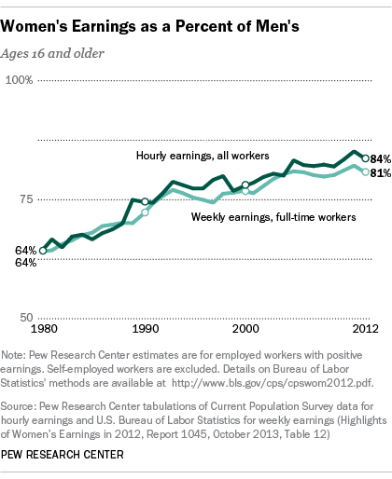
Pew Research Center, October 2013
Found online: http://www.pewresearch.org/files/2013/12/FT_13.12.09_genderAndWork.png
Graph C: Gender wage gap by 20 Most Common Occupations for women
The Gender Wage Gap by Occupation and by Race and Ethnicity, 2013
by Ariane Hegewisch, Stephanie Keller Hudiburg (April 2014) Institute for Women’s Policy Research
Found online: http://www.iwpr.org/publications/pubs/the-gender-wage-gap-by-occupation-and-by-race-and-ethnicity-2013

Graph D: Gender Wage gap by Race/Ethnicity and Gender – weekly earnings
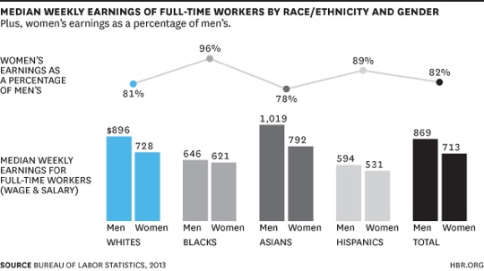
Does Race or Gender Matter More to Your Paycheck? Deborah Ashton June 2014
Harvard Business Review
Found online: https://hbr.org/2014/06/does-race-or-gender-matter-more-to-your-paycheck/

Formative Performance Task 2

Supporting Question 2  (Historical Lens) | Why has the gender wage gap changed over time?
Formative Performance Task | Write a paragraph that explains why the gender wage gap has narrowed but not disappeared.
Featured Source | Featured Source A: Gender Earnings Ratio, 1955-2013, Full-Time Workers (Graph) (2014)  Featured Source B: Excerpt from Blau & Kahn, “The Gender Pay Gap: Have women gone as far as they can?” (2007)  Featured Source C: Excerpt from Claudia Goldin, Ely Lecture Paper, “The Quiet Revolution that Transformed Women’s Employment, Education, and Family” (2006)
Conceptual Understandings | The degree to which economic inequality reflects social, political, or economic injustices versus individual choices is hotly debated. The role that the government should play in decreasing this gap, including the variety of government programs designed to combat poverty, is debated as well.
Content Specifications | n/a
Social Studies Practices | Gathering, Using, and Interpreting Evidence  Chronological Reasoning & Causation

Supporting Question

In order to answer the compelling question, “what should be done about the gender wage gap?” students will need to establish an understanding of the historic roots of the gender wage gap in America. The supporting question for this task, “why has the gender wage gap changed over time?” has students consider the ways in which the gender wage gap has narrowed in the past 60 years and why it persists. In analyzing the featured sources, students examine the various factors that contribute to the gender wage gap and how these factors have influenced the gender wage gap trend line.

Formative Performance Task

The formative performance task calls on students to write a paragraph that describe the reasons why the gender wage gap has narrowed over time, but also why the gap still exists. Students will develop their descriptive paragraphs by examining a graph that shows how the gender earnings ratio changes over time and also by reading excerpts from articles by economists Francine Blau & Lawrence Kahn and Claudia Goldin. As students consider the information in the sources and determine the factors that contribute to why the gender wage gap has changed over time, they are working directly with the social studies practices of Gathering, Using, and Interpreting Evidence and Chronological Reasoning & Causation.

Chronological Reasoning and Causation can often be a stumbling block for students, and teachers might organize this task differently depending on their students’ familiarity with this practice. Teachers might choose to have students work in groups to first annotate the graph from Featured Source A, “Gender Earnings Ratio, 1955-2013, Full-Time Workers.” Students could use both articles from Featured Source B and Featured Source C for this annotation, but they could also be encouraged to research on their own sources or use the additional sources listed. Additionally, Featured Source B and C are exclusively text based and require students to read closely terms and ideas. Teachers could significantly reduce the two articles to key ideas (as shown below) that would answer the supporting question, “what should we do about the gender wage gap?” Teachers could also excerpt the two articles and use these key ideas to allow students to work together to annotate the graph in Source A. Either strategy would not preclude a teacher from showing the entire source but could help students reason with the sources as they practice Chronological Reasoning and Causation.

Students’ understandings of why the gender wage gap has changed over time builds upon their previous knowledge of the challenges of how the wage gap is calculated (Formative Task 1) and prepares them for examining the various scales of the wage gap (Formative Task 3) and discussing possible political solutions (Formative Task 4).

Featured Sources

Featured Source A is the graph “Gender Earnings Ratio, 1955-2013, Full-Time Workers” from the Institute for Women’s Policy Research, which highlights both the weekly and annual earnings ratios for full-time working women from 1955-2013. The “earnings ratio” represents the percentage of women’s median earnings as compared to men’s. The 2013 earnings ratio for annual full time/year round workers was 78.3% while the earnings ratio for weekly full time/year round workers was 82.1%. This means that the gender wage gap for annual full time/year round workers was 21.7% and the gender wage gap for weekly full time/year round workers was 17.9%. In using this source, teachers will want to help students understand the difference between the earnings ratio and the wage gap and the differences between annual and weekly rates; they will also want to have students consider the overall trends represented in the graph.

Featured Source B is an excerpt from the article “The Gender Pay Gap: Have Women Gone as Far as They Can?” by Francine Bleu & Lawrence Kahn. The article highlights several factors that influence both the narrowing of the gender wage gap (e.g., changes in educational attainment and numbers in the workforce) as well as factors that could influence its persistence (e.g., less work experience, unequal division of household labor, and discrimination). For students who need assistance navigating the source, teachers could consider having them partner read with other students or do a whole group reading of the source before asking students to begin their descriptive paragraphs. Also, teachers could reduce the text to focus students on a key idea. For example, the following quote from the article highlights that women’s role in the workforce has changed greatly over time and yet has also contributed to the persistence of the gender wage gap because women still have less work experience:

An even bigger change has occurred in the past 20 to 30 years as increasing numbers of women, including married women, started staying in the labor force fairly continuously even when they had small children at home. Today, even the majority of women with children a year or less in age are participating in the labor force. Nonetheless, on average, women have less work experience than men and that difference in qualifications is quantitatively important in explaining the gender pay gap.

Featured Source C is an excerpt from the Ely Lecture paper, “The Quiet Revolution that Transformed Women’s Employment, Education, and Family” by economist Claudia Goldin. The excerpted sections focus on two time periods that contributed to the changes in the labor force and the gender wage gap, namely the 1950s-1970s and the 1970s to the present. Once again, teachers could focus students on a key idea. For example, the following quote from the paper highlights that women’s increased enrollment in professional and graduate schools happened around 1970 and probably contributed to the narrowing of the wage gap:

Women also began to further their education in professional and graduate schools around 1970. Whereas in the late 1960s one in twenty entering law school students was a woman, two out of five were in 1980, and parity was reached in the early 2000s.

Additional Sources

Teachers wanting to provide additional sources on how the gender wage gap has changed and persisted over time might examine:

- National Public Radio (NPR), interactive graph on how the gender pay gap has and has not changed, which uses a 2014 paper from Harvard economist Claudia Goldin
Found online: http://www.npr.org/blogs/money/2014/12/15/370357880/how-the-gender-pay-gap-has-changed-and-how-it-hasn’t

- American Association of University Women, Graduating to a Pay Gap Report, which explores the gender wage gap in recent college graduates after controlling for major, occupation, and hours worked. Found online: http://www.aauw.org/research/graduating-to-a-pay-gap/

- National Women’s Law Center, The Wage Gap Over Time, which explores the timeline of the gender wage gap while also exploring how the gap looks different for women based on race/ethnicity. Found online: http://www.nwlc.org/our-blog/wage-gap-over-time

Supporting Question 2 Featured Source A | Gender Earnings Ratio, 1955-2013, Full-Time Workers (Graph)  From the Institute for Women’s Policy Research, 2014

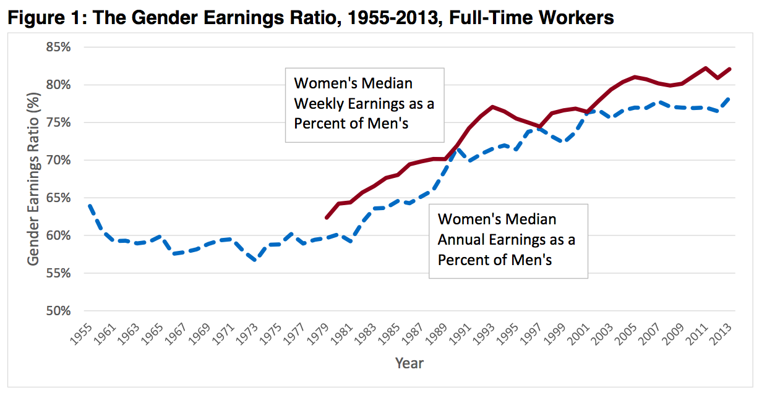

Source: http://www.iwpr.org/publications/pubs/the-gender-wage-gap-2013

Supporting Question 2 Featured Source B | Excerpt from “The Gender Pay Gap: Have women gone as far as they can?”  Francine Bleu & Lawrence Kahn (2007)

The Role of Qualifications and Discrimination

Economists point to a number of factors that could be important in explaining the lower earnings of women compared to men, but traditionally have focused on two primary factors. Following Juhn, Murphy, and Pierce (1991), we call these “gender-specific” factors in that they relate specifically to differences between women and men, either in their qualifications or how they are treated. With regard to qualifications, the human capital model has been especially important in pointing out the potential role played by education and experience.

The gender gap in educational attainment was never particularly large in the United States. The biggest difference historically was that, although women were more likely to graduate from high school than men, they were less likely to go on to college and graduate education. Moreover, men tended to concentrate in career-orientated fields of study such as engineering, law, medicine, and business that led to relatively high earnings. These educational differences have decreased quite a bit in recent years, especially at the college level where women are actually now over half of college students; women have also greatly increased their representation in traditionally-male professional fields. Thus gender differences in education levels have never explained a large portion of the overall gender pay gap; most recently, in some samples gender differences in years of schooling favor women.

The qualification that has proven to be quite important is work experience because traditionally women moved in and out of the labor market based on family considerations. Before World War II, most women left the labor market permanently when they got married and had children. In the immediate post-war period, a pattern arose whereby older married women returned to the labor market after their children were in school or grown. An even bigger change has occurred in the past 20 to 30 years as increasing numbers of women, including married women, started staying in the labor force fairly continuously even when they had small children at home. Today, even the majority of women with children a year or less in age are participating in the labor force. Nonetheless, on average, women have less work experience than men and that difference in qualifications is quantitatively important in explaining the gender pay gap.

Jacob Mincer and Solomon Polachek (1974) have done especially important work in highlighting the role of labor market experience in explaining the gender pay gap. Given the traditional division of labor by gender in the family, women tend to accumulate less labor market experience than men. Further, because women anticipate shorter and more discontinuous work lives, they have lower incentives to invest in market-oriented formal education and on-the-job training. Their resulting smaller human capital investments lower their earnings relative to those of men. An additional way in which the traditional division of labor may disadvantage women is that the longer hours women spend on housework may also decrease the effort they put into their market jobs compared to men, controlling for hours worked, and hence also reduce their productivity and wages (Becker, 1985).

To the extent that women choose occupations for which on-the-job training is less important, gender differences in occupations are also expected. Women may especially avoid jobs requiring large investments in skills that are unique to a particular enterprise, because the returns to such investments are reaped only as long as one remains with that employer. At the same time, employers may be reluctant to hire women for such jobs because the firm bears some of the costs of such firm-specific training, and fears not getting a full return on that investment.

However, even controlling for experience and whatever qualifications can readily be measured, there tends to be a pay difference between men and women that is not explained and is potentially due to discrimination. Gary Becker (1971; 1st ed., 1957) has been especially instrumental in developing analyses of labor market discrimination. Although he was looking at differences between black and whites, the idea of prejudice and its negative consequences are readily transferable to women versus men. Becker conceptualized discriminatory preferences as the desire to maintain social distance from the discriminated group. It may at first seem odd to hypothesize that men would not like to associate with women on the job when they generally live together with women in families. However, the issue here may be more one of socially appropriate roles than of the desire to maintain social distance, as Becker postulated was the case with race.

Source: https://web.stanford.edu/group/scspi/_media/pdf/key_issues/gender_research.pdf

Supporting Question 2 Featured Source C | Excerpt from Ely Lecture paper, “The Quiet Revolution that Transformed Women’s Employment, Education, and Family”  Claudia Goldin (2006)

Married women’s labor force participation continued to expand in the 1950s to 1970s, greatly at first for an older group of women (45 to 54 years old) and with soaring rates later for a younger group (25 to 34 years old). For married women in the 35 to 44 year old group, participation increased from 25 to 46 percent from 1950 to 1970. In the 1940s and 1950s female labor supply had become considerably more elastic and thus more responsive to changes in wages. At the same time, the income effect continued its downward trend as work for married women became more acceptable. The average married workingwoman by the 1940s was more educated that the average married women in the population, a reverse of the previous observation…

Many factors contributed to the increase in the own-wage elasticity [the percentage change in employment]. One was the creation of scheduled part-time employment. The availability of part-time work by firms led to an increase in those working less than 35 hours per week from 18 percent of the female labor force in 1940 to 28 percent in 1960 and from 14 percent of the female sales sector in 1940 to 40 percent in 1960. Another factor was the greater acceptance of married women in the labor force and the almost complete end of marriage bars [practices restricting married women from employment]….

But despite large gains in employment, married women were still the “secondary earners” in their households. They took the labor supply decisions of their husbands as given; they were tied stayers at times and tied movers at others. Their human capital continued to increase, but the investments occurred mainly off the job in formal education or vocational training, rather than on the job. Secretaries, teachers, nurses, social workers, and librarians, among others, came to their jobs with most of the necessary skills. Some advancement was possible in offices and elsewhere but not much, according to most estimates of earnings functions. Interviews for first jobs, even those of college graduate women, often began with the straightforward question: “How well do you type?”…

Even though many would eventually be employed for a significant portion of their lives, their expectations of future employment, when they were young, were quite different. Women born from 1931 to 1940, for example, were eventually employed for more than 40 percent of their post-schooling years (up to around age fifty); the figure is 55 percent for those born from 1941 to 1950. Most of these women had anticipated brief and intermittent employment in various jobs, not generally in a career. Some trained for the remote possibility that they would have to support themselves later in life. College, for many, was a way to meet a suitable spouse rather than a way to embark on a career. Their investments in education and training were consistent with their expectations…. As real incomes rose, the labor force participation rate of married women increased even though the earnings of women relative to those of men advanced only slightly.

Late 1970s to the present

Most labor force participation measures do not divulge that there was a revolution in women’s economic status since the late 1970s. Participation rates for married women, as well as rates for the fraction working full-time, reveal only small increases in the past several decades. An exception is the labor force participation rate for married women (20 to 44 years old) with a child under the age of one year, which soared from 0.20 in 1973 to 0.62 in 2000.

For marriage age, college graduation, and professional school enrollment, the turning points were all around 1970. Changes in occupations occurred in the early 1970s. For earnings relative to comparable men, the turning point was a bit later, around 1980. Expectations regarding future work, social norms concerning women’s family and career, and factors accounting for women’s life satisfaction began to change in the late 1960s and 1970s. Some of these changes were preconditions for others and thus are intricately related, such as college majors, professional school enrollment, and occupational change. The series, taken together, present a logical progression….

By “expanded horizons” I mean that women more accurately anticipated their future work lives, although not necessarily their number of children. With more accurate expectations they could better prepare by investing in formal education and they could assume positions that involved advancement. That is, they could plan for careers rather than jobs…. Women also began to further their education in professional and graduate schools around 1970. Whereas in the late 1960s one in twenty entering law school students was a woman, two out of five were in 1980, and parity was reached in the early 2000s. A similar trend occurred for medical students. The increase in the fraction female similarly rose for many other professional programs including those in veterinary medicine, dentistry, optometry, pharmacy, and business administration. Most important is that the turning points are coincident and all occurred during the early 1970s….

The earnings of women relative to those of men began to increase around 1980 after remaining flat since the 1950s. Much of the increase was due to women’s greater job experience and to their more market relevant skills as reflected in the increased return to experience. Occupations shifted, not surprisingly, from those that had once been the more traditional ones, such as teachers, nurses, librarians, and social workers, to a varied group of professions including lawyers, physicians, professors, and managers. But it has also been noted that even within cohorts the earnings of women increased relative to those of men, suggesting that change may have diffused to those in their middle-age and was caused, at least in part, by changes within the labor market or imposed

Formative Performance Task 3

Supporting Question 1  (Geographic Lens) | Where is the gender wage gap the most pronounced?
Formative Performance Task | Using a graphic organizer, summarize data and describe at various scales where the gender wage gap is most pronounced.
Featured Source | Featured Source A: Women’s Pay As A Percentage of Men’s Pay, Chart, 2014  Compiled by Intuit using Census Data  Featured Source B: Median earnings of men and women based on New York congressional districts (2013), American Association of University Women  Featured Source C: Collection of demographic data on gender wage gap from  Breadwinner Moms, Pew Research Center May 2013
Conceptual Understandings | The degree to which economic inequality reflects social, political, or economic injustices versus individual choices is hotly debated. The role that the government should play in decreasing this gap, including the variety of government programs designed to combat poverty, is debated as well.
Content Specifications | n/a
Social Studies Practices | Gathering, Using, and Interpreting Evidence  Geographic Reasoning

Supporting Question

For the third supporting question, “where is the gender wage gap the most pronounced?” students build on their understandings of the gender wage gap by examining its effect at different levels. Students examine a series of maps and other demographic data that inform their understanding of the gender wage gap’s impact on a national, state, and local scale. By closely examining each piece of data, students should better understand the spatial dimensions of the gender wage gap and to think critically about how to address it in both formative performance task 4 and the summative argument.

Formative Performance Task

The formative performance task calls on students to examine a series of maps and other geographic data and to summarize the data in order to answer the question: Where is the gender wage gap most pronounced? Each piece of geographic data is ordered so that students examine the gender wage gap at different levels For example, the first representation is a choropleth map that shows the difference in annual salaries between men and women at a national scale whereas the second source is an examination of median income between men and women by congressional district in New York. Students should pay close attention to any patterns or trends for these pieces of geographic data. For instance, in many of the mid-western states, the gap between annual income between men and women is the greatest in the United States. At the local scale, students examine a collection of charts from the Pew Research Center that examine the changing demographics of U.S. families. The charts depict the economic role of women as pertaining to the modern American family.

Below is a graphic organizer that students can use in order to record key data and trends from the maps and demographic data for this formative performance task. Within this task, students are working directly with the social studies practices of Gathering, Using, and Interpreting Evidence and Geographic Reasoning as they analyze the data in order to visualize where the gender wage gap is most pronounced. By analyzing the graphs, students should consider questions such as, where is the gender wage gap most pronounced in the U.S? Where is the gender wage gap greatest in New York? What is the effect of the gender wage gap on families? Students’ understanding of where the gender pay gap is most pronounced establishes the foundation for the work in the subsequent formative task in which students examine the possible political solutions to the gender wage gap.

Featured Sources

The featured sources for this task include maps and other demographic data featuring the gender wage gap on a national, state, and local scale. Students analyze the sources in order to gather information about where the gender gap is most pronounced. As they work through the sources, students should be thinking about how each source contributes to the supporting question. Teachers will want students to work through these graphs in small groups using the graphic organizer in order to record important data and trends.

Featured Source A is a collection of demographic data that examines the changing role of the American family. The first graph looks at the economic composition of the American family. For example, students will want to note the trend that most families rely on both parents having full-time jobs. The second graph looks closely at the trend of female breadwinners. The chart splits women into two categories—married and single. Students may note that female breadwinners now make up 40% of families and that the larger percentage of female breadwinners are from single-parent families. With those ideas in mind, the third graph looks at the average income for single-parent families led by women. It is here where students can see how the gender wage gap affects families. The last chart examines the education level of mothers and fathers. Students will want to think about the education levels of men and women along with the income disparity seen in other sources.

Featured Source B is a choropleth map of the United States that examines women’s pay as a percentage of men’s pay based on data from the U.S Census. The map allows students to analyze where the gender wage gap is most pronounced on a national scale. For example, students will be able to see that the gender wage gap is larger in the mid-western states than in the southwestern states.

Featured Source C is a chart that examines the gender wage gap by looking at the median earnings for men and women in New York’s 27 congressional districts. This source allows students to analyze where the gender wage gap is most pronounced in their state. Teachers may want to point out to students that even though New York does not have the worst gender wage gap at the national scale, by looking at the state scale, it is evident that there are parts of New York where the issue is more pronounced. In the additional sources, there is a map of the 27 congressional districts that may help students to visualize the location of where the gender wage gap is more pronounced.

Additional Sources

While this supporting task focuses on the gender wage gap in America as a way to discuss income inequality, teachers may want to examine the gender wage gap at the global scale. The additional source below is an article from Time Magazine as well as an info-graphic that sheds light on the global gender wage gap:

- New York Congressional District Map 2012. Found online:
http://alloveralbany.com/archive/2012/03/20/new-congressional-district-lines-for-the-capital-r

- From Time Magazine in 2014: "This Map Shows Just How Big The Wage Gap Between Men and Women Is." Found online: http://time.com/14153/global-gender-pay-gap-map/

Gender Wage Gap at National, State, and Local Levels
Scale | Key Data/ Trends | How does this information help answer the question “Where is the gender gap most pronounced?”
National
State
Local

Supporting Question 3 Featured Source A | Collection of demographic data on gender wage gap from  Breadwinner Moms, Pew Research Center  May 2013

Employment Arrangements among Couples, 1960-2011 | 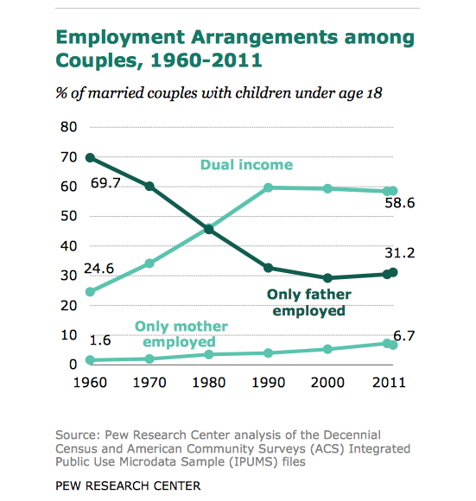
Mother as Sole or Primary Provider, 1960-2011 | 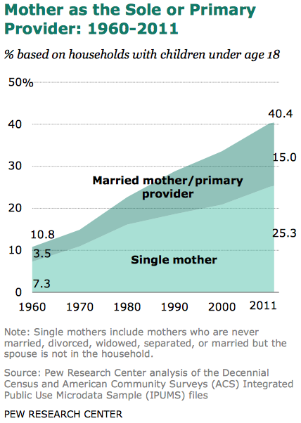
Family Income of Two Types of Single Mothers | 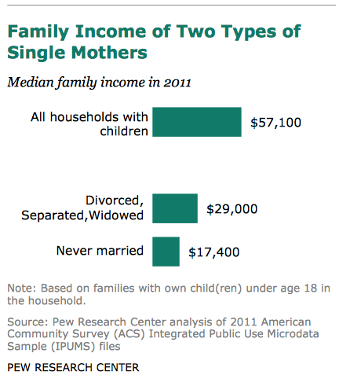
Mothers are Increasingly More Educated Than Fathers | 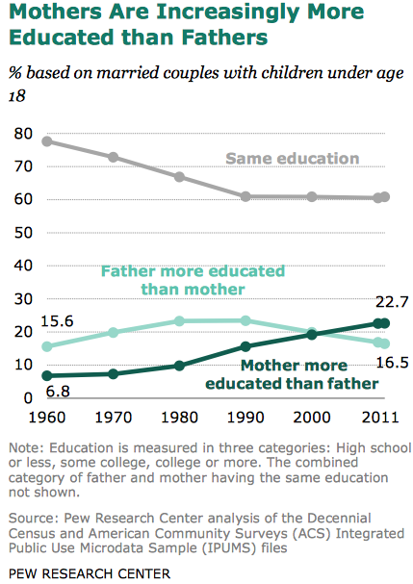
Found online: http://www.pewsocialtrends.org/files/2013/05/Breadwinner_moms_final.pdf

Supporting Question 3 Featured Source B | Women’s Pay As A Percentage of Men’s Pay, Chart, 2014  Compiled by Intuit using Census Data

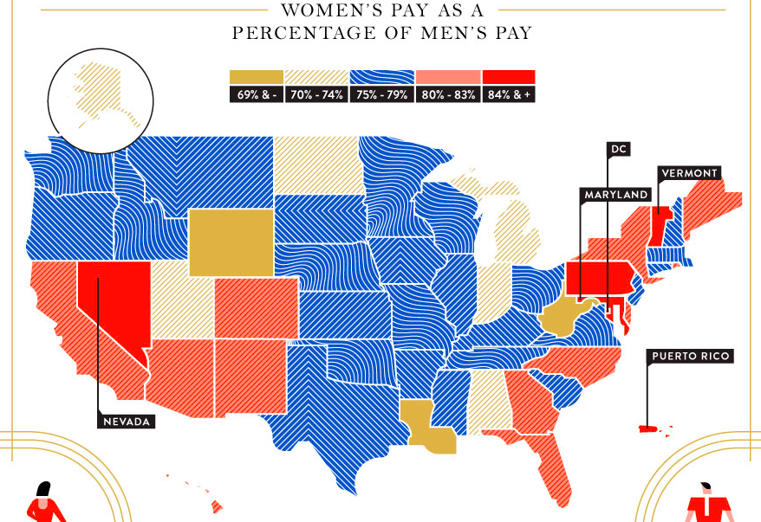

Found online: http://quickbooks.intuit.com/r/employees/the-gender-pay-gap-state-by-state

Supporting Question 3 Featured Source C | Median earnings of men and women based on New York congressional districts (2013), American Association of University Women

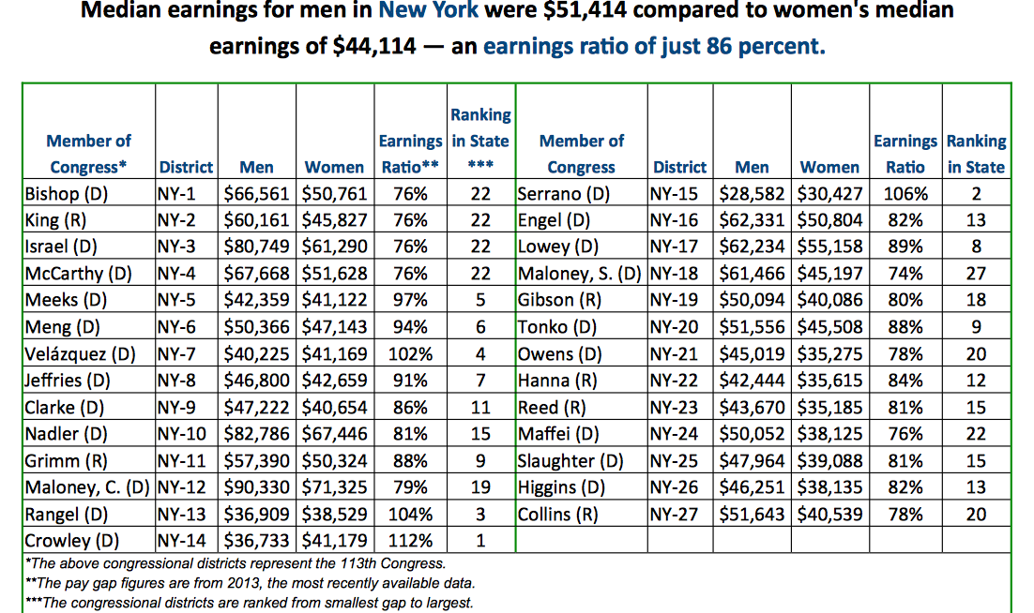

Found online: http://www.aauw.org/files/2014/09/New-York-Pay-Gap-2014.pdf

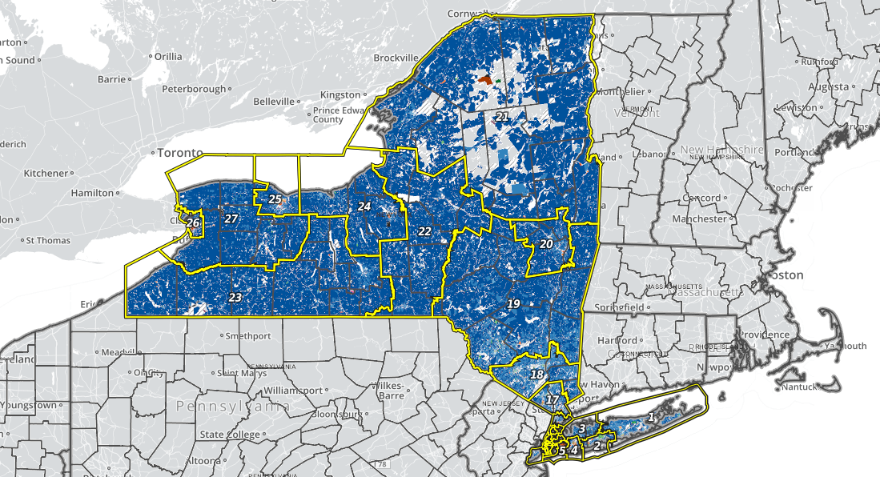

Interactive Map of New York Congressional Districts that includes demographic information can be found at:

http://www.urbanresearchmaps.org/nycongress2012/map.html

Formative Performance Task 4

Supporting Question 1  (Political Lens) | Is there a political solution to the gender wage gap?
Formative Performance Task | Write a claim supported with evidence that explains whether or not there is a political solution to the wage gap.
Featured Sources | Featured Source A: Should the Senate Pass the Paycheck Fairness Act?, U.S. News & World Report’s Debate Club, May 2012  Featured Source B: Higher State Minimum Wages Promote Fair Pay for Women, National Women’s Law Center, September 2013  Featured Source C: Government Can’t Fix Real Gender Pay Gap, Bloomberg View, April 2014
Conceptual Understandings | The degree to which economic inequality reflects social, political, or economic injustices versus individual choices is hotly debated. The role that the government should play in decreasing this gap, including the variety of government programs designed to combat poverty, is debated as well.
Content Specifications | n/a
Social Studies Practices | Gathering, Using, and Interpreting Evidence  Civic Participation

Supporting Question

Having examined the challenge of calculating the gender way gap as well as its roots and implications, students next consider possible solutions. Students analyze a number of contemporary sources in order to develop a claim that addresses the question, “is there a political solution to the gender wage gap?” In doing so, students will move towards the summative task by examining arguments about the plausibility and suitability of a political solution.

Formative Performance Task

The formative task requires that students address the supporting question by using sources and developing claims with evidence to explain whether or not there is a political solution to the gender wage gap. Students will work with a news magazine debate, a report from a non-profit organization, and an online news column to shed light on two suggested political solutions as well as the general debate surrounding the potential of political actions to rectify the gender wage gap.

Within this task, students work directly with the social studies practice Gathering, Using, and Interpreting Evidence as they read and analyze each source while making claims supported by evidence. Students also work with the social studies practice Civic Participation as they begin to formulate their arguments for an appropriate response to the gender wage gap. Depending on their experience with making claims supported with evidence, students may need examples or guided instruction on how to develop a claim and what constitutes a claim with evidence. The scaffold below could help students organize their claims and evidence.

Is there a political solution to the gender wage gap?
Your “emerging” claim about whether or not there is a political solution to the gender pay gap. | There is not a political solution to the gender pay gap because the gap is a result of personal choices, which cannot be rectified through government actions.

Evidence from the sources that supports your claim | “The differences in pay between men and women come down to choices. Choices women—and men—make have costs. More women than men choose to take time off to raise a family, but that's a far cry from discrimination. And costs are the result of a woman's freedom, not an injustice imposed on her by society.”  Source A: Should the Senate Pass the Paycheck Fairness Act?, Sabrina Schaeffner, U.S. News & World Report’s Debate Club, May 2012  “There are always exceptions on both sides: women who will sacrifice anything for the career they feel called to and men who would rather be home. But on average, the women I talk to just aren’t nearly as willing to sacrifice close friendships, and family relationships, for the sake of their jobs.”  Source C: Government Can’t Fix Real Gender Pay Gap, Bloomberg View, April 2014

It is important to note that when working with any current event, especially those that are controversial, it may be wise to substitute or supplement the sources included here with more recent commentary. Students could be encouraged to search for additional data that captures the latest thinking on and impact of the gender wage gap. In doing so, they should triangulate their data using multiple sources and perspectives in order to more fully understand various viewpoints of those writing about the gender wage gap.

Featured Sources

Teachers should start by having students examine Featured Source A, a U.S. News & World Report Debate Club focused on “Should the Senate Pass the Paycheck Fairness Act?” from May 2012. The site includes arguments from seven different women, whose positions range from the belief that the Paycheck Fairness Act is unable to remedy the true cause of the gender wage gap – personal choice – to the belief that greater oversight of business practices will decrease the gender wage gap. Teachers should prompt students to think about the merits and drawbacks of this particular political solution.

Featured Source B is a report from the National Women’s Law Center entitled “Higher State Minimum Wages Promote Fair Pay for Women” dated September 2013. Within the report, the authors draw from economic data to argue that states with a higher minimum wage exhibit a lower gender wage gap. The authors conclude that this solution is particularly important for women of color. Teachers should prompt students to think about the merits and drawbacks of this particular political solution as well as the potential to address the gender wage gap issue from a state rather than a federal level.

Featured Source C is an excerpt from a Bloomberg View column by Megan McArdle (April 2014) entitled “Government Can’t Fix Real Gender Pay Gap.” The author argues that, even though some of the gender wage gap is due to discrimination, the greater part is due to individual choices that women make regarding professions and work hours. McArdle contends that political solutions to the gender wage gap would be ineffective and could potentially heighten wage disparities. Teachers should prompt students to think about the degree to which the government has the authority and/or ability to mediate the impact of personal choices.

Additional Sources

For students or teachers looking for more information on the Lilly Ledbetter Fair Pay Act, they might consider consulting the following sources:

- National Women’s Law Center, Lilly Ledbetter Fair Pay Act
http://www.nwlc.org/resource/lilly-ledbetter-fair-pay-act-0

- U.S. Chamber of Commerce, Letter Opposing S. 181, “the Lilly Ledbetter Fair Pay Act”
https://www.uschamber.com/letter/letter-opposing-s-181-lilly-ledbetter-fair-pay-act

For students or teachers looking for more information on potential social and business solutions to the gender wage gap, they might consider consulting the following sources:

- New York Times, How to Attack the Gender Wag Gap? Speak Up
http://www.nytimes.com/2012/12/16/business/to-solve-the-gender-wage-gap-learn-to-speak-up.html?pagewanted=all&_r=0

- The Atlantic, How to End the Gender Pay Gap Once and for All
http://www.theatlantic.com/business/archive/2014/03/how-to-end-the-gender-pay-gap-once-and-for-all/284208/

Supporting Question 4 Featured Source A | Should the Senate Pass the Paycheck Fairness Act?, U.S. News & World Report’s Debate Club, May 2012

Should the Senate Pass the Paycheck Fairness Act?
After battles over the reauthorization of the Violence Against Women Act and the mandate by President Obama’s healthcare law that religious institutions cover contraceptives for employees, another storm is brewing in Washington over women-oriented issues. The Senate is expected to call a vote in the coming weeks on the Paycheck Fairness Act, an update on 1963’s Equal Pay Act, which made wage discrimination based on one’s sex illegal. With a reported 77 cents to the dollar pay gap between women and men, respectively, persisting nearly five decades later, the Paycheck Fairness Act is designed to help those who believe they are victims of gender-based wage discrimination by making wages more transparent, by requiring that employers prove that wage discrepancies are tied to legitimate business qualifications and not gender, and by prohibiting companies from taking retaliatory action against employees who raise concerns about gender-based wage discrimination. The bill, supported by the Obama administration, was passed by the House in January 2009 only to be stalled in the Senate in November 2010, and was reintroduced in both chambers in April 2011. Democratic National Committee Chair and Florida Democratic Rep. Debbie Wasserman Schultz recently urged presumed GOP presidential nominee Mitt Romney to take a stand on the bill, bringing it back into the political limelight and putting the pressure on Senate Dems to prioritize a vote on the legislation.

Proponents say that more must be done to close the pay gap between men and women, particularly with much greater participation by women in the workforce since the Equal Pay Act became law. Opponents say that the proposed new law misdiagnoses the problem, questioning the data cited by its supporters, and would unfairly harm small businesses as the economic recovery struggles to pick up steam. Should the Senate pass the Paycheck Fairness Act? Here is the Debate Club’s take.

Christina Hoff Sommers Resident Scholar at the American Enterprise Institute

The Paycheck Fairness Act looks like common sense, but instead of helping women it will hurt all workers. The legislation, built on 30 years of spurious advocacy research, will impose unnecessary and onerous requirements on employers

Groups like the National Organization for Women insist that women are being cheated out of 24 percent of their salary. The pay equity bill is driven by indignation at this supposed injustice. Yet no competent labor economist takes the NOW perspective seriously. An analysis of more than 50 peer-reviewed papers, commissioned by the Labor Department, found that the so-called wage gap is mostly, and perhaps entirely, an artifact of the different choices men and women make—different fields of study, different professions, different balances between home and work. Wage-gap activists argue that even when we control for relevant variables, women still earn less. But it always turns out that they have omitted one or two crucial variables. Congress should ignore the discredited claims of activist groups.

The misnamed Paycheck Fairness Act is a special-interest bill for litigators and aggrieved women's groups. A core provision would encourage class-action lawsuits and force defendants to settle under threat of uncapped punitive damages. Employers would be liable not only for intentional discrimination (banned long ago) but for the "lingering effects of past discrimination." What does that mean? Employers have no idea. Universities, for example, typically pay professors in the business school more than those in the school of social work. That's a fair outcome of market demand. But according to the gender theory permeating this bill, market forces are tainted by "past discrimination." Gender "experts" will testify that sexist attitudes led society to place a higher value on male-centered fields like business than female-centered fields like social work. Faced with multimillion-dollar lawsuits and attendant publicity, innocent employers will settle. They will soon be begging for the safe harbor of federally determined occupational wage scales.

This bill also authorizes the secretary of labor to award grants to organizations to teach women and girls how to negotiate better salaries and compensation packages. Where is the justice in that? The current recession has hit men harder than women. Census data from 2008 show that single, childless women in their 20s now earn 8 percent more on average than their male counterparts in metropolitan areas. If Congress is going to enact labor legislation with the word "fair" in it, it cannot limit the benefits to women. Senators may be tempted to vote for the Paycheck Fairness Act out in the mistaken belief that it is a common-sense equity bill. It is not. It won't help women, but it will create havoc in an already precarious job market.

Sarah Jane Glynn Policy Analyst at the Center for American Progress

In 1963, President John F. Kennedy signed the Equal Pay Act making it illegal to pay women lower wages because of their gender. Yet nearly 40 years after our government declared that paying a woman less for the same job as a man was illegal, the gender-wage gap persists.

According to the U.S. Census Bureau, in 2010 the average woman working full time, year-round earned 77 cents to the average man's dollar. Critics argue the wage gap exists because men work longer hours in higher-wage industries, and because women take time out of the workforce when they become mothers. When these factors are taken into account using statistical modeling, a painful truth remains—women with similar credentials in similar jobs are paid less than their male counterparts.

The Institute for Women's Policy Research found that in 19 of the top 20 occupations for men, women earn less than men. The only male-dominated occupation where women do not earn less is among stock clerks and order fillers, which is one of the lowest-paid occupations on the list. The top 20 most common occupations for women account for more than 40 percent of full-time working women, yet they still earn less than men in all but one. Women who work in bookkeeping, accounting, and auditing earn slightly more than their male peers, but don't get too excited, the difference is a median of $2 per week.

The American Association of University Women has shown that the gender-wage gap emerges immediately after college graduation. A woman who goes to the same college and graduates with the same major and grades, takes the same type of job with similar workplace flexibility and benefits, and is of the same race and marital status with the same number of children as her male counterpart will still be paid 5 percent less. And if she acquires the same level of work experience 10 years down the road, the wage gap will widen to 12 percent.

The wage gap is not simply about the "choices" women make regarding careers or motherhood. The Paycheck Fairness Act would give women additional and much-needed equal pay protections. In addition to compensating victims of gender discrimination in the same ways as those who experience racial or ethnic discrimination, and making it easier for people who have been discriminated against to work together in class-action suits, the act would also create greater wage transparency. In these tough economic times, when nearly two thirds of mothers are breadwinners or co-breadwinners for their families, pay equity is more important than ever before.

Diana Furchtgott-Roth Senior Fellow at the Manhattan Institute for Policy Research

The Paycheck Fairness Act failed to become law in the 111th Congress, when the House and Senate had overwhelming Democratic majorities and President Obama, in his State of the Union Address, called the bill "common sense."

Why?

The act is based on a misapplied statistic, that women earn 77 cents on a man's dollar. This is true when comparing all women's wages with all men's wages, but not when comparing men and women with the same experience in the same job. The 77 cent statistic combines men and women who work in different jobs with different numbers of hours. When job, experience, and hours of work are taken into account, rigorous economic

When women believe they are the victims of discrimination, they have many laws under which to seek justice, such as the Equal Pay Act, the Lilly Ledbetter Fair Pay Act, and the Civil Rights Act.
On average, women will never be at complete parity with men, because they choose different jobs and many choose to combine work and family and work part time. When women work full time, they work fewer hours. In April, full-time working women worked 12 percent fewer hours than men.
Even in 2011, the year after Mr. Obama called for passage of the Paycheck Fairness Act, women on the White House staff made 82 percent of male staffers' wages. The White House put more experienced men into senior positions, skewing the average. If Mr. Obama can't pay women the same as men in his own White House, with countless competent women willing to work there, why should he expect employers to do so in their businesses?

The Paycheck Fairness Act would require practically all employers to give the government information on workers' pay, by race and sex, with the goal of equalizing wages of men and women in different job classifications. This would represent a substantial intrusion of government into wage-setting and would discourage hiring.

And hiring is what the economy needs. On Friday, the Labor Department reported that the economy created only 115,000 jobs, below expectations. The unemployment rate fell to 8.1 percent because more discouraged Americans stopped looking for work. The labor force participation rate declined to 63.6 percent, equal to December 1981, when there were almost no women leaders in business, law, and government. For women's sake, we need more hiring, not more red tape.

Deborah J. Vagins Senior Legislative Counsel for the ACLU's Washington Legislative Office

Today, women are more likely than ever to be their family's breadwinners, in management positions, and hold advanced degrees. Yet some critics are re-litigating decades-old policy debates, which secured basic rights for women's autonomy, including pay equity.

The Equal Pay Act of 1963, which helped to secure workplace protections for wage discrimination, passed almost 50 years ago. Despite new debates to the contrary, there is no doubt that updates to improve our fair pay laws are needed. Half a century later, women, on average, earn only 77 cents for every dollar earned by men—just 17 cents more than when President Kennedy signed the law. For women of color, the progress has been even slower.

The Paycheck Fairness Act would enable President Kennedy's vision to be fully realized. Among other things, the bill would amend the Equal Pay Act to require employers to demonstrate that disparities in pay between men and women working the same job result from factors other than sex. It would also prohibit retaliation against employees who inquire about their employers' wage practices or disclose their own pay and would strengthen penalties for equal pay violations.

In the 111th Congress, the bill passed overwhelmingly, and on a bipartisan basis, in the House of Representatives. In spite of support from a majority of senators, it fell just two votes short of moving forward in the Senate. If Congress cannot pass the Paycheck Fairness Act this year, women will once again be left waiting.
Fortunately, the Obama administration can help right now, by signing an executive order that would protect people who work for federal contractors against retaliation for disclosing or inquiring about their wages. Punitive pay secrecy policies—which the Paycheck Fairness Act would address—are a serious problem. If you don't know you are being paid less, there is nothing you can do about it.

According to the Institute for Women's Policy Research, nearly half of American workers are forbidden or strongly discouraged from discussing their pay with colleagues—in other words, you can be fired for asking about your own wages. By issuing an executive order, President Obama could ensure that never happens to the 26 million workers who are employed by federal contractors—that's over 20 percent of the U.S. workforce.

The Paycheck Fairness Act is still sorely needed, especially during these difficult economic times. As we continue to press for the bill's passage, we must seize every opportunity along the way to advance equal pay for women.

Sabrina L. Schaeffer Executive Director of the Independent Women's Forum

Passing the Paycheck Fairness Act is the Democrats' next battle in advancing the War on Women mantra this election season. But this law will not create equal pay; it will expand the definition of "wage discrimination," make it easier to file class-action lawsuits, and open businesses up to greater litigation and uncertainty—all of which would be devastating to job creation. Ultimately, this bill will hurt women, who will become far more costly to employ.

Often overlooked during these debates over the PFA is the fact that there are already two federal laws in place to protect employees from gender-based wage discrimination—the Civil Rights Act (1964) and the Equal Pay Act (1963).

What's more, the PFA is based on the premise of the so-called wage gap: the notion that women earn 77 cents for every dollar a man earns. This gap is highly exaggerated. When controlling for variables like education, college major, or time spent out of the workforce this gap largely disappears. The fact is discrimination is no longer a significant reason why women earn, on average, less than men.

The differences in pay between men and women come down to choices. Choices women—and men—make have costs. More women than men choose to take time off to raise a family, but that's a far cry from discrimination. And costs are the result of a woman's freedom, not an injustice imposed on her by society.
If passed, the PFA would limit the reasons employers could give for salary differences, making it easier for employees to file suits, but also making the workplace less flexible and making it nearly impossible for employers to tie compensation to work quality. And Democrats want to do this at a time when government should be backing off and allowing businesses to make hiring decisions that make the most sense.
While Democrats frame this in terms of "protecting" women, they overlook the fact that women--and their families--benefit tremendously from a flexible work environment. For instance, some women may choose to accept a lower salary if it means they have the ability to work part-time, flexible hours, or from home. PFA will discourage employers from making such options available.

There are bad employers out there who might still discriminate. But in the aggregate, women are outperforming men in terms of college-graduation rates, advanced degrees, purchasing power, and increasingly in earnings. Bills like the PFA do little to help women; instead they advance the notion that the workplace and society are openly hostile to women and reinforce the idea that women are a victim class in need of special government protection.

Debbie Wasserman Schultz Chair of the Democratic National Committee

In 2009, the first piece of legislation signed by President Obama was the Lilly Ledbetter Fair Pay Act. This important legislation ensures that women are able to take their case to court if they are subject to paycheck discrimination because of their gender. However, there is still more that must be done to address the wage gap facing American women.

On average, women earn 77 cents for every dollar a man earns for doing the same job. The Lilly Ledbetter Fair Pay Act ensures that women can challenge a wage gap in court. The Paycheck Fairness Act would give women the legal tools they need to close the wage gap and it would close loopholes that have been used to get around the Equal Pay Act.

Too often, women cannot address gender discrimination in the workplace because they cannot access the information they need to determine whether or not this discrimination is occurring. The Paycheck Fairness Act would give women the legal tools and safeguards they need to address this very problem. The Paycheck Fairness Act would toughen the requirements for employers to demonstrate a legitimate business reason for a wage gap between its male and female employees and would prohibit retaliation against employees who sought information on how their pay compared to that of their co-workers.

When women make less, it hurts our economy, our communities and our families. It means less money in take-home pay that can be spent on goods and services. It's also unfair to our mothers, sisters, and daughters. They earn the right to equal pay each and every day by punching in and doing their jobs as well as anyone, and their compensation should reflect their talent, commitment, and creativity.

Equal pay for women is critical to families' economic security and our nation's economic recovery. We don't know where Mitt Romney stands on this issue, but the president has made his position crystal clear: Pass the bill. President Obama is committed to equal pay because he knows that we're all in it together. Ensuring basic fairness in our economy is a central tenet of creating an economy that's built to last. Congress should do what's right for our economy and our families and pass the Paycheck Fairness Act.

Penny Nance President and CEO of Concerned Women for America

Proponents of the Paycheck Fairness Act assert that the 1963 Equal Pay Act failed because women still earn approximately 70 cents for every dollar a man earns. However, the wage gap is not necessarily the result of discrimination. There are factors that skew the wage gap between men and women that are based on a variety of aspects, including education, experience, or tenure.

There are employers who discriminate in hiring and salary based on superficial traits, including race, gender, and religion. I understand that. But women have been protected against discrimination since 1963 under by the Equal Pay Act as well as the Civil Rights Act. In reality, the person who gets the job in today's corporate America is the one best qualified. American women are certainly well qualified, as they currently earn roughly 60 percent of higher education degrees and account for 51 percent of all workers in high-paying professional occupations.

The gap in pay arises because of individual choice and not usually because of discrimination, according to a 2009 study commissioned by the U.S. Bureau of Labor Statistics on the issues of the wage gap. Women were more likely than men to leave the workforce with intentions to sacrifice their paychecks for the sake of caring for their families.

Many mothers, including myself, have sacrificed several years of their careers to raise their children. Women's prerogative in the workforce goes far beyond matching men's wages. Gallup notes that 50 percent of women prefer homemaking to working. Yet, working women often seek jobs that offer non-monetary benefits, such as health insurance, flexible hours, and childcare provisions. I know women who rejected promotions because it meant more travel and less time at home.

Rather than helping women, the Paycheck Fairness Act would actually hurt them by abolishing jobs. It eliminates the flexibility between a woman and her employer. If passed, liability will be based not only on intentional discrimination but on "lingering effects of past discrimination." This will encourage frivolous lawsuits against companies, which will hurt business. Any time you hurt business, you hurt women.
It is foolish in an economy with unemployment at 8.2 percent and 12.7 million Americans out of work to heap more government regulation on the backs of companies. If you really want the economy to soar, then nix excessive government regulations and taxation for the sake of both working women and men.

Source: http://www.usnews.com/debate-club/should-the-senate-pass-the-paycheck-fairness-act

Supporting Question 4 Featured Source B | Higher State Minimum Wages Promote Fair Pay for Women,” National Women’s Law Center, September 2013

Source: http://www.nwlc.org/sites/default/files/pdfs/minimumwageandwagegap.pdf

Supporting Question 4 Featured Source C | Government Can’t Fix Real Gender Pay Gap, Megan McArdle,  Bloomberg View, April 2014 (Excerpt)

How much of the pay gap is driven by those choices [choice to spend more time on chores and children], and how much is driven by sexism in the workplace? The answer seems to be that almost all of the gap is driven by choice of occupation, and working hours, with an emphasis on working hours. Childless women who work the same hours as men make very close to what men do.
Does that mean there is no discrimination against women? No. The residual gap that’s left after you control for age, experience, work hours, choice of profession and so forth, is small. But it’s not zero. That residual most likely represents sexism. As a woman, I kind of take exception to that.
Most of the gap, however, seems to be driven by the fact that women work less, and that in many high-paying professions, how much you get paid is a function of how much you work … but not a linear function. There are outsized rewards to working the kinds of hours that make it very hard to care for a family.
As I’ve inched into middle age, I’ve noticed an interesting progression among my female friends, which I described last year:
There are always exceptions on both sides: women who will sacrifice anything for the career they feel called to and men who would rather be home. But on average, the women I talk to just aren’t nearly as willing to sacrifice close friendships, and family relationships, for the sake of their jobs.
We can say that they shouldn’t have to, of course, but the sad fact is that there are trade-offs in this world. In your 20s you can finesse them -- work super hard and also have a roaring social life -- because you have boundless energy and no one depending on you. This is the age at which young women write furious articles and Facebook posts denouncing anyone who suggests that women opt-out of high pressure jobs for any reason other than the rankest sexism.
As you age, your body refuses to cooperate with your plan to work from 7 a.m. to 11 p.m. and then hang out with friends. Your parents start to need you more, if only to lift heavy things. And of course, there are kids. You start having to make direct trade-offs, and then suddenly you look up and you haven’t seen your friends for two years and your mother is complaining that you never call. This is the age at which women write furious articles defending their decision to step back from a high-pressure job and/or demanding subsidized childcare, generous paid maternity leave and “family friendly policies,” a vague term that ultimately seems to mean that people who leave at five to pick up the kids should be entitled to the same opportunities and compensation as people who stay until 9 to finish the client presentation. These pleas usually end (or begin) by pointing to the family-friendly utopia of Northern Europe.

What they are talking about is a world where pay and opportunities scale linearly with effort -- where working half time means that you get almost half of the pay and perks of someone who works full time. Unfortunately, as I also noted last year, this isn’t universally true anywhere:
There is no paradise where women enjoy prestige work at high salaries for part-time efforts, nor where men and women all head home after 37 hours with no impact on their careers. There are countries where more women work than they do here, because of all the mandated leave policies and subsidized childcare -- but the U.S. puts more women into management than a place like Sweden, where women work mostly for the government, while the private sector is majority-male. A Scandinavian acquaintance describes the Nordic policy as paying women to leave the home so they can take care of other peoples’ aged parents and children. This description is not entirely fair, but it’s not entirely unfair, either; a lot of the government jobs involve coordinating social services that women used to provide as homemakers.
There are not enough hours in the day to be the parents we would like to be, do the jobs we would like to do, and have the marriages we would like to have. Everyone is going to have to prioritize.

There are professions where this is more or less possible: Pharmacists, as Claudia Goldin points out, get paid mostly in proportion to the hours they work. But in all sorts of professions, availability really matters. It matters even if you’re less productive after 60 hours than you were at 40 hours, because a client would rather talk to a slightly burned-out lawyer who knows everything about the case, and can explain it whenever is convenient for the client, than to one of two lawyers who know most of what is going on in the case, and are only available when they don’t have family duties.
You can see some professions, like medicine, moving to more of a shift work model as the profession feminizes. But in others, the women drop out and will continue to drop out unless companies radically change how they do business.
I think you can make a strong case that at least some of these decisions are driven by residual cultural sexism -- that women who would rather pursue careers than family duties feel pressured to be supermom, or unable to find men who will support their career ambitions. I think that’s unfair. But I also have to ask: What specific thing are we supposed to enact to fix this?
That’s the point of these op-eds, isn’t it? We are supposed to do something. The problem is, what?
Let’s say that pay disparity consists of a small amount of residual sexism, plus a large difference in family responsibilities. What should a company do? What should the government do?
The part of pay disparity driven by sexism is so small that it will be very difficult to detect in any given case, or even in aggregate. The sexism that drives it probably mostly operates below the conscious level, in men and women who know that they don’t like hard-charging, opinionated women, but don’t recognize that this is partly because they’re women.
The part of pay disparity that is driven by differential ability to work long hours is easy to detect, but what do we do? Mandate that everyone be paid a flat rate by the hour? Put everyone in the country on something like the government’s GS [Government Schedule Classification and Pay] system? Cap working hours? To state the meaningful solutions is to reject them.
The solutions that often do get proposed -- mandatory paid maternity leave for at least a year, generously subsidized childcare, more flexible schedules and so forth -- would certainly make it more convenient for working women to be mothers, but to the extent that they make it easier to take off chunks of time, they might even increase pay disparity, not decrease it, particularly among educated women. Subsidized day care is not going to help anyone work 14 hours a day. You can mandate paternity leave, but you cannot mandate that men use it to take care of their kids, rather than getting some work in.
When married men were paid more than single women as a matter of explicit policy, this was relatively easy to fix. When married men are paid more than single women because their wives are relieving them of the burden of home duties, it’s a lot harder to describe a remedy. To the extent that it’s needed,* the remaining work to be done on the pay gap has to be done in places where the government, or indeed any explicit policy, has difficulty going: inside families, or the subconscious recesses of our minds.
Source: http://www.bloombergview.com/articles/2014-04-08/government-can-t-fix-real-gender-pay-gap

Summative Performance Task

Summative Performance Task | What should be done about the gender wage gap? Construct an argument (e.g., detailed outline, poster, essay) that addresses the compelling question using specific claims and relevant evidence using information from contemporary sources. Action: Write an op-ed for a local or national newspaper stating an argument for what should be done about the gender wage gap and address economic, historic, geographic, and political factors that have informed the argument.
Conceptual Understandings | The degree to which economic inequality reflects social, political, or economic injustices versus individual choices is hotly debated. The role that the government should play in decreasing this gap, including the variety of government programs designed to combat poverty, is debated as well.
Content Specifications | n/a
Social Studies Practices | Gathering, Using, and Interpreting Evidence  Economics and Economics Systems  Chronological Reasoning and Causation  Geographic Reasoning  Civic Participation

In this task, students construct an extended, evidence-based argument responding to the prompt, what should be done about the gender wage gap? At this point in the students’ inquiry, they have examined the economic, historical, geographic, and political aspects of the gender wage gap. Students should be expected to demonstrate the breadth of their understandings and their abilities to use evidence from multiple sources to support their distinct claims. As students work through the summative task, they are demonstrating their use of five of the six social studies practices: Gathering, Using, and Interpreting Evidence, Economics and Economics Systems, Chronological Reasoning and Causation, Geographic Reasoning, Civic Participation.

Prior to the Summative Performance Task, it may be helpful for students to review the sources provided and the graphic organizers created during the formative performance tasks. Doing so should help them develop their claims and highlight the appropriate evidence to support their arguments. The Evidence to Argument Chart below can be used to provide students with support as they build their arguments with claims and evidence.

Students’ arguments likely will vary, but could include any of the following:

- There is not a legislative solution to the gender wage gap because the gap is a result of personal choices, which cannot be rectified through government actions.

- The gender wage gap should be rectified with the passage of the Paycheck Fairness Act which would add protections to the Equal Pay Act of 1963.

- The gender wage gap will continue to shrink as women continue to pursue their education and businesses work to accommodate the modern American family.

It is possible for students to find support for any of these arguments in the sources provided and through their analysis of the sources.

It is important to note that students’ arguments could take a variety of forms. In some cases, teachers may have students complete a detailed outline that includes claims with evidentiary support. In other cases, teachers may want students to write a paper that formalizes their argument. Their decision to do either may be predicated on whether they plan to do the Taking Action task below.

Action

This inquiry embeds Taking Informed Action into the formative and summative tasks. The formative and summative tasks described in this inquiry represent a logic that asks students to a) understand the issues evident from the inquiry in a larger and/or current context, b) assess the relevance and impact of the issues, and c) act in ways that allow students to demonstrate agency in a real-world context.

In Formative Tasks 1, 2, & 3 students work to understand the economic, historical, and geographic dimensions of the gender wage gap. In Formative Task 4, students begin assessing potential political solutions for addressing the gender wage gap. Finally, students act within the summative task. After constructing their argument in response to the compelling question, “what should we do about the gender wage gap?” students write an op-ed for a local or national newspaper stating their argument for what should or should not be done about the gender wage gap. It is important that, as 12th graders, students express complex arguments around public policy issues by calling upon the disciplinary lenses of the social studies (civic, economic, geographic, historic). For this reason, the op-ed should include attention to the economic interpretations and consequences of the gender wage gap, the historic roots or causes, the geographic dimensions of the issue, and the ways in which citizens and their government can effectively address a public problem within a democracy.

Evidence Chart

Initial claim
What is your opening claim about what should be done about the gender wage gap? This claim should appear in the opening section of your argument.
Evidence
What evidence do you have from the sources that you investigated to support your initial claim? Make sure to cite your source.
Additional Claims
What are some additional claims you can make that extend your initial claim?
Additional Evidence
What additional evidence do you have from the sources that you investigated that support your additional claims? Make sure to cite your source.
Double Check
What ideas from the sources contradict your claims? Have you forgotten anything?
Pulling it together
What is your overall understanding of the compelling question? This should be included in your conclusion.

Appendix A: Vocabulary Guide for Gender Wage Gap Inquiry

Gender Wage Gap Vocabulary

Term | Definition
American Association of University Women (AAUW) | A non-profit organization that advances equity from women and girls through advocacy, education, and research.
Breadwinner/Primary Provider | A person who earns an income that is primary to the care of dependents.
Earnings Ratio | The percentage of women’s median earnings as compared to men’s.
Equal Pay Act 1963 | A United States Federal law amending the Fair Labor Standards Act, aimed at abolishing wage disparity based on sex.
Gender-Specific | For, characteristic of, or limited to either males or females
Gender Wage Gap | The difference between male and female earnings expressed as a percentage of male earnings.
Human Capital | Is the knowledge, habits, social and personality attributes, including creativity, embodied in the ability to perform labor so as to produce economic value.
Institute for Women’s Policy Research | Organization that focuses on issues of poverty, welfare, earnings, family, and civic participation of women.
Lily Ledbetter Fair Pay Act | Act that states that the 180-day statue of limitations for filing an equal-pay lawsuit regarding pay discrimination resets with each new paycheck affected by that discriminatory action.
Median Income | The amount obtained by dividing the total aggregate income of a group by the number of units in that group.
Paycheck Fairness Act | Proposed legislation that would add procedural protections to the Equal Pay Act of 1963 and the Fair Labor Standards Act as part of an effort to address male–female income disparity in the United States.
Pew Research Center | Nonpartisan think tank that provides information on social issues, public opinion, and demographic trends.
Secondary Earner | Second person in a household, usually a spouse, who also earns a salary.
Sex Based Discrimination | Involves treating someone (an applicant or employee) unfavorably because of that person's sex.

Appendix B: Additional Sources for Teaching this Inquiry

Books:

Blau, Francine D. The Economics of Women, Men, and Work

Diprete, Thomas A. and Claudia Buchmann. The Rise of Women: The Growing Gender Gap in Education and What It Means for American Schools.

Goldin, Claudia. Understanding the Gender Gap: An Economic History of American Women

Hess, D. Controversy in the Classroom: The Democratic Power of Discussion.

Articles:

Blau, Francine D. and Lawrence M. Kahn. “Rising Wage Inequity and the U.S. Gender Gap.” The American
Economic Review. http://www.jstor.org/discover/10.2307/2117795?sid=21105735703503&uid=2&uid=3739664&uid=3739256&uid=4

Weichselbaumer, Doris and Rufold Winter-Ebmer. “A Meta-Analysis of the International Gender Wage
Gap.” Journal of Economic Surveys.
http://www.readcube.com/articles/10.1111%2Fj.0950-
0804.2005.00256.x?r3_referer=wol&tracking_action=preview_click&show_checkout=1

Websites:

The Gender Wage Gap by Occupation by Race and Ethnicity (2013), Institute for Women’s Policy Research
http://www.iwpr.org/publications/pubs/the-gender-wage-gap-by-occupation-and-by-race-and-ethnicity-2013

Breadwinner Moms, Pew Research Center http://www.pewsocialtrends.org/files/2013/05/Breadwinner_moms_final.pdf

The Simple Truth about the Gender Wage Gap, American Association of University Women
http://www.aauw.org/files/2014/09/The-Simple-Truth_Fall.pdf

