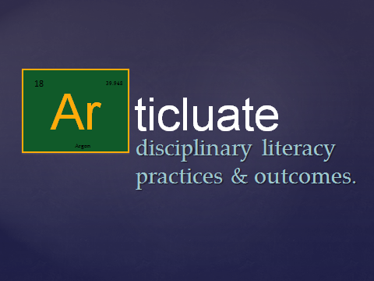
4

Rate yourself! | 1 5

