TEACHING STUDENTS TO ASK THEIR OWN QUESTIONS

Kentucky Council for the Social Studies
Annual Conference

September 23, 2014

The Right Question Institute offers many of our materials through a Creative Commons License and we encourage you to make use of and/or share this resource. Please reference the Right Question Institute as the source on any materials you use.

Source: www.rightquestion.org

STAYING CONNECTED:

The RQI Educator Network

Sign-up for free at www.rightquestion.org/educators

- Share how you are using the QFT
- Download resources

NEA-NH

Concord, NH

May 17, 2014

Ma

May 2,

2464 Massachusetts Avenue, Suite 314, Cambridge, MA 02140
617-492-1900
www.rightquestion.org

THINKING ABOUT THE RULES FOR PRODUCING QUESTIONS

Think about each one of these rules and their use in the classroom. How does each rule differ from usual classroom practice?

Rule | Differs from usual classroom practice in the following ways:
Ask as many questions as you can.
Do not stop to discuss, judge, or answer the questions.

Write down every question exactly as stated.

Change any statements into questions.
REVIEWING QFT CLASSROOM EXAMPLES
Directions:
- Review each step in the example. Look at how the steps in the process connect to each other.
- Write your observations about each section in the chart below.
- Share in your group your observations, comments, and questions.

STEPS | EXAMPLE # | EXAMPLE #
Content
Question Use
The Question Focus (QFocus)
The questions students produced
Prioritization Instructions
Outcomes or reflections
PREPARING TO USE THE QFT

CONTENT:
1. Grade:_________ Course: _________________________ Topic:________________________________________

2. Unit description (few sentences describing main components).

3. Place in the unit where you will use the Question Formulation Technique:
__ at beginning __ in middle __ at end __ at different points in unit/lesson

4. What is your teaching objective? (By the end of the lesson students will be able to…)

5. What dimensions of the C3 Framework will the lesson be incorporating?
__ Dimension 1: Developing questions and planning inquiries
__ Dimension 2: Applying disciplinary tools and concepts
__ Dimension 3: Evaluating sources and using evidence
__ Dimension 4: Communicating conclusions and taking informed action

QUESTION USE:

6. Students will use the questions they produce to do the following:

__ To conduct research
__ For a socratic seminar or debate
__ To write a paper or essay
__ For an individual project
__ To develop a group project
__ To prepare for a presentation/interviews
__ To gather information
__ The students will determine how the
questions will be used
__ Other:

QFOCUS DESIGN:
You will need a Question Focus for students to ask questions. It can be a statement, a visual or aural aid in any medium related to the content.

7. Brainstorm some examples. Remember, the simpler your QFocus, the better. Do NOT use a question.
8. Test two of your ideas below by writing out possible questions. Try to imagine different lines of questioning. You can do this with a partner or on your own.
Q-Focus 1: | Q-Focus 2:

9. Trouble shooting your QFocus. Revise your QFocus based on your answers to the following questions:

Is there too much information? | Yes / No
Will the QFocus discourage students from asking many questions about the topic? | Yes / No
Is there a word that might distract students? | Yes / No
Will they perceive the QFocus as just another way of presenting the teacher’s message or ideas? | Yes / No
Is there a change you could make that would stimulate new lines of thinking? | Yes / No
Do you want to make it more provocative? | Yes / No
Do you want to make it more neutral? | Yes / No

10. Choose or modify the QFocus you think will help reach your purpose for using the QFT.
Explain why you chose this example:

PRIORITIZATION INSTRUCTIONS:
11. What will be your prioritization instructions for students to choose their three priority questions?

12. Why did you choose these instructions?

BACKWARDS PLANNING FOR EFFECTIVE QFT USE
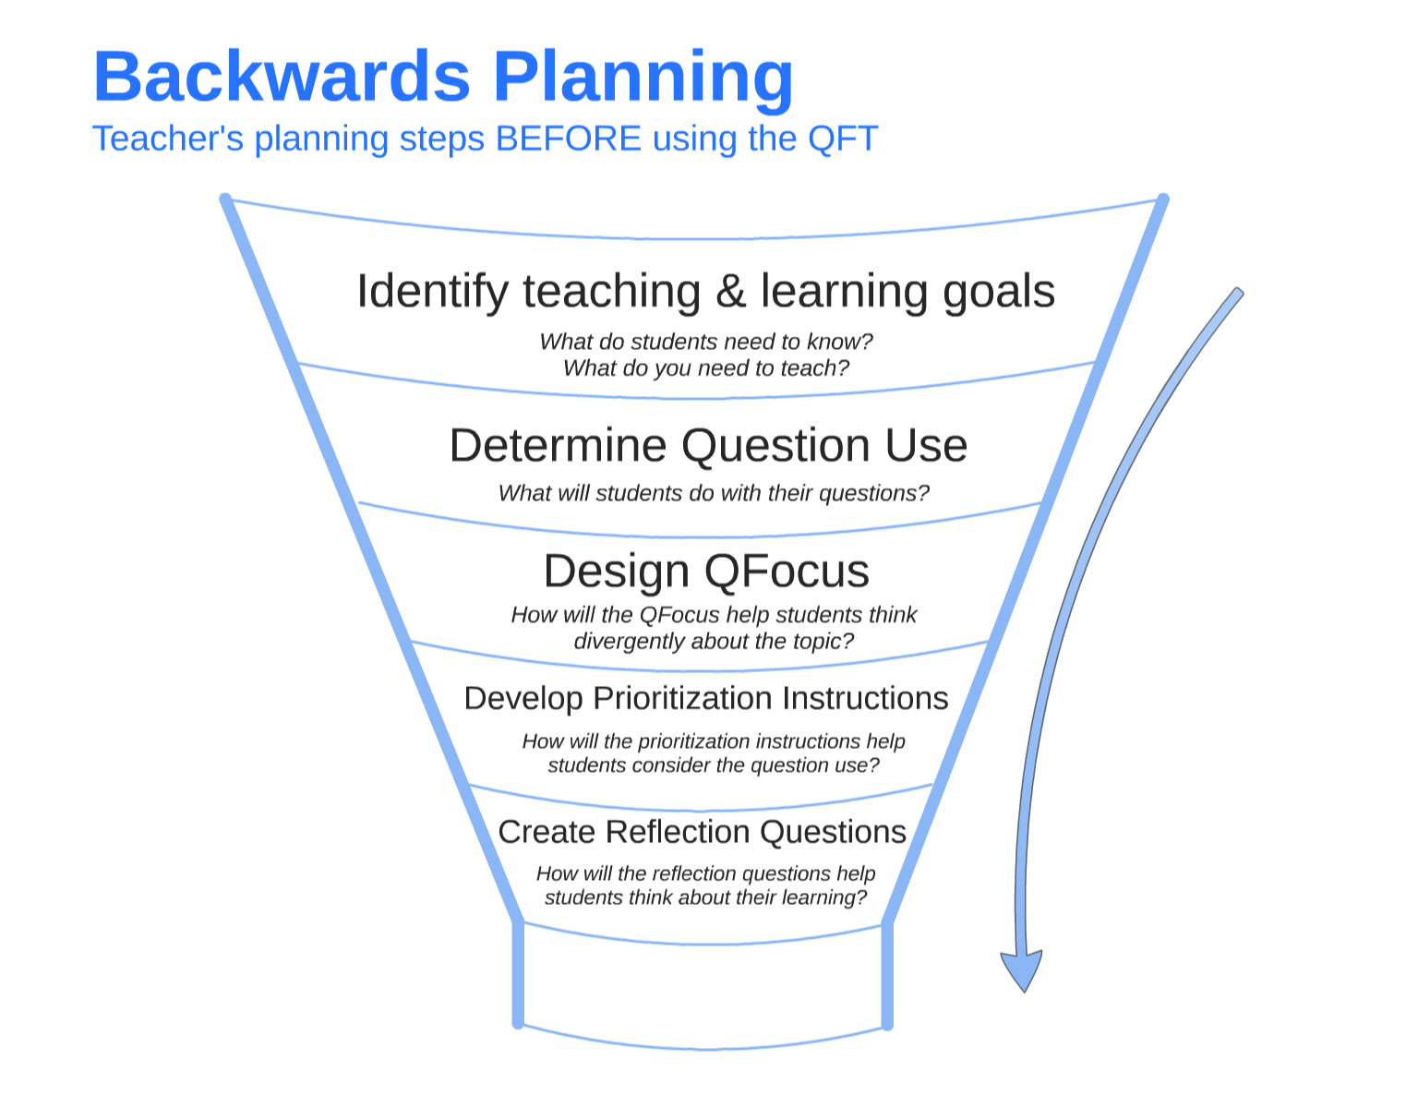

RECOMMENDATIONS ON FACILITATING THE QUESTION FORMULATION TECHNIQUE (QFT) IN YOUR CLASSROOM

Remember that teachers and students have different roles during the QFT process. After you have planned your use of the QFT, created a Question Focus (QFocus) and are about to share the QFT in your classroom:
- Your role (as a teacher) is to facilitate students moving through the question formulation process by giving succinct instructions at each step.
- The students’ role is to ask questions and do all the thinking without you having to model or explain.

Key points for teachers when facilitating the QFT process:

- Let students know that you will be giving them a focus for asking questions, but, first, you will ask them to discuss the rules for producing questions.

- Give simple instructions. Do not over-explain.

- Do not give examples of what to think about or questions to ask. Do not answer or assess student questions during the process of producing questions.

- Help facilitate group work by reminding students to stay on task.

We also, when facilitating, acknowledge all contributions by simply saying ‘thank you.’ We try to refrain from judgment, negative or positive.

