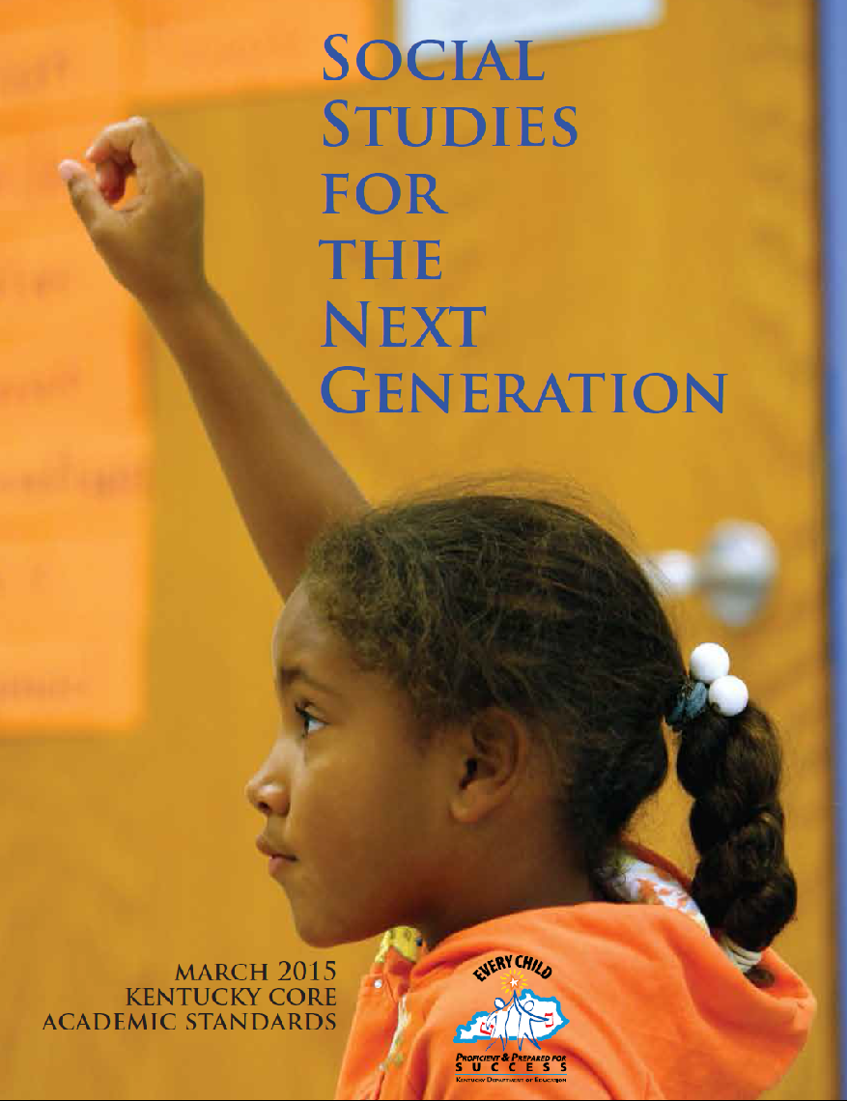
Social Studies Standards for the Next Generation
Introduction
As young learners of the 21st century engage in the integrated study of social studies, it is critical that they are equipped with the dexterity of mind to question, evaluate and communicate what is necessary to become active, productive and engaged citizens in a culturally diverse, democratic society. Kentucky’s Social Studies Standards for the Next Generation enables educators to design curriculum that enhances students’ content knowledge, while building critical thinking skills. These standards empower 21st century learners to move beyond the acquisition of isolated facts, while equipping them with the dispositions necessary to become stewards of democracy as citizens in an interdependent world.
Disciplinary Core Concepts
Kentucky’s Social Studies Standards for the Next Generation answer the demand from educators to reimagine how students learn and the desired or anticipated outcome of that learning. These standards have identified Disciplinary Core Concepts (DCCs), derived from the C3 Framework, Global Competence Matrix and the Partnership for 21st Century Skills, as the approaches social scientists take when engaging in disciplinary thinking. Kentucky’s Social Studies Standards for the Next Generation use the DCCs to define the content of the social studies discipline as the development of: Civic Mindedness (CM), Economic Decision Making (EDM), Geographic Reasoning (GR) and Historical Thinking (HT).
Inquiry Cycle
Kentucky’s Social Studies Standards for the Next Generation builds a paradigm of teaching and learning that asks learners to be meaningfully engaged in the Practices in the Inquiry Cycle: Questioning, Evaluating and Communicating, while accessing and developing Disciplinary Core Concepts. The components of the Practices in the Inquiry Cycle frame the Disciplinary Core Concepts to construct opportunities to critically think about and collaborate on fundamental aspects of what it means to think like a social scientist. The outcomes from such rich and meaningful learning experiences will better prepare future citizens to communicate and creatively resolve the problems of our world through the combined lenses of civics, economics, geography and history.
Crosscutting Threads
It is the responsibility of social studies educators to support the development of active citizens who participate productively in the world around them. It is essential that all Kentucky students are globally-prepared and ready to support communities and companies with citizens and workers who understand how to cooperate and compete in an increasingly global economy. Kentucky’s Social Studies Standards for the Next Generation attempts to meet these needs by infusing the following crosscutting threads into both the Practices in the Inquiry Cycle and the Disciplinary Core Concepts: Global Competencies, 21st Century Skills and Kentucky Studies.

TABLE OF CONTENTS

Acknowledgments

Introduction

Vision Statement

Considerations for Curriculum Development Rationale

Kindergarten – MY World

First Grade – Considering MY World

Second Grade – Explaining and Describing MY World

Third Grade – Working Together

Fourth Grade – Relationships

Fifth Grade – Change and Impact

Sixth Grade – Making Meaning

Seventh Grade – Cause and Effect

Eighth Grade – Participating in Change

High School – Learners and Leaders

Anchor Standards with Progressions

Storyline Abstracts

Appendix A: Glossary of Key Terms
Appendix B: Literacy Connections
Appendix C: Professional Organizations, Museums and Kentucky Resources
Appendix D: Social Studies Web Links and Digital Resources
Appendix E: Global Crosswalk

ACKNOWLEDGEMENTS
ACKNOWLEDGEMENTS

THANK YOU TO ALL THOSE WHO SERVED ON WRITING COMMITTEES:

Stephen Bolton Jr.  Bell County Schools  Tammy Brantley  Crittenden County Schools  Lori Bricken  Floyd County Schools  Christina (Niki) Cecil  Corbin Independent Schools  Monica Clark  Bullitt County Schools  Adam Decker  Logan County Schools  Heather Dunn  Beechwood Independent Schools  Paradise Forbes  Williamstown Independent Schools  Penny Gaskins  Taylor County Schools  Jennifer Gobin  Hopkins County Schools  Tiffany Gruen  Covington Independent Public Schools  Katie Holbrook  Ashland Independent Schools  THANK YOU TO THE COUNTLESS SOCIAL STUDIES EDUCATORS AND KENTUCKY CITIZENS WHO REVIEWED AND HELPED DEVELOP THIS DOCUMENT | Tammy Jones  Pike County Schools  Ryan Lewis  Woodford County Schools  Erin Mathis  Marshall County Schools  Lynnette McGiffen-Newkirk  Oldham County Schools  Susan Montgomery  Elizabethtown Independent Schools  Leslie Moyer  Greenup County Schools  Kim Mroch  Trigg County Schools  Howard Muncy  Laurel County Schools  Debra Napier  Harlan County Schools  Ryan New  Boyle County Schools  Rhonda Osburn  Boyd County Schools  Lisa Petrey-Kirk  Anderson County Schools | Steven Quertermous  Ballard County Schools  Robin Reid  Fayette County Schools  Kristina Sauer  Jefferson County Schools  Valerie (Jill) Spaw  Casey County Schools  Terry Spencer  Wolfe County Schools  Anthony Spires  Warren County Schools  Steven Taylor  Pike County Schools  Roger Thomas  Jefferson County Schools  Lori Thurman  Owensboro Independent Schools  Elizabeth Tronoski  Fayette County Schools  Jennie Watkins  Corbin Independent Schools  Susan Watts  Shelby County Schools  Jennie Whitehead  Mason County Schools

ACKNOWLEDGEMENTS
ACKNOWLEDGEMENTS

THANK YOU TO ALL THOSE WHO SERVED ON ADVISORY COMMITTEES:

Ron Adkisson  Oldham County Schools  Aaron Biddle  Pendleton County Schools  Sara Bollinger  Hardin County Schools  Holly Carter  Boyle County Schools  Maurice Chappell  Jessamine County Schools  Rick Daniel  Jefferson County Schools  Kristin Davis  Fayette County Schools  Nick Easter  Kentucky Department of Education  Dr. Kay Gandy  Western Kentucky University  Dr. Cynthia Harter  Eastern Kentucky University | Allison Hunt  Jefferson County Schools  Dr. John Kleber  University of Louisville  Dr. James Klotter  Georgetown College  Barry Leonard  Graves County Schools  Joseph Moneymaker  Livingston Independent Schools  John Moore  Western Kentucky University  Toni Perry  Elizabethtown Independent Schools  Merrill Punke  Henderson County Schools  James Riffe  Oldham County Schools  Pam Rowland  Rowan County Schools | Susan Sandage  Kentucky Economic Council  Kim Sergent  Letcher County Schools  Dr. Kimberlee Sharp  Morehead State University  Amy Sizemore  Graves County Schools  Dr. Kathy Swan  University of Kentucky  Tim Talbott  Kentucky Historical Society  Dr. Emma Thacker  University of Kentucky  Cletus Turner  Martin County Schools  Donnie Wilkerson  Russell County Schools

THANK YOU TO THE PROFESSIONAL ORANIZATIONS WHO PROVIDED GUIDANCE AND REVIEW

C3 Teachers
Council of Chief State School Officers - Social Studies Assessment, Curriculum and Instruction Collaborative
Eastern Kentucky University’s Center for Economic Education
Federal Reserve Bank of St. Louis - Louisville Branch
Frazier History Museum
Kentucky Historical Society
Kentucky Educational Television
Kentucky Council for the Social Studies
Kentucky Association for Early Childhood Education
Kentucky Chamber of Commerce
Kentucky Council on Economic Education
Kentucky Geographic Alliance
Kentucky Out-of-School Alliance
Kentucky Association for Gifted Education
Junior Achievement of the Bluegrass
National Council for the Social Studies
The Pritchard Committee

INTRODUCING KENTUCKY’S SOCIAL STUDIES STANDARDS FOR THE NEXT GENERATION

Through a collaborative and informed writing process, the writing team constructed future-oriented standards, which respond to the demands of global competencies and 21st century learning. We believe this is an opportunity to transform the future of social studies education in our commonwealth and the creation of flexible, forward-thinking standards is a step in the right direction.

Aware of the unfamiliar construct of the new standards and how it might generate concern regarding the perceived vague nature of the standards and possible difficulties translating them into viable curriculum, we were very purposeful in all decisions during the development of this document. While the standards do lack context, they are rich with content appropriate for 21st century students.

Historically, educators did not have a voice in what context was used to meet the standards. Past social studies standards were very prescriptive in context by grade-level and did not allow teachers to make professional decisions or to exercise their expertise. Lack of flexibility to make decisions in response to students’ interests and needs is a common point of contention among educators. Educators should have the ability to design relevant curriculum for 21st century learning experiences.

Additionally, we deliberately chose to develop standards in such a way to allow students to build skills and content understanding in tandem. The advent of technological resources allows students greater independent access to content. Consequently, current needs go beyond the dissemination of content and the acquisition of facts to the development of critical skills such as communicating effectively in writing, demonstrating higher-level thinking or crafting claims based upon evidence.

As a result, the standards were drafted with a focus on student development of skills because of the following reasons:
Skills are transferrable between content areas and can help students in a variety of settings even beyond school.
Skills empower students to take ownership of their own learning and allow them to analyze their own development.
Focus on skills allows for greater differentiation to be provided for students as they learn instead of using a “one-size-fits-all” approach to content matter.

Ultimately, we believe the content inherent in the standards will become apparent to teachers as they analyze the standards and will allow them to make informed curricular decisions at the district and school levels. However, our main intention and goal was and is to create a system that allows teachers to empower students to become independent thinkers and problem solvers.

Sincerely,
The Writing Task Force
Niki Cecil, Monica Clark, Jennifer Gobin, Tiffany Gruen, Katie Holbrook, Kim Mroch, Ryan New, Tammy Jones

VISION FOR THE SOCIAL STUDIES STANDARDS FOR THE NEXT GENERATION

As social studies educators, we should work toward creating active citizens who participate productively in the world around them. In the twenty-first century, citizenship requires a global outlook with certain skills needed to navigate the political realm. Being globally aware in Kentucky requires an understanding of past and present world events, past and present American events and the tools and skills of citizenship.

Social studies education in Kentucky should aim to provide the curriculum and instruction necessary to produce active, informed, productive, globally aware Kentucky citizens which provides for understandings about civics, economics, geography and a wide array of history.

In elementary schools, social studies education should provide the foundations for understanding local communities, Kentucky, the United States, as well as other countries. The theme for these early years should be beginning citizenship. Students should learn what it means to be a globally aware citizen of Kentucky and the United States.

In middle schools, social studies education should begin to focus more on the formation of governments, economies and geographies of communities from a local-to-global scale. Students should be growing their understanding of the world around them and what it means to be a member of society in an inter-connected world.

In high schools, social studies education should help students to understand topics more deeply from the transformation of isolated countries, governments and economies into a more globally-dependent system. Students should leave high school as deeply rooted, globally competent Kentucky citizens.

-The Standards Advisory Committee

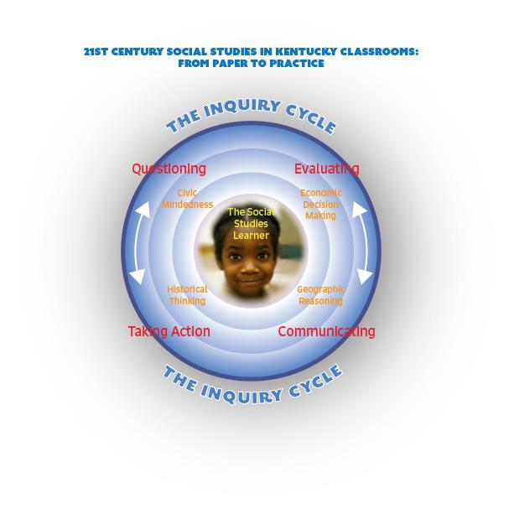

CONSIDERATIONS FOR CURRICULUM DEVELOPMENT RATIONALE

The Social Studies Standards for the Next Generation are a noted departure to the emphasis on the content-heavy learning of people, places and dates to a more skill driven response to the needs of Kentucky students now and for the future. The Standards document supports this shift in social studies instruction as articulated by the creators of the C3 Framework:
Instructional Shifts of the C3 Framework
1. Inquiry should be the primary form of investigation in all social studies classes.
2. Student (and teachers) should craft investigative questions that matter.
3. Teachers should establish a collaborative context to support student inquiry.
4. Teachers should integrate content and skills meaningful.
5. Teachers should help students articulate disciplinary literacy practices and outcomes (thinking, reading,
writing, speaking and listening like a historian, a geographer and an economist, etc.).
6. Teachers should provide, and help students develop tangible opportunities to take informed action.

The Considerations for Curriculum Development resources provide a foundation for both context and scope and sequence for Kentucky districts, schools and teachers to assist in developing curriculum around the Social Studies Standards for the Next Generation. The Considerations are just that, samples of possible ways to integrate social studies in a meaningful and rich manner, they are not and should not be read as mandatory or required but are offered as suggested ways of presenting content to meet the standards.
Each grade level contains grade-level assumptions and goals that narrow the grade level context and expectations. Referring back to the Practices of the Inquiry Cycle, there are suggested general and year-long compelling and supporting questions.
After the introduction of year-long inquiry, each grade-level set of Disciplinary Core Concepts (Civic, Economics, Geography, History) are presented as a group. Each set has a more defined listing of possible compelling and supporting questions framed by a Key Idea. Sample student learning targets and a listing of possible Key Concepts are provided as starter for conversations around what deconstructed standards would look like and ways of bundling academic vocabulary.
The Considerations are merely a starting point for district curriculum. As a local control state, Kentucky values and encourages social studies professionals to know what is best for their student’s learning progression and to advocate for the bundling and organization of standards that best fits their needs. The Social Standards for the Next Generation provide the opportunity for reimagining social studies, the Considerations is just one way to bring the standards to life.

College, Career and Civic Ready Anchor Standards
1 | Civic and Political Institutions  Determine the importance of the institutions of society and the principles that these institutions are intended to reflect, which requires the demonstration of in-depth understanding of law, politics and government.
2 | Participation and Deliberation: Applying Civic Virtues and Democratic Principles  Analyze foundational documents and determine key understandings in order to evaluate how citizens should interact with each other in formal institutions and informal interactions.
3 | Processes, Rules and Laws  Evaluate and critique how decisions, procedures and policies are used to address problems and/or needs in a variety of settings.
4 | Economic Decision Making  Analyze and explain how resource availability, opportunity cost and incentives are an essential part of economic decision making.
5 | Exchange and Markets  Analyze how the interactions of buyers and sellers in a variety of economic markets impact goods, services, labor, credit and foreign exchange in the markets; evaluate and critique the effectiveness of government policies on market outcomes.
6 | National Economy  Analyze and explain how the amounts and qualities of capital (human and physical) and natural resources influence current and future economic conditions as well as standards of living by evaluating and critiquing the intended and unintended consequences of policies on fluctuations in growth, supply, spending, inflation, employment and growth.
7 | Global Economy  Analyze and explain the benefits and costs of globalization among individuals and businesses (considering specialization and trade) and how this leads to increased economic interdependence (cross-border movement of goods, services, technology, information and human, physical and financial capital).
8 | Spatial Views of the World  Create and utilize maps and other geographical representations to seek and communicate knowledge that is personally and socially useful.
9 | Human-Environment Interaction  Determine how society is impacted at local-to-global scales through the interactions of human and physical systems.
10 | Human Populations: Spatial Patterns and Movements  Analyze the movements and spatial patterns of human populations (size, composition, distribution) to determine the relationships between these spatial patterns and physical, political, economic and technological phenomenon.
11 | Global Interconnections: Changing Spatial Patterns  Evaluate the dynamic interactions among the world’s people, nations and economic organizations and how they impact global scale issues.
12 | Chronological Reasoning: Causation and Continuity  Analyze similarities and differences between historical periods and between the past and present, to determine processes of change and continuity over time by evaluating the causation of political, social, economic, cultural and intellectual factors.
13 | Historical Understanding: Contextualization and Perspectives  Evaluate historical developments by analyzing a multiplicity of points of view to gain a broader historical perspective of regional, national and global processes.
14 | Historical Arguments  Utilize evidence to craft claims that demonstrate an analysis and evaluation of sources, taking into consideration change over time, perspectives of those involved and relevance of sources.
15 | Interpretation and Synthesis  Evaluate the multiplicity of historical points of view, context and circumstances through the use of a wide range of sources in order to create a synthesis of the past, while applying insights from the present.

Kindergarten: MY World

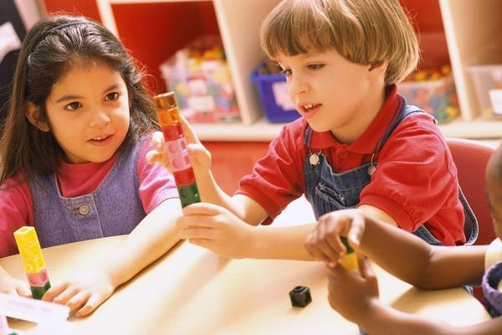
The goal for 21st century learners in Kindergarten is to wonder and reason, which are the initial building blocks of a rich foundation of inquiry. By embracing the theme of “My World” throughout the school year, students will explore, question and investigate important social elements in their immediate sphere. The expectation for students is to see the world through the lens of all four Disciplinary Core Concepts and to begin an early progression towards college, career and civic readiness. Throughout the Practices in the Inquiry Cycle, students will come to the understanding of civic-mindedness through questioning rules and evaluating roles. Students will use their personal experiences to generate possible reasons for events, leading to the idea that historical events are driven by cause and effect. By connecting everyday classroom experiences to economic decision-making, young learners will be able to question and evaluate the motivations behind these decisions. Also, students will investigate relationships between the environment and their communities. Over the course of a series of experiences, students will begin to develop the essential practices of determining compelling questions to guide their exploration and evaluating information to plan and implement appropriate actions to address authentic problems.

Kindergarten: MY World
Practices in the Inquiry Cycle
Questioning  Students will independently and collaboratively:  1. Develop compelling questions that promote inquiry around key disciplinary concepts and embedded enduring issues.  2. Develop supporting questions that identify facts, concepts and research interpretations associated with a key disciplinary concept. | Evaluating Sources  Students will independently and collaboratively:  3. Determine the types of sources that will assist in answering compelling and supporting questions.  4. Gather relevant information from multiple sources from a wide range of perspectives and evaluate for credibility.  5. Identify and utilize evidence to seek solutions to questions. | Communicating  Students will independently and collaboratively:  6. Develop and create claims and counterclaims using appropriate evidence to construct strengths and weaknesses  7. Construct viable arguments, relevant explanations and/or public demonstrations that convey ideas and perspectives to a wide array of appropriate audiences.  8. Critique the arguments and explanations of others paying particular attention to credibility and relevance of information. | Taking Action  Students will independently and collaboratively:  9. Address options of individuals and groups to identify and apply a range of strategies and complex reasoning to take public action or propose a solution.  10. Engage in disciplinary thinking used by social scientists (historians, economists, political scientists and geographers) independently and proficiently resulting in civic readiness.
Civic Mindedness |  | Geographic Reasoning
K.CM.1 Civic and Political Institutions Identify the roles and responsibilities of community members.  K.CM.2 Participation and Deliberation: Applying Civic Virtues and Democratic Principles Describe how people treat each other, then demonstrate respect for authority and peers.  K.CM.3 Processes, Rules and Laws Describe rules in various settings. |  | K.GR.8 Spatial Views of the World Create models of familiar places.  K.GR.9 Human-Environment Interaction Identify the characteristics of climate and explain how it affects peoples’ lives in specific places.  K.GR.10 Human Populations Spatial Patterns and Movements Explain how and why people move.  K.GR.11 Global Interconnections Identify ways that physical and cultural characteristics may affect people living in a place.
Economic Decision Making |  | Historical Thinking
K.EDM.4 Economic Decision Making Explain how scarcity of resources affects individuals’ choices.  K.EDM.5 Exchange and Markets Explain how people purchase goods and services.  K.EDM.6 National Economy Describe examples of goods and services.  K.EDM.7 Global Economy Describe the origins of goods and services. |  | K.H.12 Chronological Reasoning: Causation and Continuity Create a chronological sequence and generate a possible cause for an event.  K.HT.13 Historical Understanding: Contextualization and Perspectives Compare different perspectives of people.  K.HT.14 Historical Arguments Identify a possible reason for historical developments and events.  K.HT.15 Interpretation and Synthesis Identify different kinds of historical sources.

First Grade: Considering MY World?

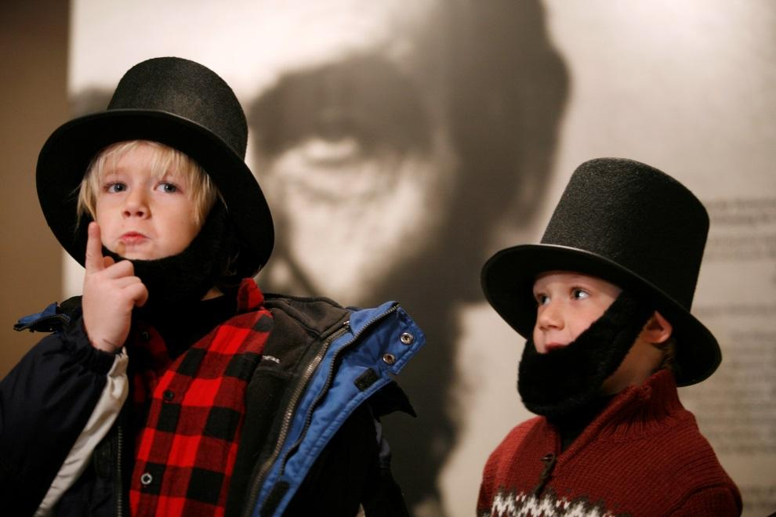
Building on their experiences of “My World” during Kindergarten, 1st graders will engage in 21st century learning, deepening their learning in all Practices in the Inquiry Cycle. Through a woven experience within all four Disciplinary Core Concepts, students begin to see their world as structured where both the past and the present interact. During the first grade, much of the groundwork for cause and effect thinking is constructed so that students can make sense of relationships and interactions at a local level. Experiences throughout the school year will create opportunities for students to question how roles and responsibilities in their communities relate to rules and decision-making, develop historical-thinking skills by questioning and evaluating sources, foster economic decision-making by asking questions and evaluating their roles as consumers and develop geographic-reasoning skills that will challenge students to see relationships between cultures and the environment. This year of wonder and investigation will lead to the development of an understanding of how these concepts affect their world and empower students to see themselves as contributors to the solutions. By the end of first grade, these young learners are equipped to ask relevant questions and make connections to the world they know.

Grade 1: Considering MY World
Practices in the Inquiry Cycle
Questioning  Students will independently and collaboratively:  1. Develop compelling questions that promote inquiry around key disciplinary concepts and embedded enduring issues.  2. Develop supporting questions that identify facts, concepts and research interpretations associated with a key disciplinary concept. | Evaluating Sources  Students will independently and collaboratively:  3. Determine the types of sources that will assist in answering compelling and supporting questions.  4. Gather relevant information from multiple sources from a wide range of perspectives and evaluate for credibility.  5. Identify and utilize evidence to seek solutions to questions. | Communicating  Students will independently and collaboratively:  6. Develop and create claims and counterclaims using appropriate evidence to construct strengths and weaknesses  7. Construct viable arguments, relevant explanations and/or public demonstrations that convey ideas and perspectives to a wide array of appropriate audiences.  8. Critique the arguments and explanations of others paying particular attention to credibility and relevance of information. | Taking Action  Students will independently and collaboratively:  9. Address options of individuals and groups to identify and apply a range of strategies and complex reasoning to take public action or propose a solution.  10. Engage in disciplinary thinking used by social scientists (historians, economists, political scientists and geographers) independently and proficiently resulting in civic readiness.
Civic Mindedness |  | Geographic Reasoning
1.CM.1 Civic and Political Institutions Explain the need for and purposes of rules in a community.  1.CM.2 Participation and Deliberation: Applying Civic Virtues and Democratic Principles Describe and demonstrate equality, fairness and freedom when making decisions.  1.CM.3 Processes, Rules and Laws Explain the purpose of rules in various settings. |  | 1.GR.8 Spatial Views of the World Identify characteristics of places using maps, graphs, photographs and other models.  1.GR.9 Human-Environment Interaction Identify environmental characteristics of specific places.  1.GR.10 Human Populations Spatial Patterns and Movements Explain why and how goods and ideas move to meet daily needs.  1.GR.11 Global Interconnections Explain how the consumption of products connects people to other places through trade.
Economic Decision Making |  | Historical Thinking
1.EDM.4 Economic Decision Making Explain and generate examples of how scarcity affects economic decisions.  1.EDM.5 Exchange and Markets Describe the connection between the costs of production and the price of goods and services.  1.EDM.6 National Economy Explain how and why people save and spend money.  1.EDM.7 Global Economy Describe why people trade for goods and services. |  | 1.HT.12 Chronological Reasoning: Causation and Continuity Compare life today to the past, utilize a chronological sequence and identify significant individuals and groups.  1.HT.13 Historical Understanding: Contextualization and Perspectives Compare and contrast perspectives of people in the past to those of people in the present.  1.HT.14 Historical Arguments Summarize possible reasons for historical developments and events.  1.HT.15 Interpretation and Synthesis Identify the maker, date and place of origin for a historical source from information in the source.

Grade 2: Explaining and Describing MY World

With students developing a keen sense of the world around them 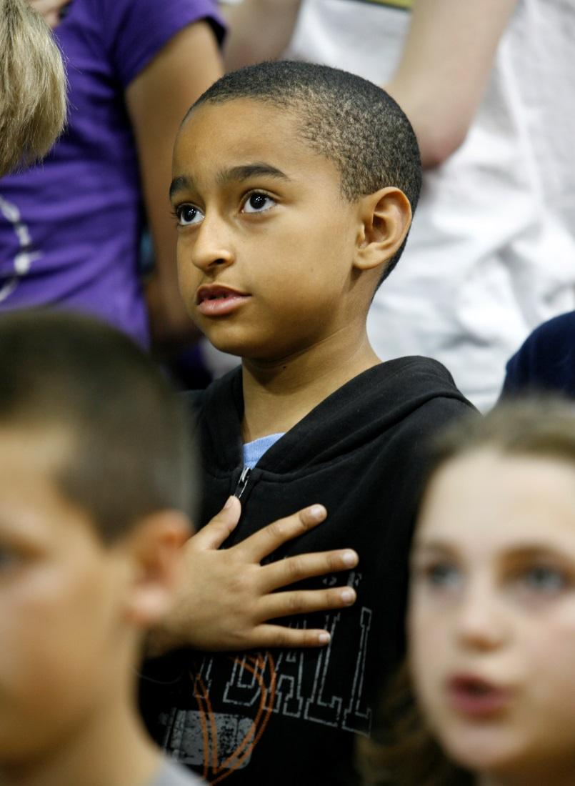in the previous grade levels, 21st century learners will connect foundational concepts to explain and describe aspects of the world around them in 2nd grade. By creating experiences and opportunities enriched by the Practices in the Inquiry Cycle across the four Disciplinary Core Concepts, the essential skills for college, career and civic readiness continue to develop. Students will explain, describe, and question why and how people and governments make decisions that benefit their communities and explain how availability of goods and services are key in their economic decision making, including the process of production, distribution and consumption. Further, students will describe how human-environmental interactions affect their understanding of the world, and how the world changes as a result of physical characteristics and human activities. As students’ perception of text shifts from “learning to read” to “reading to learn,” interrogating text by questioning, comparing different historical perspectives and creating time lines will be key in their social studies development. During second grade, it is fundamental to further students’ abilities to recognize cause and effect relationships. By the end of 2nd grade, students are ready to stretch their perspectives outside of their immediate surroundings.

Grade 2: Explaining and Describing MY World
Practices in the Inquiry Cycle
Questioning  Students will independently and collaboratively:  1. Develop compelling questions that promote inquiry around key disciplinary concepts and embedded enduring issues.  2. Develop supporting questions that identify facts, concepts and research interpretations associated with a key disciplinary concept. | Evaluating Sources  Students will independently and collaboratively:  3. Determine the types of sources that will assist in answering compelling and supporting questions.  4. Gather relevant information from multiple sources from a wide range of perspectives and evaluate for credibility.  5. Identify and utilize evidence to seek solutions to questions. | Communicating  Students will independently and collaboratively:  6. Develop and create claims and counterclaims using appropriate evidence to construct strengths and weaknesses  7. Construct viable arguments, relevant explanations and/or public demonstrations that convey ideas and perspectives to a wide array of appropriate audiences.  8. Critique the arguments and explanations of others paying particular attention to credibility and relevance of information. | Taking Action  Students will independently and collaboratively:  9. Address options of individuals and groups to identify and apply a range of strategies and complex reasoning to take public action or propose a solution.  10. Engage in disciplinary thinking used by social scientists (historians, economists, political scientists and geographers) independently and proficiently resulting in civic readiness.
Civic Mindedness |  | Geographic Reasoning
2.CM.1 Civic and Political Institutions Explain how communities work to accomplish tasks and establish responsibilities.  2.CM.2 Participation and Deliberation: Applying Civic Virtues and Democratic Principles Compare individual and group perspective and how they affect decisions.  2.CM.3 Processes, Rules and Laws Describe how people have tried to improve their communities through rules or laws. |  | 2.GR.8 Spatial Views of the World Describe places and the relationships and interactions that shape them using maps, graphs, photographs and other models.  2.GR.9 Human-Environment Interaction Identify cultural characteristics of specific places.  2.GR.10 Human Populations Spatial Patterns and Movements Describe connections between the physical environment and the economic activities of a place.  2.GR.11 Global Interconnections Explain why cultural characteristics vary among regions.
Economic Decision Making |  | Historical Thinking
2.EDM.4 Economic Decision Making Describe opportunity costs of economic decisions.  2.EDM.5 Exchange and Markets Identify examples of human, capital and natural resources to explain why individuals and businesses specialize and trade.  2.EDM.6 National Economy Describe how examples of capital, human and natural resources are related to goods and services.  2.EDM.7 Global Economy Explain the concepts of imports and exports and describe products that are imported and exported. |  | 2.HT.12 Chronological Reasoning: Causation and Continuity Create and use a chronological sequence to generate possible causes for historical developments and events and how these were shaped by individuals and groups.  2.HT.13 Historical Understanding: Contextualization and Perspectives Compare different accounts of the same historical event.  2.HT.14 Historical Arguments Summarize possible reasons for historical developments and events by viewing a historical source.  2.HT.15 Interpretation and Synthesis Generate questions about a historical source and explain how the source is related to a historical development or event.

Grade 3: Working Together
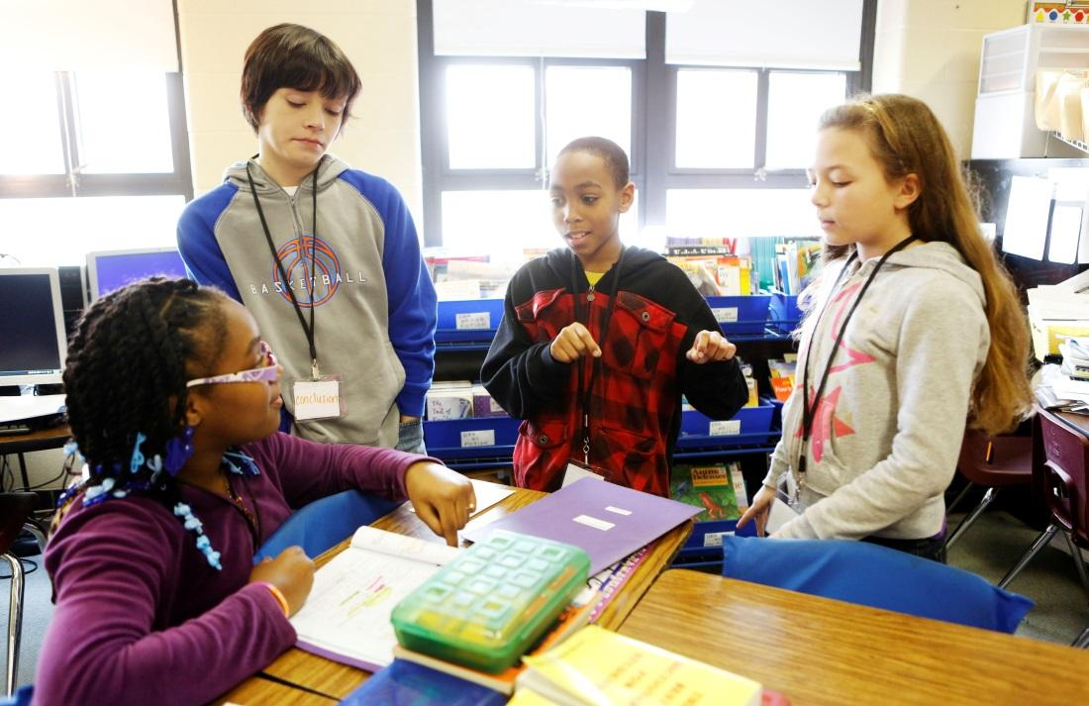

To continue building the foundation for college, career and civic readiness, the goal for 3rd graders as 21st century learners is to continue to refine their questioning and evaluation skills, while building a broader understanding of the world around them. Students are ready to investigate how collaboration and the establishment of various responsibilities in a community and respect for others are necessary to achieve and maintain a functioning society. These investigations begin by developing an understanding of democratic processes and principles, through the concept of rules and authority. Using their understanding of rules and authority, students will build a context for the larger concept of democracy by exploring how ideas, events and people are connected through history, geography, economics and civics; how they all "work together.” As students examine how events from the past shape the future, they will also evaluate how their own understandings are shaped by the past. These engaged learners will use their growing understanding of the world to compare historical sources and establish cause and effect across time while investigating different historical perspectives. They will analyze and evaluate how productivity and opportunity costs influence decision-making and ​the role of money and financial institutions on decisions on both a small and large scale. They will examine why people exchange goods and services and how goods and productivity can be improved. In addition, these 21st century learners will come to an understanding that the physical environment plays a pivotal role in determining how society developed over time. Most significantly, through the Practices in the Inquiry Cycle, students will take informed action on issues that arise from the home, school and/or community, understand cause and effect and work collaboratively to communicate their ideas to authentic audiences. By the end of 3rd grade, students get a sense that people, ideas and events function both independently and together.

Grade 3: Working Together
Practices in the Inquiry Cycle
Questioning  Students will independently and collaboratively:  1. Develop compelling questions that promote inquiry around key disciplinary concepts and embedded enduring issues.  2. Develop supporting questions that identify facts, concepts and research interpretations associated with a key disciplinary concept. | Evaluating Sources  Students will independently and collaboratively:  3. Determine the types of sources that will assist in answering compelling and supporting questions.  4. Gather relevant information from multiple sources from a wide range of perspectives and evaluate for credibility.  5. Identify and utilize evidence to seek solutions to questions. | Communicating  Students will independently and collaboratively:  6. Develop and create claims and counterclaims using appropriate evidence to construct strengths and weaknesses  7. Construct viable arguments, relevant explanations and/or public demonstrations that convey ideas and perspectives to a wide array of appropriate audiences.  8. Critique the arguments and explanations of others paying particular attention to credibility and relevance of information. | Taking Action  Students will independently and collaboratively:  9. Address options of individuals and groups to identify and apply a range of strategies and complex reasoning to take public action or propose a solution.  10. Engage in disciplinary thinking used by social scientists (historians, economists, political scientists and geographers) independently and proficiently resulting in civic readiness.
Civic Mindedness |  | Geographic Reasoning
3.CM.1 Civic and Political Institutions Explain how citizens engage in democratic processes and practice civic responsibility through government.  3.CM.2 Participation and Deliberation: Applying Civic Virtues and Democratic Principles Demonstrate civic virtues, democratic principles and respect for various perspectives.  3.CM.3 Processes, Rules and Laws Compare decision-making procedures in a variety of circumstances to address issues. |  | 3.GR.8 Spatial Views of the World Construct various geographical representations of both familiar and unfamiliar places.  3.GR.9 Human-Environment Interaction Explain how the culture of places and regions influences how people modify and adapt to their environments.  3.GR.10 Human Populations Spatial Patterns and Movements Explain how human settlements and movements relate to the availability of natural resources.  3.GR.11 Global Interconnections Describe how changes in physical and cultural characteristics of world regions affect people.
Economic Decision Making |  | Historical Thinking
3.EDM.4 Economic Decision Making Explain how economic decisions are affected by opportunity costs.  3.EDM.5 Exchange and Markets Explain the role of money and financial institutions in economic markets.  3.EDM.6 National Economy Describe ways people can increase productivity by using improved capital goods and human capital.  3.EDM.7 Global Economy Describe and give examples of economic interdependence. |  | 3.HT.12 Chronological Reasoning: Causation and Continuity Create and use chronological sequences of events to explain probable causes and effects of historical developments and events.  3.HT.13 Historical Understanding: Contextualization and Perspectives Compare and explain why individuals and groups during the same historical period differed in their perspectives.  3.HT.14 Historical Arguments Determine the cause(s) of historical developments and events by examining secondary sources.  3.HT.15 Interpretation and Synthesis Compare information provided by different historical sources about the past to identify multiple points of view.

Grade 4: Relationships
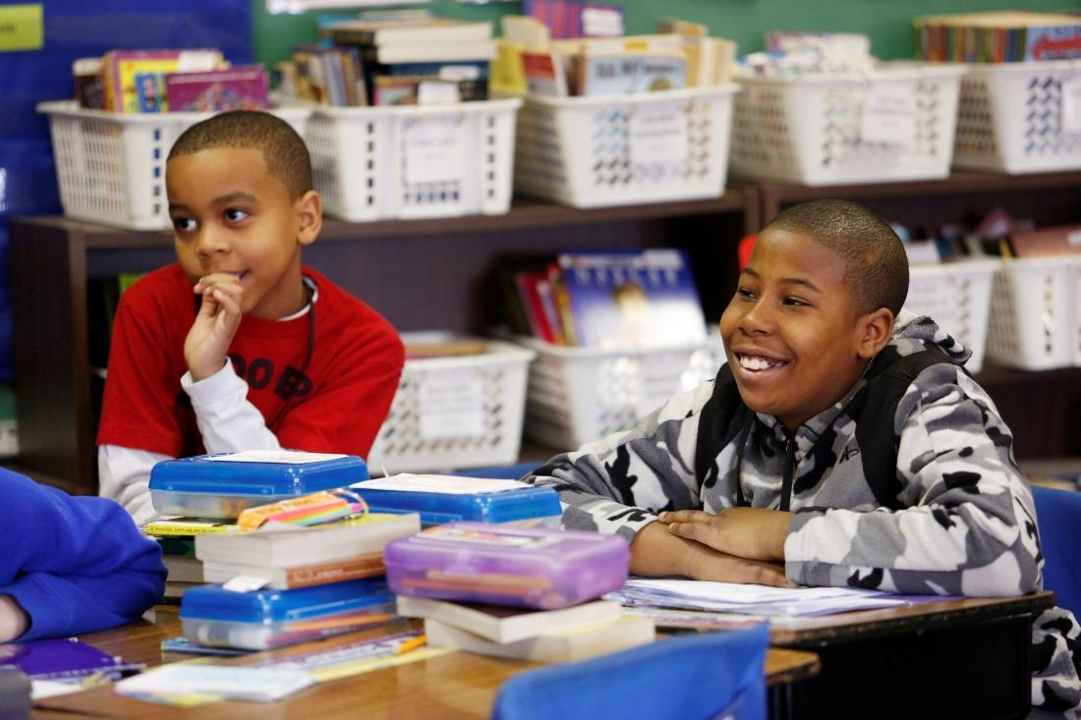
To further develop independent thinking and collaboration skills, the goal for 21st century learners in 4th grade is to continue fostering curiosity and engagement through learning experiences that focus on the complex and overlapping relationships within communities, states and nations. Student experiences will allow them to interact with and evaluate the relationships through the lenses of perspective, change and interdependence and how these viewpoints impact an individual, a society and the world.

Students will continue to focus on questioning as they consider perspectives and how these impact the reasons for why people create and make changes to rules and laws to meet the needs of society. They will question and evaluate perspective, context and cause and effect, as they continue to examine historical sources. Work will be done to judge the validity and usefulness of sources when studying a particular topic as they sharpen historical-thinking skills. By building on the economic understandings of scarcity, opportunity costs and human capital, 21st century learners will develop questions to investigate how the relationships between buyers and sellers, supply and demand, trade and specialization and changes to human capital all impact economic decision-making. Using geographic tools, students will examine how the cultural, environmental and man-made characteristics impact humanity’s interaction with its surroundings. As students continue refining their ability to question, evaluate and communicate, they will examine school and community relationships to identify and address issues that affect students' lives. They will also engage with and meet perceived needs in their communities through the application of civic readiness, sharing research and communicating solutions to local issues of importance in a meaningful and authentic way. By the end of 4th grade, students can make connections to relationships within communities, states and nations and evaluate these relationships through the lenses of perspective, change and interdependence.

Grade 4: Relationships
Practices in the Inquiry Cycle
Questioning  Students will independently and collaboratively:  1. Develop compelling questions that promote inquiry around key disciplinary concepts and embedded enduring issues.  2. Develop supporting questions that identify facts, concepts and research interpretations associated with a key disciplinary concept. | Evaluating Sources  Students will independently and collaboratively:  3. Determine the types of sources that will assist in answering compelling and supporting questions.  4. Gather relevant information from multiple sources from a wide range of perspectives and evaluate for credibility.  5. Identify and utilize evidence to seek solutions to questions. | Communicating  Students will independently and collaboratively:  6. Develop and create claims and counterclaims using appropriate evidence to construct strengths and weaknesses  7. Construct viable arguments, relevant explanations and/or public demonstrations that convey ideas and perspectives to a wide array of appropriate audiences.  8. Critique the arguments and explanations of others paying particular attention to credibility and relevance of information. | Taking Action  Students will independently and collaboratively:  9. Address options of individuals and groups to identify and apply a range of strategies and complex reasoning to take public action or propose a solution.  10. Engage in disciplinary thinking used by social scientists (historians, economists, political scientists and geographers) independently and proficiently resulting in civic readiness.
Civic Mindedness |  | Geographic Reasoning
4.CM.1 Civic and Political Institutions Describe the origins, functions and structure of government to determine how it provides structure to protect citizens and provide equal opportunity within a framework of laws.  4.CM.2 Participation and Deliberation: Applying Civic Virtues and Democratic Principles Compare the beliefs, experiences and values that affect individual and group perspectives.  4.CM.3 Processes, Rules and Laws Explain how the development of policies improves communities and attempts to meet the needs of society. |  | 4.GR.8 Spatial Views of the World Describe the locations of cultural and environmental characteristics and patterns of movement using maps of different scales.  4.GR.9 Human-Environment Interaction Explain how cultural and environmental characteristics of places and regions change over time.  4.GR.10 Human Populations Spatial Patterns and Movements Explain how cultural and environmental characteristics affect the distribution and movement of people, goods and ideas.  4.GR.11 Global Interconnections Describe how the spatial patterns of economic activities in a place change over time because of interactions with nearby and distant places.
Economic Decision Making |  | Historical Thinking
4.EDM.4 Economic Decision Making Describe and evaluate the relationship between resource availability, incentives and opportunity costs.  4.EDM.5 Exchange and Markets Explain the role of buyers, sellers, products and labor in economic markets.  4.EDM.6 National Economy Describe the functions of the monetary system in personal, local and national economies.  4.EDM.7 Global Economy Explain how trade leads to increasing economic interdependence among nations. |  | 4.HT.12 Chronological Reasoning: Causation and Continuity Create and use chronological sequences of events to explain probable causes and effects of historical developments and events.  4.HT.13 Historical Understanding: Contextualization and Perspectives Explain how historical contexts influence people’s perspectives.  4.HT.14 Historical Arguments Explain the concept of a claim and identify evidence for a secondary source to summarize a claim about the past.  4.HT.15 Interpretation and Synthesis Analyze the information gathered from historical sources (maker, date, place of origin, audience and purpose), to judge the extent to which the sources are useful for studying a particular topic.

Grade 5: Change and Impact

Once a sense of self and the importance of relationships are established for civic-readiness, the goal for 21st century learners in 5th grade is to use the Practices in the Inquiry Cycle to examine the idea of change.

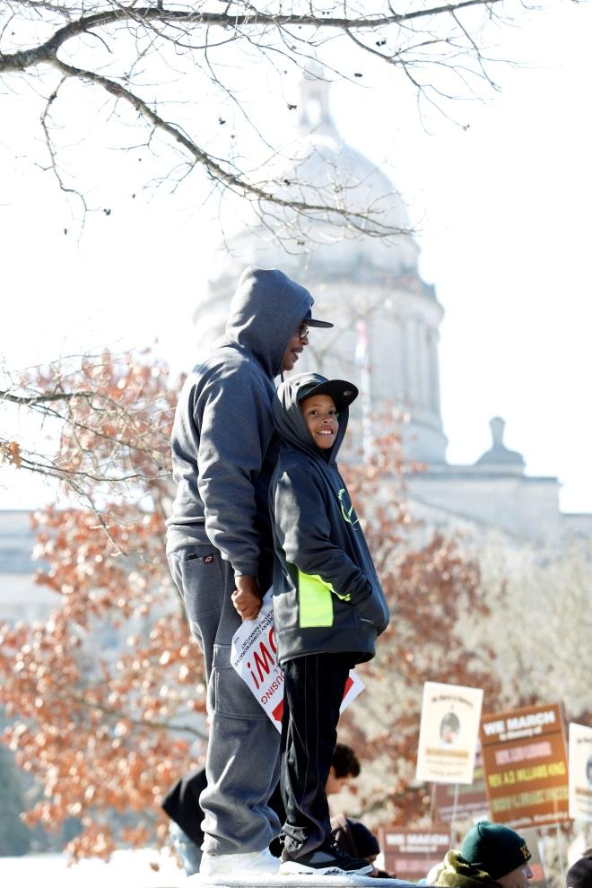This close examination will not only focus on whom, why and how of events, but ultimately the outcomes of these events: the impacts of change. While investigating the power of change, students will develop a sense of civic-mindedness by examining how and why groups and individuals work to establish better forms of government in the United States and around the world and how rules and laws promote the greater good. They will refine historical-thinking skills by interpreting historical sources to generate insights on both how and why context affects perspectives and determine why evidence is important in a historical claim. As they search to explain how the influence of groups and individuals factor into economic decision-making both at home and abroad, they will see how competition can create a healthy economy. They will also apply geographic-reasoning by conducting inquiries into how cultural and environmental outcomes change over time and are impacted by both natural and man-made events.

Most importantly students will utilize the Practices in the Inquiry Cycle to create meaningful opportunities to take informed action. These practices allow students to have an impact; to make change and start to build the idea of their role as an important individual in local and world events. By the end of 5th grade, students are ready to determine the power and impacts of change both at home and around the world.

Grade 5: Change and Impact
Practices in the Inquiry Cycle
Questioning  Students will independently and collaboratively:  1. Develop compelling questions that promote inquiry around key disciplinary concepts and embedded enduring issues.  2. Develop supporting questions that identify facts, concepts and research interpretations associated with a key disciplinary concept. | Evaluating Sources  Students will independently and collaboratively:  3. Determine the types of sources that will assist in answering compelling and supporting questions.  4. Gather relevant information from multiple sources from a wide range of perspectives and evaluate for credibility.  5. Identify and utilize evidence to seek solutions to questions. | Communicating  Students will independently and collaboratively:  6. Develop and create claims and counterclaims using appropriate evidence to construct strengths and weaknesses  7. Construct viable arguments, relevant explanations and/or public demonstrations that convey ideas and perspectives to a wide array of appropriate audiences.  8. Critique the arguments and explanations of others paying particular attention to credibility and relevance of information. | Taking Action  Students will independently and collaboratively:  9. Address options of individuals and groups to identify and apply a range of strategies and complex reasoning to take public action or propose a solution.  10. Engage in disciplinary thinking used by social scientists (historians, economists, political scientists and geographers) independently and proficiently resulting in civic readiness.
Civic Mindedness |  | Geographic Reasoning
5.CM.1 Civic and Political Institutions Examine the origins, functions and structure of the U.S. Constitution to determine how it provides structure to protect citizens and equal opportunities within the framework of laws.  5.CM.2 Participation and Deliberation: Applying Civic Virtues and Democratic Principles Demonstrate deliberative procedures when making decisions and reaching judgments as an individual and as a group.  5.CM.3 Processes, Rules and Laws Explain how rules and laws promote the general welfare using historical and contemporary examples. |  | 5.GR.8 Spatial Views of the World Explain relationships between the locations of places and regions and their environmental characteristics using maps, satellite images and other models.  5.GR.9 Human-Environment Interaction Describe how changing environmental and cultural characteristics of places and regions influence how people modify and adapt to their environments and impact population distribution.  5.GR.10 Human Populations Spatial Patterns and Movements Analyze the effects of devastating environmental events and technological advancements on human settlement and movement.  5.GR.11 Global Interconnections Explain how natural and human-made disasters in one place affect people living in other places.
Economic Decision Making |  | Historical Thinking
5.EDM.4 Economic Decision Making Evaluate economic decisions using cost-benefit analysis.  5.EDM.5 Exchange and Markets Describe the role of competition in the determination of prices and wages and explain how profits influence sellers in a market.  5.EDM.6 National Economy Describe government spending on goods and services and analyze the impact of these goods on the standards of living.  5.EDM.7 Global Economy Analyze the effects of increasing economic interdependence on different groups within participating nations. |  | 5.HT.12 Chronological Reasoning: Causation and Continuity Analyze and explain why individuals and groups impacted significant historical developments and events.  5.HT.13 Historical Understanding: Contextualization and Perspectives Explain how connections among historical contexts and people’s perspectives influenced the development of historical sources during the same historical time period.  5.HT.14 Historical Arguments Develop claims about historical developments and events utilizing evidence from historical sources.  5.HT.15 Interpretation and Synthesis Infer the intended audience and purpose of a historical source by sourcing the document in order to generate questions about how it relates to particular events and developments.

Grade 6: Making Meaning

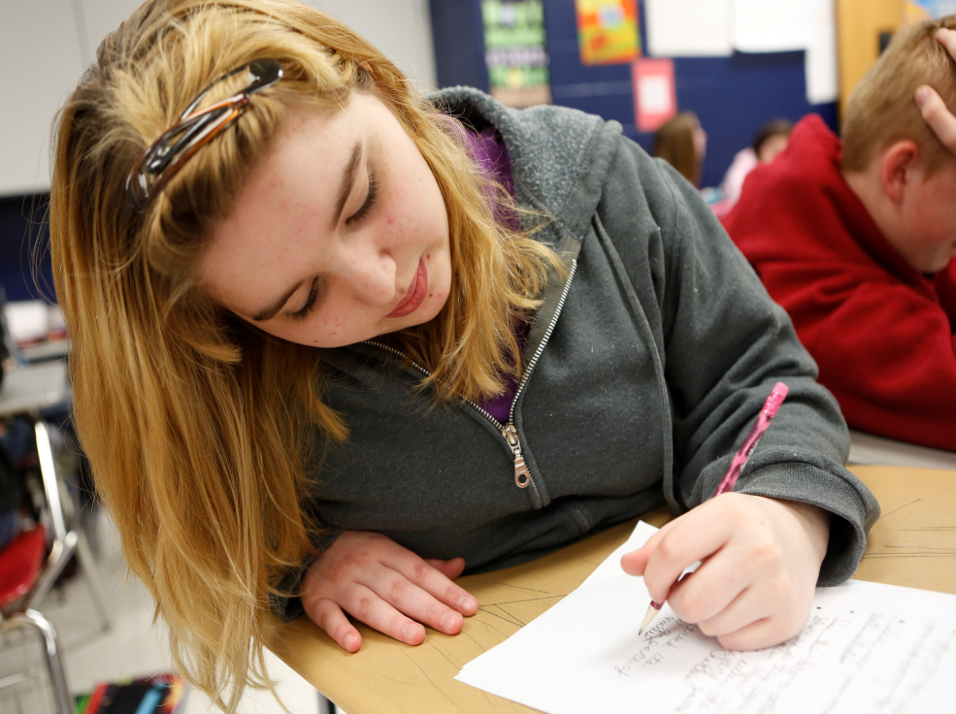
As students continue to thrive in environments that encourage them to wonder and reason, the goal for 21st century learners in 6th grade is to search for ways to understand why change occurs and to question and evaluate the meaning of this change. Students will seek to understand how government functions to serve the interest of the greater good, the multiple influences on how decisions are made and how policies are created. Students will continue to engage in disciplinary thinking by investigating how humans interact with their environments and the role that communication and transportation technologies play in these interactions throughout various regions of the world and analyzing their findings to determine impacts. They will engage in experiences that allow them to develop an understanding of how economic decisions affect the well-being of individuals and society as a whole. Drawing on the Practices in the Inquiry Cycle, especially the ability to engage in historical thinking, students will seek to generate their own questions using historical sources as evidence and launch investigations that will allow them to uncover their own explanations of why change occurs.

Students will need to routinely use the Practices in the Inquiry Cycle in order to develop deeper understandings and to plan, implement and reflect on taking informed action. Together, the power of the Disciplinary Core Concepts and the Practices in the Inquiry Cycle will empower students to not only understand true citizenship, but also to recognize that they themselves are citizens with the power and responsibility to impact their communities. By the end of 6th grade, students will be able to make meaning of these practices to uncover historical understandings and demonstrate civic competencies.

Grade 6: Making Meaning
Practices in the Inquiry Cycle
Questioning  Students will independently and collaboratively:  1. Develop compelling questions that promote inquiry around key disciplinary concepts and embedded enduring issues.  2. Develop supporting questions that identify facts, concepts and research interpretations associated with a key disciplinary concept. | Evaluating Sources  Students will independently and collaboratively:  3. Determine the types of sources that will assist in answering compelling and supporting questions.  4. Gather relevant information from multiple sources from a wide range of perspectives and evaluate for credibility.  5. Identify and utilize evidence to seek solutions to questions. | Communicating  Students will independently and collaboratively:  6. Develop and create claims and counterclaims using appropriate evidence to construct strengths and weaknesses  7. Construct viable arguments, relevant explanations and/or public demonstrations that convey ideas and perspectives to a wide array of appropriate audiences.  8. Critique the arguments and explanations of others paying particular attention to credibility and relevance of information. | Taking Action  Students will independently and collaboratively:  9. Address options of individuals and groups to identify and apply a range of strategies and complex reasoning to take public action or propose a solution.  10. Engage in disciplinary thinking used by social scientists (historians, economists, political scientists and geographers) independently and proficiently resulting in civic readiness.
Civic Mindedness |  | Geographic Reasoning
6.CM.1 Civic and Political Institutions Explain how government affects the functioning of citizens, political and economic groups within society.  6.CM.2 Participation and Deliberation: Applying Civic Virtues and Democratic Principles Explain how personal interests, civic virtues and democratic principles influence decisions.  6.CM.3 Processes, Rules and Laws Examine and explain the procedures for making civic decisions based on the needs of society. |  | 6.GR.8 Spatial Views of the World Explain spatial patterns between places and regions and their corresponding cultural and environmental characteristics using geographical representations.  6.GR.9 Human-Environment Interaction Explain how the physical and human characteristics of places and regions are connected to human identities and cultures.  6.GR.10 Human Populations Spatial Patterns and Movements Explain how transportation and communication technology influence spatial connections among human settlement and affect the diffusion of ideas and cultural practices.  6.GR.11 Global Interconnections Analyze why cultural and environmental characteristics vary among regions of the world.
Economic Decision Making |  | Historical Thinking
6.EDM.4 Economic Decision Making Explain how economic decisions affect the well-being of individuals and society.  6.EDM.5 Exchange and Markets Explain how changes in supply and demand, resource availability and production can be used to study economic markets.  6.EDM.6 National Economy Explain the influence of resource types and availability on economic development.  6.EDM.7 Global Economy Explain barriers to trade and how those barriers influence trade among nations. |  | 6.HT.12 Chronological Reasoning: Causation and Continuity Analyze connections among historical developments and events in order to classify them as examples of change or continuity.  6.HT.13 Historical Understanding: Contextualization and Perspectives Analyze primary and secondary sources to explain how and why perspectives of people have changed over time.  6.HT.14 Historical Arguments Create an argument about the past that is supported by evidence generated from historical sources.  6.HT.15 Interpretation and Synthesis Classify the kinds of historical sources used in a secondary interpretation and analyze them to identify further areas of inquiry and additional sources.

Grade 7: Cause and Effect

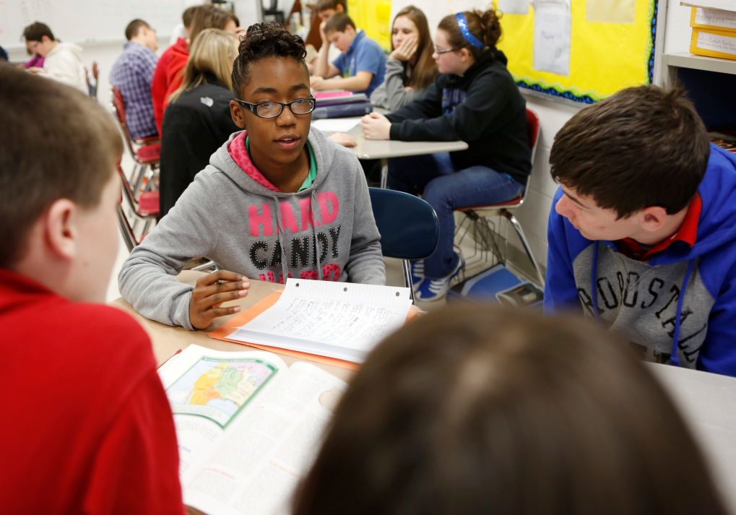Empowered to be leaders of their own educational experiences, the goal for 21st century learners in 7th grade will be to consider deeply the cause of why things happen in addition to thoughtfully examining the effects of these decisions. Students in the 7th grade will explore the powers, limitations and responsibilities that both governments and citizens are afforded as they look beyond their national borders to develop an understanding of society from a global perspective by creating inquiries and evaluating information to formulate new insights. Students will seek to deeply understand how economic decisions are reached through the critical analysis of market outcomes on a national and global scale. As students seek to support and develop their explanations with evidence, they turn toward a critical examination of historical events to provide them with the insight necessary to develop and support a claim that showcases their ability to analyze and embrace the disciplinary thinking required of a social scientist.

Additionally, the 7th grade experience catapults students into the Practices of the Inquiry Cycle by planning, implementing and reflecting upon informed action. 21st century learners need opportunities and experiences that empower them to access and apply complex understandings in order to fully connect the power of causation. By the end of 7th grade, students will be able to use evidence to understand and illustrate the importance of cause and effect within civic mindedness, economic decision making, geographic reasoning and historical thinking, but also how it impacts them both nationally and abroad.

Grade 7: Cause and Effect
Practices in the Inquiry Cycle
Questioning  Students will independently and collaboratively:  1. Develop compelling questions that promote inquiry around key disciplinary concepts and embedded enduring issues.  2. Develop supporting questions that identify facts, concepts and research interpretations associated with a key disciplinary concept. | Evaluating Sources  Students will independently and collaboratively:  3. Determine the types of sources that will assist in answering compelling and supporting questions.  4. Gather relevant information from multiple sources from a wide range of perspectives and evaluate for credibility.  5. Identify and utilize evidence to seek solutions to questions. | Communicating  Students will independently and collaboratively:  6. Develop and create claims and counterclaims using appropriate evidence to construct strengths and weaknesses  7. Construct viable arguments, relevant explanations and/or public demonstrations that convey ideas and perspectives to a wide array of appropriate audiences.  8. Critique the arguments and explanations of others paying particular attention to credibility and relevance of information. | Taking Action  Students will independently and collaboratively:  9. Address options of individuals and groups to identify and apply a range of strategies and complex reasoning to take public action or propose a solution.  10. Engage in disciplinary thinking used by social scientists (historians, economists, political scientists and geographers) independently and proficiently resulting in civic readiness.
Civic Mindedness |  | Geographic Reasoning
7.CM.1 Civic and Political Institutions Explain how constitutions structure the powers and limitations of government and defines powers and responsibilities of citizens.  7.CM.2 Participation and Deliberation: Applying Civic Virtues and Democratic Principles Compare deliberate processes for making decisions and evaluating conclusions as an individual and in groups.  7.CM.3 Processes, Rules and Laws Compare historical and contemporary methods of changing society to promote the general welfare. |  | 7.GR.8 Spatial Views of the World Construct geographical representations to illustrate spatial patterns of cultural and environmental characteristics.  7.GR.9 Human-Environment Interaction Analyze how both the cultural and environmental characteristics of a place are similar to and different from other places.  7.GR.10 Human Populations Spatial Patterns and Movements Analyze how relationships between humans and environments extend or contract spatial patterns of settlement and movement.  7.GR.11 Global Interconnections Explain how global changes in population distribution influence land use.
Economic Decision Making |  | Historical Thinking
7.EDM.4 Economic Decision Making Evaluate alternative approaches to economic issues in terms of benefits, costs and unintended consequences for different groups and society as a whole.  7.EDM.5 Exchange and Markets Explain how changes in supply and demand fuel innovation and explain how market outcomes are impacted by external costs and/or benefits.  7.EDM.6 National Economy Explain the impact of money supply on economic development.  7.EDM.7 Global Economy Analyze the benefits and costs of trade policies and specialization to individuals and society. |  | 7.HT.12 Chronological Reasoning: Causation and Continuity Analyze connections among historical developments and events in order to classify them as examples of change or continuity.  7.HT.13 Historical Understanding: Contextualization and Perspectives Analyze multiple factors that influenced the perspectives of people during different historical eras and explain how and why perspectives of people have changed over time.  7.HT.14 Historical Arguments Create an argument about the past, while acknowledging opposing claims, that is supported by relevant evidence generated from historical sources.  7.HT.15 Interpretation and Synthesis Infer the maker, date, place of origin, audience and/or purpose of a historical source from other relevant historical sources when information is not easily identified.

Grade 8: Participating in Change

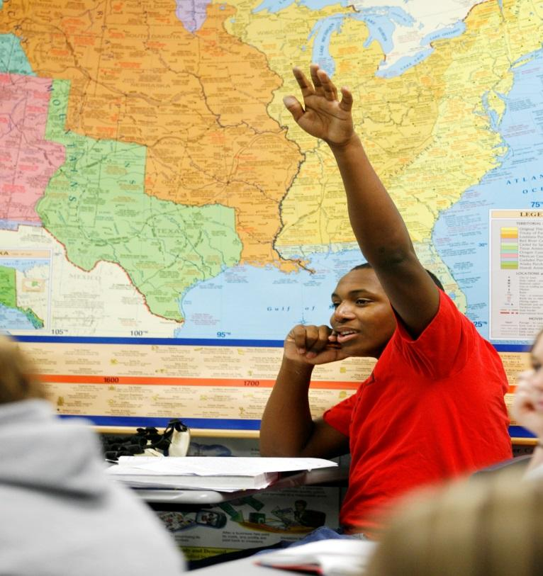When encouraged to wonder, question, analyze and communicate their understandings, students embrace their roles in creating and sustaining change that will have positive implications in their communities, nation and world. The goal for 21st century learners in 8th grade is that through the application of the Practices in the Inquiry Cycle, students will demonstrate their development of civic-mindedness by clearly articulating the significance of civic participation and explaining how these processes are encouraged in order to address and influence societal needs. Students will seek to expand their global perspectives by analyzing how humans interact with their environment in ways that impact culture and create long-term, human-induced change. They will also begin to explore their functions in this change as they seek to develop an understanding of the role that economic issues and decisions made at all levels play on their nation and their world.

These critical thinkers will uncover and effectively utilize data that support their analyses and lead to the development of informed opinions that will determine how they choose to participate in change and impact their society. These 21st century learners will embrace change and take necessary steps to move this change into action. By the end of 8th grade, students will be able to utilize knowledge from understandings about the interconnectedness of geography, economics and history to actively engage through civic mindedness and progress from basic civic dispositions to civic participation.

Grade 8: Participating in Change
Practices in the Inquiry Cycle
Questioning  Students will independently and collaboratively:  1. Develop compelling questions that promote inquiry around key disciplinary concepts and embedded enduring issues.  2. Develop supporting questions that identify facts, concepts and research interpretations associated with a key disciplinary concept. | Evaluating Sources  Students will independently and collaboratively:  3. Determine the types of sources that will assist in answering compelling and supporting questions.  4. Gather relevant information from multiple sources from a wide range of perspectives and evaluate for credibility.  5. Identify and utilize evidence to seek solutions to questions. | Communicating  Students will independently and collaboratively:  6. Develop and create claims and counterclaims using appropriate evidence to construct strengths and weaknesses  7. Construct viable arguments, relevant explanations and/or public demonstrations that convey ideas and perspectives to a wide array of appropriate audiences.  8. Critique the arguments and explanations of others paying particular attention to credibility and relevance of information. | Taking Action  Students will independently and collaboratively:  9. Address options of individuals and groups to identify and apply a range of strategies and complex reasoning to take public action or propose a solution.  10. Engage in disciplinary thinking used by social scientists (historians, economists, political scientists and geographers) independently and proficiently resulting in civic readiness.
Practices in the Inquiry Cycle Civic Mindedness |  | Geographic Reasoning
8.CM.1 Civic and Political Institutions Evaluate and demonstrate the roles of citizens at various levels in the U.S. political system.  8.CM.2 Participation and Deliberation: Applying Civic Virtues and Democratic Principles Analyze founding documents to explain how democratic principles influence government, society and communities.  8.CM.3 Processes, Rules and Laws Analyze the purpose, implementation and consequences of bills, laws and policies to address societal needs. |  | 8.GR.8 Spatial Views of the World Create various geographical representations in order to analyze how patterns of settlement arise, how people make changes to the land and how cultures develop in response to surroundings.  8.GR.9 Human-Environment Interaction Explain how cultural patterns and economic decisions influence environments and daily lives of people in both nearby and distant places.  8.GR.10 Human Populations Spatial Patterns and Movements Evaluate the influences of long-term human-induced environmental changes on spatial patterns.  8.GR.11 Global Interconnections Explain how environmental characteristics and production of goods influence spatial patterns of world trade.
Economic Decision Making |  | Historical Thinking
8.EDM.4 Economic Decision Making Use economic analysis to construct alternative approaches to solve various economic problems.  8.EDM.5 Exchange and Markets Use economic analysis to evaluate the ways in which incentives, competition and the consequences of competition influence buyers and sellers in markets.  8.EDM.6 National Economy Use economic analysis to evaluate data in order to explain the influence of monetary changes on spending, production and supply of money in the national economy.  8.EDM.7 Global Economy Use economic analysis to illustrate how barriers of trade, and the benefits and costs of trade policies affect individuals, businesses and society. |  | 8. HT.12 Chronological Reasoning: Causation and Continuity  Explain multiple causes and effects of developments, events and historical periods and evaluate the relative influence of various causes on these events.  8.HT.13 Historical Understanding: Contextualization and Perspectives Analyze how people’s perspectives and multiple factors influenced what information the creators of historical documents included, and explain how and why perspectives of people have changed over time.  8.HT.14 Historical Arguments Organize applicable evidence from historical sources into a coherent argument including the examination of any opposing claim.  8.HT.15 Interpretation and Synthesis Evaluate the relevancy and usefulness of a historical source by examining and detecting possible limitations based on evidence collected from different kinds of historical sources.

High School: Learners and Leaders

The goal of high school social studies education is to develop 21st century learners who are prepared for responsible citizenship in the future.

In order for students to assume the responsibility of being care-takers of our society, knowledge alone will not adequately prepare today’s learners for success in tomorrow’s society. By constructing educational experiences and opportunities that allow students to apply skills and develop new insights, the future stewards of democracy will be empowered with the skills and aptitudes for being college, career and civic ready.

Through implementation of Practices in the Inquiry Cycle, learners will discover they must understand more than just the immediate surroundings in which they live. By questioning, evaluating and communicating, learners will gain an understanding of how the environment not only impacts them but how they impact the environment. High school students will come to understand that history is a series of interpretations and critical analysis is required to come to a deeper understanding of how these interpretations have shaped people’s decisions, perceptions and the world around them. Proficient questioning and evaluating impacts and outcomes of decisions will yield learners who can investigate economic conditions in multiple ways in order to make connections between the government, other countries and their own lives. While learning to be stewards of democracy, students will further their understanding of the responsibility of civic life by actively participating in civic spaces found in their communities, state, nation and world.

While the high school standards encompass four progressions, these may be interpreted as a culminating performance level that students should master by the end of their social studies education, not necessarily as a fourth year course. Therefore, the “Effective Citizenry” level standards should be clustered into courses that create opportunities for students to demonstrate college, career and civic readiness.

High School 1: Influence
Practices in the Inquiry Cycle
Questioning  Students will independently and collaboratively:  1. Develop compelling questions that promote inquiry around key disciplinary concepts and embedded enduring issues.  2. Develop supporting questions that identify facts, concepts and research interpretations associated with a key disciplinary concept. | Evaluating Sources  Students will independently and collaboratively:  3. Determine the types of sources that will assist in answering compelling and supporting questions.  4. Gather relevant information from multiple sources from a wide range of perspectives and evaluate for credibility.  5. Identify and utilize evidence to seek solutions to questions. | Communicating  Students will independently and collaboratively:  6. Develop and create claims and counterclaims using appropriate evidence to construct strengths and weaknesses  7. Construct viable arguments, relevant explanations and/or public demonstrations that convey ideas and perspectives to a wide array of appropriate audiences.  8. Critique the arguments and explanations of others paying particular attention to credibility and relevance of information. | Taking Action  Students will independently and collaboratively:  9. Address options of individuals and groups to identify and apply a range of strategies and complex reasoning to take public action or propose a solution.  10. Engage in disciplinary thinking used by social scientists (historians, economists, political scientists and geographers) independently and proficiently resulting in civic readiness.
Civic Mindedness |  | Geographic Reasoning
HS2.CM.1 Civic and Political Institutions Analyze founding and governing documents of governments and evaluate the impacts on citizens, political and economic groups.  HS1.CM.2 Participation and Deliberation: Applying Civic Virtues and Democratic Principles Evaluate the effectiveness of social and political systems to promote civic virtues and democratic principles by using primary and secondary sources  HS2.CM.2 Participation and Deliberation: Applying Civic Virtues and Democratic Principles Analyze the civic responsibilities, democratic principles and constitutional rights that guide individuals and societies when addressing governmental and societal issues.  HS3.CM.2 Participation and Deliberation: Applying Civic Virtues and Democratic Principles Analyze how human rights and global responsibility influence individual perspectives and societies when addressing governmental and societal issues. |  | HS1.GR.11 Global Interconnections Analyze ways in which environmental and cultural characteristics influence patterns of trade and modify patterns of land use in places or regions.  HS2.GR.8 Spatial Views of the World Utilize multiple technologies to create maps on multiple scales to interpret and depict spatial patterns of cultural and environmental characteristics.  HS3.GR.8 Spatial Views of the World Predict future trends and outcomes using understanding of spatial patterns related to cultural and/or environmental characteristics at multiple scales.  HS3.GR.9 Human-Environment Interaction Evaluate the impact of human settlement on the environment and culture of places and regions.  HS4.GR.10 Human Populations Spatial Patterns and Movements Evaluate the influence of long-term climate variability on human migration and settlement patterns, resource and land use at local to global scales.  HS4.GR.11 Global Interconnections Synthesize how economic global interdependence and expanding use of resources contribute to conflict and cooperation at the local, state, national and global levels.
Economic Decision Making |  | Historical Thinking
HS3.EDM.4 Economic Decision Making Use economic analysis to determine marginal benefits and marginal costs of the solution for an economic issue.  HS4.EDM.4 Economic Decision Making Construct an argument that evaluates approaches to solving an economic issue, considering resource availability, opportunity cost and incentives.  HS2.EDM.6 National Economy Use economic analysis to identify current and future economic trends using economic indicators.  HS2.EDM.7 Global Economy Use economic analysis to evaluate current economic trends and the role of comparative advantage in the international trade of goods and services.  HS4.EDM.7 Global Economy Evaluate how current globalization trends and policies affect human rights and the environment. |  | HS1.HT.12 Chronological Reasoning: Causation and Continuity Analyze multiple and complex causes and effects of developments, events and historical periods and identify the differences between long-term and triggering events.  HS1.HT.13 Historical Understanding: Contextualization and Perspectives Analyze complex and interactive factors that influenced the perspectives of people during different historical eras and explain how perspectives of people in the present shape interpretations of the past.  HS1.HT.14 Historical Arguments Categorize and prioritize various arguments obtained from historical sources to help build a valid argument, including counterclaims, after considering change over time, historical perspectives and relevance of sources.  HS1.HT.15 Interpretation and Synthesis Detect limitations in historical evidence and interpretations about multiple historical sources to pursue further inquiry and investigate additional sources.

High School 2: Interpretations
Practices in the Inquiry Cycle
Questioning  Students will independently and collaboratively:  1. Develop compelling questions that promote inquiry around key disciplinary concepts and embedded enduring issues.  2. Develop supporting questions that identify facts, concepts and research interpretations associated with a key disciplinary concept. | Evaluating Sources  Students will independently and collaboratively:  3. Determine the types of sources that will assist in answering compelling and supporting questions.  4. Gather relevant information from multiple sources from a wide range of perspectives and evaluate for credibility.  5. Identify and utilize evidence to seek solutions to questions. | Communicating  Students will independently and collaboratively:  6. Develop and create claims and counterclaims using appropriate evidence to construct strengths and weaknesses  7. Construct viable arguments, relevant explanations and/or public demonstrations that convey ideas and perspectives to a wide array of appropriate audiences.  8. Critique the arguments and explanations of others paying particular attention to credibility and relevance of information. | Taking Action  Students will independently and collaboratively:  9. Address options of individuals and groups to identify and apply a range of strategies and complex reasoning to take public action or propose a solution.  10. Engage in disciplinary thinking used by social scientists (historians, economists, political scientists and geographers) independently and proficiently resulting in civic readiness.
Civic Mindedness |  | Geographic Reasoning
HS1.CM.3 Processes, Rules and Laws Evaluate how multiple procedures are used at various levels of government to enact policies and laws to address societal needs.  HS2.CM.3 Processes, Rules and Laws Analyze how people use and challenge laws concerning societal issues across various levels of government.  HS3.CM.3 Processes, Rules and Laws Evaluate public policies in terms of intended and unintended outcomes across various levels of government.  HS4.CM.3 Processes, Rules and Laws Analyze historical, contemporary and emerging methods for changing societies, while promoting the general welfare. |  | HS4.GR.8 Spatial Views of the World Create and use geographical representations to investigate and communicate knowledge that is personally and socially useful and can be applied in making decisions and solving problems.  HS4.GR.9 Human-Environment Interaction Synthesize various types of data about human and physical systems to determine the reciprocal influences of people and places.  HS1.GR.10 Human Populations Spatial Patterns and Movements Analyze how migration patterns and human population distribution are influenced by and influence historical events, ideas, technology and cultural practices.  HS2.GR.11 Global Interconnections Evaluate how human-made or natural catastrophic events may alter environmental and cultural characteristics of an area, impacting trade, politics and human migration on a global scale.  HS3.GR.11 Global Interconnections Evaluate how the development of economic globalization and the desire for access to scarce resources and markets contribute to global conflict and cooperation.
Economic Decision Making |  | Historical Thinking
HS2.EDM.4 Economic Decision Making Use economic analysis to evaluate how economic choices and government policies impact individuals and groups.  HS1.EDM.5 Exchange and Markets Explain how money facilitates exchange by reducing transactional costs and describe its relationship to financial institutions and related institutions.  HS2.EDM.5 Exchange and Markets Identify market inefficiencies and analyze the effectiveness of government policies on both domestic and foreign markets.  HS1.EDM.6 National Economy Use economic analysis to determine how advancements in technology and investment in capital and human resources impact both economic growth and standards of living.  HS1.EDM.7 Global Economy Explain the role of comparative advantage in the international trade of goods and services |  | HS2.HT.12 Chronological Reasoning: Causation and Continuity Analyze multiple and complex causes and effects of developments, events and historical periods to identify change and continuity in historical contexts and explain why it is significant.  HS2.HT.13 Historical Understanding: Contextualization and Perspectives Analyze how historical contexts shaped and continue to shape people’s perspectives and explain how perspectives of people in the present shape interpretations of the past.  HS4.HT.13 Historical Understanding: Contextualization and Perspectives Analyze how current interpretations of the past are limited by the extent to which available historical sources represent perspectives of people at the time and explain how perspectives of people in the present shape interpretations of the past.  HS2.HT.14 Historical Arguments Analyze the central arguments from several historical sources to collect evidence to construct a coherent argument, acknowledging all counterclaims, while taking into consideration change over time, historical perspectives and relevance of sources.  HS2.HT.15 Interpretation and Synthesis Analyze and synthesize evidence obtained from historical sources and secondary interpretations to determine their relationship.  HS4.HT.15 Interpretation and Synthesis Evaluate and question multiple historical sources to pursue further inquiry, for the purpose of synthesizing insights about the past with insights from the present.
High School 3: Impacts and Outcomes
Practices in the Inquiry Cycle
Questioning  Students will independently and collaboratively:  1. Develop compelling questions that promote inquiry around key disciplinary concepts and embedded enduring issues.  2. Develop supporting questions that identify facts, concepts and research interpretations associated with a key disciplinary concept. | Evaluating Sources  Students will independently and collaboratively:  3. Determine the types of sources that will assist in answering compelling and supporting questions.  4. Gather relevant information from multiple sources from a wide range of perspectives and evaluate for credibility.  5. Identify and utilize evidence to seek solutions to questions. | Communicating  Students will independently and collaboratively:  6. Develop and create claims and counterclaims using appropriate evidence to construct strengths and weaknesses  7. Construct viable arguments, relevant explanations and/or public demonstrations that convey ideas and perspectives to a wide array of appropriate audiences.  8. Critique the arguments and explanations of others paying particular attention to credibility and relevance of information. | Taking Action  Students will independently and collaboratively:  9. Address options of individuals and groups to identify and apply a range of strategies and complex reasoning to take public action or propose a solution.  10. Engage in disciplinary thinking used by social scientists (historians, economists, political scientists and geographers) independently and proficiently resulting in civic readiness.
Civic Mindedness |  | Geographic Reasoning
HS1.CM.1 Civic and Political Institutions Distinguish the powers and responsibilities of local, state, national and international civic and political institutions.  HS3.CM.1 Civic and Political Institutions Analyze and evaluate the roles of US citizens as compared to the roles of citizens in other countries.  HS4.CM.1 Civic and Political Institutions Compare and evaluate the effectiveness of domestic and foreign policies of the United States and other countries.  HS4.CM.2 Participation and Deliberation: Applying Civic Virtues and Democratic Principles Demonstrate deliberative processes by applying democratic principles when making decisions and reaching judgments as an individual and in groups for diverse situations. |  | HS1.GR.8 Spatial Views of the World Explain the relationship between places, regions and their political, cultural and economic dynamics using maps, satellite images, photographs and other geographical representations  HS1.GR.9 Human-Environment Interaction Analyze interactions of human and physical systems to explain the corresponding influences among them.  HS2.GR.9 Human-Environment Interaction Evaluate how political and economic decisions influence cultural and environmental characteristics of various places and regions.  HS2.GR.10 Human Populations Spatial Patterns and Movements Evaluate the impact of economic activities on geographical arrangements in urban, suburban and rural areas.  HS3.GR.10 Human Populations Spatial Patterns and Movements Evaluate the impact of political decisions on spatial patterns in urban, suburban and rural areas.
Economic Decision Making |  | Historical Thinking
HS1.EDM.4 Economic Decision Making Explain and evaluate how incentives influence both individual and group choices and government policies.  HS3.EDM.5 Exchange and Markets Evaluate the effectiveness of government policies to regulate markets and analyze the impact of intended and unintended consequences of these policies on market outcomes.  HS4.EDM.5 Exchange and Markets Use economic analysis to determine the impact of property rights and the rule of law on a market economy.  HS3.EDM.6 National Economy Evaluate government monetary and fiscal policy choices in a variety of economic conditions, both past and present.  HS4.EDM.6 National Economy Evaluate and critique the intended and unintended consequences of policies on fluctuations in growth, supply, spending, inflation and employment. |  | HS3.HT.12 Chronological Reasoning: Causation and Continuity Analyze multiple and complex causes and effects of events in the past to identify change and continuity in historic eras and evaluate how historical events, developments and historical periods were shaped by unique circumstances of time and place, as well as broader historical contexts.  HS4.HT.12 Chronological Reasoning: Causation and Continuity Analyze multiple and complex causes and effects of events in the past to identify change and continuity in historical eras and assess how the significance of the actions of individuals and groups change over time and are shaped by the historical context.  HS3.HT.13 Historical Understanding: Contextualization and Perspectives Analyze the ways in which the perspective of the creators of historical documents shaped the history that they produced and explain how perspectives of people in the present shape interpretations of the past.  HS3.HT.14 Historical Arguments Review and critique the main arguments from multiple reliable historical sources to construct a complex rational argument, addressing all major counterclaims and taking into consideration change over time, historical perspectives and relevance of sources.  HS4.HT.14 Historical Arguments Synthesize evidence from multiple historical sources and interpretations into a complex logical argument, fairly and thoroughly developing counterclaims, while considering change over time, historical perspectives and relevance of sources.  HS3.HT.15 Interpretation and Synthesis Critique the usefulness and appropriateness of historical sources based on sourcing for a specific historical inquiry or use in a secondary interpretation.

Anchor Standard 1 | Civic and Political Institutions  Determine the importance of the institutions of society and the principles that these institutions are intended to reflect, which requires the demonstration of in-depth understanding of law, politics and government.
K | Identify the roles and responsibilities of community members.
1st | Explain the need for and purposes of rules in a community.
2nd | Explain how communities work to accomplish tasks and establish responsibilities.
3rd | Explain how citizens engage in democratic processes and practice civic responsibility through government.
4th | Describe the origins, functions and structure of government to determine how it provides structure to protect citizens and provide equal opportunity within the framework of laws.
5th | Examine the origins, functions and structure of the U.S. Constitution to determine how it provides structure to protect citizens and equal opportunities within the framework of laws.
6th | Explain how government affects the functioning of citizens, political and economic groups within society.
7th | Explain how constitutions structure the powers and limitations of government and defines powers and responsibilities of citizens.
8th | Evaluate and demonstrate the roles of citizens at various levels in the U.S. political system.
HS-1 | Distinguish the powers and responsibilities of local, state, national and international civic and political institutions.
HS-2 | Analyze founding and governing documents of governments and evaluate the impact on citizens, political and economic groups.
HS-3 | Analyze and evaluate the roles of US citizens as compared to the roles of citizens in other countries.
HS-4 | Compare and evaluate the effectiveness of domestic and foreign policies of the United States and other countries.

Anchor Standard 2 | Participation and Deliberation: Applying Civic Virtues and Democratic Principles  Analyze foundational documents and determine key understandings in order to evaluate how citizens should interact with each other in formal institutions and informal interactions.
K | Describe how people treat each other, then demonstrate respect for authority and peers.
1st | Describe and demonstrate equality, fairness and freedom when making decisions.
2nd | Compare individual and group perspective and how they affect decisions.
3rd | Demonstrate civic virtues, democratic principles and respect for various perspectives.
4th | Compare the beliefs, experiences and values that affect individual and group perspectives.
5th | Demonstrate deliberative procedures when making decisions and reaching judgments as an individual and as a group.
6th | Explain how personal interests, civic virtues and democratic principles influence decisions.
7th | Compare deliberate processes for making decisions and evaluating conclusions as an individual and in groups.
8th | Analyze founding documents to explain how democratic principles influence government, society and communities.
HS-1 | Evaluate the effectiveness of social and political systems to promote civic virtues and democratic principles by using primary and secondary sources.
HS-2 | Analyze the civic responsibilities, democratic principles and constitutional rights that guide individuals and societies when addressing governmental and societal issues.
HS-3 | Analyze how human rights and global responsibility influence individual perspectives and societies when addressing governmental and societal issues.
HS-4 | Demonstrate deliberative processes by applying democratic principles when making decisions and reaching judgments as an individual and in groups for diverse situations.

Anchor Standard 3 | Processes, Rules and Laws  Evaluate and critique how decisions, procedures and policies are used to address problems and/or needs in a variety of settings.
K | Describe rules in various settings.
1st | Explain the purpose of rules in various settings.
2nd | Describe how people have tried to improve their communities through rules or laws.
3rd | Compare decision-making procedures in a variety of circumstances to address issues.
4th | Explain how the development of policies improves communities and attempts to meet the needs of society.
5th | Explain how rules and laws promote the general welfare using historical and contemporary examples.
6th | Examine and explain the procedures for making civic decisions based on the needs of society.
7th | Compare historical and contemporary methods of changing society to promote the general welfare.
8th | Analyze the purpose, implementation and consequence of bills, laws and policies to address societal needs.
HS-1 | Evaluate how multiple procedures are used at various levels of government to enact policies and laws to address societal needs.
HS-2 | Analyze how people use and challenge laws concerning societal issues across various levels of government.
HS-3 | Evaluate public policies in terms of intended and unintended outcomes across various levels of government.
HS-4 | Analyze historical, contemporary and emerging methods for changing societies, while promoting the general welfare.

Anchor Standard 4 | Economic Decision Making  Analyze and explain how resource availability, opportunity cost and incentives are an essential part of economic decision making.
K | Explain how scarcity of resources affects individuals’ choices.
1st | Explain and generate examples of how scarcity affects economic decisions.
2nd | Describe opportunity costs of economic decisions.
3rd | Explain how economic decisions are affected by opportunity cost.
4th | Describe and evaluate the relationship between resource availability, incentives and opportunity costs.
5th | Evaluate economic decisions using cost-benefit analysis.
6th | Explain how economic decisions affect the well-being of individuals and society.
7th | Evaluate alternative approaches to economic issues in terms of benefits, costs and unintended consequences for different groups and society as a whole.
8th | Use economic analysis to construct alternative approaches to solve various economic problems.
HS-1 | Explain and evaluate how incentives influence both individual and group choices and government policies.
HS-2 | Use economic analysis to evaluate how economic choices and government policies impact individuals and groups.
HS-3 | Use economic analysis to determine marginal benefits and marginal costs of the solution for an economic issue.
HS-4 | Construct an argument that evaluates approaches to solving an economic issue, considering resource availability, opportunity cost and incentives.

Anchor Standard 5 | Exchange and Markets  Analyze how the interactions of buyers and sellers in a variety of economic markets impact goods, services, labor, credit and foreign exchange in the markets; evaluate and critique the effectiveness of government policies on market outcomes.
K | Explain how people purchase goods and services.
1st | Describe the connection between the costs of production and the price of goods and services.
2nd | Identify examples of human, capital and natural resources to explain why individuals and businesses specialize and trade.
3rd | Explain the role of money and financial institutions in economic markets.
4th | Explain the role of buyers, sellers, products and labor in economic markets.
5th | Describe the role of competition in the determination of prices and wages and explain how profits influence sellers in a market.
6th | Explain how changes in supply and demand, resource availability and production can be used to study economic markets.
7th | Explain how changes in supply and demand fuel innovation and explain how market outcomes are impacted by external costs and/or benefits.
8th | Use economic analysis to evaluate the ways in which incentives, competition and the consequences of competition influence buyers and sellers in markets.
HS-1 | Explain how money facilitates exchange by reducing transactional costs and describe its relationship to financial institutions and related institutions.
HS-2 | Identify market inefficiencies and analyze the effectiveness of government policies on both domestic and foreign markets.
HS-3 | Evaluate the effectiveness of government policies to regulate markets and analyze the impact of intended and unintended consequences of these policies on market outcomes.
HS-4 | Use economic analysis to determine the impact of property rights and the rule of law on a market economy.

Anchor Standard 6 | National Economy  Analyze and explain how the amounts and qualities of capital (human and physical) and natural resources influence current and future economic conditions as well as standards of living by evaluating and critiquing the intended and unintended consequences of policies on fluctuations in growth, supply, spending, inflation, employment and growth.
K | Describe examples of goods and services.
1st | Explain how and why people save and spend money.
2nd | Describe how examples of capital, human and natural resources are related to goods and services.
3rd | Describe ways people can increase productivity by using improved capital goods and human capital.
4th | Describe the functions of the monetary system in personal, local and national economies.
5th | Describe government spending on goods and services and analyze the impact of these goods on the standards of living.
6th | Explain the influence of resource types and availability on economic development.
7th | Explain the impact of money supply on economic development.
8th | Use economic analysis to evaluate data in order to explain the influence of monetary changes on spending, production and supply of money in the national economy.
HS-1 | Use economic analysis to determine how advancements in technology and investment in capital and human resources impact both economic growth and standards of living.
HS-2 | Use economic analysis to identify current and future economic trends using economic indicators.
HS-3 | Evaluate government monetary and fiscal policy choices in a variety of economic conditions, both past and present.
HS-4 | Evaluate and critique the intended and unintended consequences of policies on fluctuations in growth, supply, spending, inflation and employment.

Anchor Standard 7 | Global Economy  Analyze and explain the benefits and costs of globalization among individuals and businesses (considering specialization and trade) and how this leads to increased economic interdependence (cross-border movement of goods, services, technology, information and human, physical and financial capital).
K | Describe the origins of goods and services.
1st | Describe why people trade for goods and services.
2nd | Explain the concepts of imports and exports and describe products that are imported and exported.
3rd | Describe and give examples of economic interdependence.
4th | Explain how trade leads to increasing economic interdependence among nations.
5th | Analyze the effects of increasing economic interdependence on different groups within participating nations.
6th | Explain barriers to trade and how those barriers influence trade among nations.
7th | Analyze the benefits and costs of trade policies and specialization to individuals and society.
8th | Use economic analysis to illustrate how barriers of trade, and the benefits and costs of trade policies affect individuals, businesses and society.
HS-1 | Explain the role of comparative advantage in the international trade of goods and services.
HS-2 | Use economic analysis to evaluate current economic trends and the role of comparative advantage in the international trade of goods and services.
HS-3 | Explain how current globalization trends and policies affect economic growth, labor markets, resources and income distribution.
HS-4 | Evaluate how current globalization trends and policies affect human rights and the environment.

Anchor Standard 8 | Spatial Views of the World  Create and utilize maps and other geographical representations to seek and communicate knowledge that is personally and socially useful.
K | Create models of familiar places.
1st | Identify characteristics of places using maps, graphs, photographs and other models.
2nd | Describe places and the relationships and interactions that shape them using maps, graphs, photographs and other models.
3rd | Construct various geographical representations of both familiar and unfamiliar places.
4th | Describe the locations of cultural and environmental characteristics and patterns of movement using maps of different scales.
5th | Explain relationships between the locations of places and regions and their environmental characteristics using maps, satellite images and other models.
6th | Explain spatial patterns between places and regions and their corresponding cultural and environmental characteristics using geographical representations.
7th | Construct geographical representations to illustrate spatial patterns of cultural and environmental characteristics.
8th | Create various geographical representations in order to analyze how patterns of settlement arise, how people make changes to the land and how cultures develop in response to surroundings.
HS-1 | Explain the relationship between places, regions and their political, cultural and economic dynamics using maps, satellite images, photographs and other geographical representations.
HS-2 | Utilize multiple technologies to create maps on multiple scales to interpret and depict spatial patterns of cultural and environmental characteristics.
HS-3 | Predict future trends and outcomes using understanding of spatial patterns related to cultural and/or environmental characteristics at multiple scales.
HS-4 | Create and use geographical representations to investigate and communicate knowledge that is personally and socially useful and can be applied in making decisions and solving problems.

Anchor Standard 9 | Human-Environment Interaction  Determine how society is impacted at local-to-global scales through the interactions of human and physical systems.
K | Identify the characteristics of climate and explain how it affects peoples’ lives in specific places.
1st | Identify environmental characteristics of specific places.
2nd | Identify cultural characteristics of specific places.
3rd | Explain how the culture of places and regions influences how people modify and adapt to their environment.
4th | Explain how cultural and environmental characteristics of places and regions change over time.
5th | Describe how changing environmental and cultural characteristics of places and regions influence how people modify and adapt to their environments and impact population distribution.
6th | Explain how the physical and human characteristics of places and regions are connected to human identities and cultures.
7th | Analyze how both the cultural and environmental characteristics of a place are similar to and different from other places.
8th | Explain how cultural patterns and economic decisions influence environments and daily lives of people in both nearby and distant places.
HS-1 | Analyze interactions of human and physical systems to explain the corresponding influences among them.
HS-2 | Evaluate how political and economic decisions influence cultural and environmental characteristics of various places and regions.
HS-3 | Evaluate the impact of human settlement on the environment and culture of places and regions.
HS-4 | Synthesize various types of data about human and physical systems to determine the reciprocal influences of people and places.

Anchor Standard 10 | Human Populations: Spatial Patterns and Movements  Analyze the movements and spatial patterns of human populations (size, composition, distribution) to determine the relationships between these spatial patterns and physical, political, economic and technological phenomenon.
K | Explain how and why people move.
1st | Explain why and how goods and ideas move to meet daily needs.
2nd | Describe connections between the physical environment and the economic activities of a place.
3rd | Explain how human settlements and movements relate to the availability of natural resources.
4th | Explain how cultural and environmental characteristics affect the distribution and movement of people, goods and ideas.
5th | Analyze the effects of devastating environmental events and technological advancements on human settlement and movement.
6th | Explain how transportation and communication technology influence spatial connections among human settlement and affect the diffusion of ideas and cultural practices.
7th | Analyze how relationships between humans and environments extend or contract spatial patterns of settlement and movement.
8th | Evaluate the influences of long-term human-induced environmental changes on spatial patterns.
HS-1 | Analyze how migration patterns and human population distribution are influenced by and influence historical events, ideas, technology and cultural practices.
HS-2 | Evaluate the impact of economic activities on geographical arrangements in urban, suburban and rural areas.
HS-3 | Evaluate the impact of political decisions on spatial patterns in urban, suburban and rural areas.
HS-4 | Evaluate the influence of long-term climate variability on human migration and settlement patterns, resource and land use at local to global scales.

Anchor Standard 11 | Global Interconnections: Changing Spatial Patterns  Evaluate the dynamic interactions among the world’s people, nations and economic organizations and how they impact global scale issues.
K | Identify ways that physical and cultural characteristics may affect people living in a place.
1st | Explain how the consumption of products connects people to other places through trade.
2nd | Explain why cultural characteristics vary among regions.
3rd | Describe how changes in physical and cultural characteristics of world regions affect people.
4th | Describe how the spatial patterns of economic activities in a place change over time because of interactions with nearby and distant places.
5th | Explain how natural and human-made disasters in one place affect people living in other places.
6th | Analyze why cultural and environmental characteristics vary among regions of the world.
7th | Explain how global changes in population distribution influence land use.
8th | Explain how environmental characteristics and production of goods influence spatial patterns of world trade.
HS-1 | Analyze ways in which environmental and cultural characteristics influence patterns of trade and modify patterns of land use in places or regions.
HS-2 | Evaluate how human-made or natural catastrophic events may alter environmental and cultural characteristics of an area, impacting trade, politics and human migration on a global scale.
HS-3 | Evaluate how the development of economic globalization and the desire for access to scarce resources and markets contribute to global conflict and cooperation.
HS-4 | Synthesize how economic global interdependence and expanding use of resources contribute to conflict and cooperation at the local, state, national and global levels.

Anchor Standard 12 | Chronological Reasoning: Causation and Continuity  Analyze similarities and differences between historical periods and between the past and present, to determine processes of change and continuity over time by evaluating the causation of political, social, economic, cultural and intellectual factors.
K | Create a chronological sequence and generate a possible cause for an event.
1st | Compare life today to the past, utilize a chronological sequence and identify significant individuals and groups.
2nd | Create and use a chronological sequence to generate possible causes for historical developments and events and how these were shaped by individuals and groups.
3rd | Create and use chronological sequences of events to explain probable causes and effects of historical developments and events.
4th | Explain probable causes and effects of historical developments and events and create chronological sequences of events and compare life from specific historical periods to life today.
5th | Analyze and explain how individuals and groups impacted significant historical developments and events.
6th | Analyze connections among historical developments and events in order to classify them as examples of change or continuity.
7th | Analyze connections among historical developments and events in order to classify them as change or examples of continuity.
8th | Explain multiple causes and effects of developments, events and historical periods and evaluate the relative influence of various causes on these events.
HS-1 | Analyze multiple and complex causes and effects of developments, events and historical periods and identify the differences between long-term and triggering events.
HS-2 | Analyze multiple and complex causes and effects of developments, events and historical periods to identify change and continuity in historical contexts and explain why it is significant.
HS-3 | Analyze multiple and complex causes and effects of events in the past to identify change and continuity in historic eras and evaluate how historical events, developments and historical periods were shaped by unique circumstances of time and place, as well as broader historical contexts.
HS-4 | Analyze multiple and complex causes and effects of events in the past to identify change and continuity in historical eras and assess how the significance of the actions of individuals and groups change over time and are shaped by the historical context.

Anchor Standard 13 | Historical Understanding: Contextualization and Perspectives  Evaluate historical developments by analyzing a multiplicity of points of view to gain a broader historical perspective of regional, national and global processes.
K | Compare different perspectives of people.
1st | Compare and contrast perspectives of people in the past to those of people in the present.
2nd | Compare different accounts of the same historical event.
3rd | Compare and explain why individuals and groups during the same historical period differed in their perspectives.
4th | Explain how historical contexts influence people’s perspectives.
5th | Explain how connections among historical contexts and people’s perspectives influenced the development of historical sources during the same historical time period.
6th | Analyze primary and secondary sources to explain how and why perspectives of people have changed over time.
7th | Analyze multiple factors that influenced the perspectives of people during different historical eras and explain how and why perspectives of people have changed over time.
8th | Analyze how people’s perspectives and multiple factors influenced what information the creators of historical documents included, and explain how and why perspectives of people have changed over time.
HS-1 | Analyze complex and interactive factors that influenced the perspectives of people during different historical eras and explain how perspectives of people in the present shape interpretations of the past.
HS-2 | Analyze how historical contexts shaped and continue to shape people’s perspectives and explain how perspectives of people in the present shape interpretations of the past.
HS-3 | Analyze the ways in which the perspective of the creators of historical documents shaped the history that they produced and explain how perspectives of people in the present shape interpretations of the past.
HS-4 | Analyze how current interpretations of the past are limited by the extent to which available historical sources represent perspectives of people at the time and explain how perspectives of people in the present shape interpretations of the past.

Anchor Standard 14 | Historical Arguments  Utilize evidence to craft claims that demonstrate an analysis and evaluation of sources, taking into consideration change over time, perspectives of those involved and relevance of sources.
K | Identify possible reasons for historical developments and events.
1st | Summarize possible reasons for historical developments and events.
2nd | Summarize possible reasons for historical developments and events by viewing a historical source.
3rd | Determine the cause(s) of historical developments and events by examining secondary sources.
4th | Explain the concept of a claim and identify evidence for a secondary source to summarize a claim about the past.
5th | Develop claims about historical developments and events utilizing evidence from historical sources.
6th | Create an argument about the past that is supported by evidence generated from historical sources.
7th | Create an argument about the past, while acknowledging opposing claims, that is supported by relevant evidence generated from historical sources.
8th | Organize applicable evidence from historical sources into a coherent argument including the examination of any opposing claim.
HS-1 | Categorize and prioritize various arguments obtained from historical sources to help build a valid argument, including counterclaims, after considering change over time, historical perspectives and relevance of sources.
HS-2 | Analyze the central arguments from several historical sources to collect evidence to construct a coherent argument, acknowledging all counterclaims, while taking into consideration change over time, historical perspectives and relevance of sources.
HS-3 | Review and critique the main arguments from multiple reliable historical sources to construct a complex rational argument, addressing all major counterclaims and taking into consideration change over time, historical perspectives and relevance of sources.
HS-4 | Synthesize evidence from multiple historical sources and interpretations into a complex logical argument, fairly and thoroughly developing counterclaims, while considering change over time, historical perspectives and relevance of sources.

Anchor Standard 15 | Interpretation and Synthesis  Evaluate the multiplicity of historical points of view, context and circumstances through the use of a wide range of sources in order to create a synthesis of the past, while applying insights from the present.
K | Identify different kinds of historical sources.
1st | Identify the maker, date and place of origin for a historical source from information in the source.
2nd | Generate questions about a historical source and explain how the source is related to a historical development or event.
3rd | Compare information provided by different historical sources about the past to identify multiple points of view.
4th | Analyze the information gathered from historical sources (maker, date, place of origin, audience and purpose), to judge the extent to which the sources are useful for studying a particular topic.
5th | Infer the intended audience and purpose of a historical source by sourcing the document in order to generate questions about how it relates to particular events and developments.
6th | Classify the kinds of historical sources used in a secondary interpretation and analyze them to identify further areas of inquiry and additional sources.
7th | Infer the maker, date, place of origin, audience and/or purpose of a historical source from other relevant historical sources when information is not easily identified.
8th | Evaluate the relevancy and usefulness of a historical source by examining and detecting possible limitations based on evidence collected from different kinds of historical sources.
HS-1 | Detect limitations in historical evidence and interpretations about multiple historical sources to pursue further inquiry and investigate additional sources.
HS-2 | Analyze and synthesize evidence obtained from historical sources and secondary interpretations to determine their relationship.
HS-3 | Critique the usefulness and appropriateness of historical sources based on sourcing for a specific historical inquiry or use in a secondary interpretation.
HS-4 | Evaluate and question multiple historical sources to pursue further inquiry, for the purpose of synthesizing insights about the past with insights from the present.

STORYLINE ABSTRACTS:
K – “MY World”

The goal for 21st century learners in Kindergarten is to wonder and reason, which are the initial building blocks of a rich foundation of inquiry. By embracing the theme of “My World” throughout the school year, students will explore, question and investigate important social elements in their immediate sphere. The expectation for students is to see the world through the lens of all four Disciplinary Core Concepts and to begin an early progression towards college, career and civic readiness. Throughout the Practices in the Inquiry Cycle, students will come to the understanding of civic-mindedness through questioning rules and evaluating roles. Students will use their personal experiences to generate possible reasons for events, leading to the idea that historical events are driven by cause and effect. By connecting everyday classroom experiences to economic decision-making, young learners will be able to question and evaluate the motivations behind these decisions. Also, students will investigate relationships between the environment and their communities. Over the course of a series of experiences, students will begin to develop the essential practices of determining compelling questions to guide their exploration and evaluating information to plan and implement appropriate actions to address authentic problems.

1 – “Considering MY World”

Building on their experiences of “My World” during Kindergarten, 1st graders will engage in 21st century learning, deepening their learning in all Practices in the Inquiry Cycle. Through a woven experience within all four Disciplinary Core Concepts, students begin to see their world as structured where both the past and the present interact. During the first grade, much of the groundwork for cause and effect thinking is constructed so that students can make sense of relationships and interactions at a local level. Experiences throughout the school year will create opportunities for students to question how roles and responsibilities in their communities relate to rules and decision-making, develop historical-thinking skills by questioning and evaluating sources, foster economic decision-making by asking questions and evaluating their roles as consumers and develop geographic-reasoning skills that will challenge students to see relationships between cultures and the environment. This year of wonder and investigation will lead to the development of an understanding of how these concepts affect their world and empower students to see themselves as contributors to the solutions. By the end of first grade, these young learners are equipped to ask relevant questions and make connections to the world they know.

2 – “Explaining and Describing MY World”

With students developing a keen sense of the world around them in the previous grade levels, 21st century learners will connect foundational concepts to explain and describe aspects of the world around them in 2nd grade. By creating experiences and opportunities enriched by the Practices in the Inquiry Cycle across the four Disciplinary Core Concepts, the essential skills for college, career and civic readiness continue to develop. Students will explain, describe and question why and how people and governments make decisions that benefit their communities and explain how availability of goods and services are key in their economic decision making, including the process of production, distribution and consumption. Further, students will describe how human-environmental interactions affect their understanding of the world, and how the world changes as a result of physical characteristics and human activities. As students’ perception of text shifts from “learning to read” to “reading to learn,” interrogating text by questioning, comparing different historical perspectives and creating time lines will be key in their social studies development. During second grade, it is fundamental to further students’ abilities to recognize cause and effect relationships. By the end of 2nd grade, students are ready to stretch their perspectives outside of their immediate surroundings.

3 - “Working Together”

To continue building the foundation for college, career and civic readiness, the goal for 3rd graders as 21st century learners is to continue to refine their questioning and evaluation skills, while building a broader understanding of the world around them. Students are ready to investigate how collaboration and the establishment of various responsibilities in a community and respect for others are necessary to achieve and maintain a functioning society. These investigations begin by developing an understanding of democratic processes and principles, through the concept of rules and authority. Using their understanding of rules and authority, students will build a context for the larger concept of democracy by exploring how ideas, events and people are connected through history, geography, economics and civics; how they all "work together.” As students examine how events from the past shape the future, they will also evaluate how their own understandings are shaped by the past. These engaged learners will use their growing understanding of the world to compare historical sources and establish cause and effect across time while investigating different historical perspectives. They will analyze and evaluate how productivity and opportunity costs influence decision-making and ​the role of money and financial institutions on decisions on both a small and large scale. They will examine why people exchange goods and services and how goods and productivity can be improved. In addition, these 21st century learners will come to an understanding that the physical environment plays a pivotal role in determining how society developed over time. Most significantly, through the Practices in the Inquiry Cycle, students will take informed action on issues that arise from the home, school and/or community, understand cause and effect and work collaboratively to communicate their ideas to authentic audiences. By the end of 3rd grade, students get a sense that people, ideas and events function both independently and together.

4 - “Relationships”

To further develop independent thinking and collaboration skills, the goal for 21st century learners in 4th grade is to continue fostering curiosity and engagement through learning experiences that focus on the complex and overlapping relationships within communities, states and nations. Student experiences will allow them to interact with and evaluate the relationships through the lenses of perspective, change and interdependence and how these viewpoints impact an individual and a society and the world.

Students will continue to focus on questioning as they consider perspectives and how these impact the reasons for why people create and make changes to rules and laws to meet the needs of society. They will question and evaluate perspective, context and cause and effect, as they continue to examine historical sources. Work will be done to judge the validity and usefulness of sources when studying a particular topic as they sharpen historical-thinking skills. By building on the economic understandings of scarcity, opportunity costs and human capital, 21st century learners will develop questions to investigate how the relationships between buyers and sellers, supply and demand, trade and specialization and changes to human capital all impact economic decision-making. Using geographic tools, students will examine how the cultural, environmental and man-made characteristics impact humanity’s interaction with its surroundings. As students continue refining their ability to question, evaluate and communicate, they will examine school and community relationships to identify and address issues that affect students' lives. They will also engage with and meet perceived needs in their communities through the application of civic readiness, sharing research and communicating solutions to local issues of importance in a meaningful and authentic way. By the end of 4th grade, students can make connections to relationships within communities, states and nations and evaluate these relationships through the lenses of perspective, change and interdependence.

5 – “Change and Impact”

Once a sense of self and the importance of relationships are established for civic-readiness, the goal for 21st century learners in 5th grade is to use the Practices in the Inquiry Cycle to examine the idea of change.

This close examination will not only focus on the who, why and how of events, but ultimately the outcomes of these events: the impacts of change. While investigating the power of change, students will develop a sense of civic-mindedness by examining how and why groups and individuals work to establish better forms of government in the United States and around the world and how rules and laws promote the greater good. They will refine historical-thinking skills by interpreting historical sources to generate insights on both how and why context affects perspectives and determine why evidence is important in a historical claim. As they search to explain how the influence of groups and individuals factor into economic decision-making both at home and abroad, they will see how competition can create a healthy economy. They will also apply geographic-reasoning by conducting inquiries into how cultural and environmental outcomes change over time and are impacted by both natural and man-made events.

Most importantly students will utilize the Practices in the Inquiry Cycle to create meaningful opportunities to take informed action. These practices allow students to have an impact; to make change and start to build the idea of their role as an important individual in local and world events. By the end of 5th grade, students are ready to determine the power and impacts of change both at home and around the world.

6 - “Making Meaning”

As students continue to thrive in environments that encourage them to wonder and reason, the goal for 21st century learners in 6th grade is to search for ways to understand why change occurs and to question and evaluate the meaning of this change. Students will seek to understand how government functions to serve the best interest of the greater good and the multiple influences on how decisions and policies are created. Students will continue to engage in disciplinary thinking by investigating how humans interact with their environments and the role that communication and transportation technologies play in these interactions throughout various regions of the world and analyzing their findings to determine impacts. They will engage in experiences that allow them to develop an understanding of how economic decisions affect the well-being of individuals and society as a whole. Drawing on the Practices in the Inquiry Cycle, especially the ability to engage in historical thinking, students will seek to generate their own questions using historical sources as evidence and launch investigations that will allow them to uncover their own explanations of why change occurs.

Students will need to routinely use the Practices in the Inquiry Cycle in order to develop deeper understandings and to plan, implement and reflect on taking informed action. Together, the power of the Disciplinary Core Concepts and the Practices in the Inquiry will empower students to not only understand true citizenship, but also to recognize that they themselves are citizens with the power and responsibility to impact their communities. By the end of 6th grade, students will be able to make meaning of these practices to uncover historical understandings and demonstrate civic competencies.

7 - “Cause and Effect”

Empowered to be leaders of their own educational experiences, the goal for 21st century learners in 7th grade will be to consider deeply the cause of why things happen in addition to thoughtfully examining the effects of these decisions. Students in the 7th grade will explore the powers, limitations and responsibilities that both governments and citizens are afforded as they look beyond their national borders to develop an understanding of society from a global perspective by creating inquiries and evaluating information to formulate new insights. Students will seek to deeply understand how economic decisions are reached through the critical analysis of market outcomes on a national and global scale. As students seek to support and develop their explanations with evidence, they turn toward a critical examination of historical events to provide them with the insight necessary to develop and support a claim that showcases their ability to analyze and embrace the disciplinary thinking required of a social scientist.

Additionally, the 7th grade experience catapults students into the Practices of the Inquiry Cycle by planning, implementing and reflecting upon informed action. 21st century learners need opportunities and experiences that empower them to access and apply complex understandings in order to fully connect the power of causation. By the end of 7th grade, students will be able to use evidence to understand and illustrate the importance of cause and effect within civic mindedness, economic decision making, geographic reasoning and historical thinking, but also how it impacts them both nationally and abroad.

8 - “Participating in Change”

When encouraged to wonder, question, analyze and communicate their understandings, students embrace their roles in creating and sustaining change that will have positive implications in their communities, nation and world. The goal for 21st century learners in 8th grade is that through the application of the Practices in the Inquiry Cycle, students will demonstrate their development of civic-mindedness by clearly articulating the significance of civic participation and explaining how these processes are encouraged in order to address and influence societal needs. Students will seek to expand their global perspectives by analyzing how humans interact with their environment in ways that impact culture and create long-term, human-induced change. They will also begin to explore their functions in this change as they seek to develop an understanding of the role that economic issues and decisions made at all levels play on their nation and their world.

These critical thinkers will uncover and effectively utilize data that support their analyses and lead to the development of informed opinions that will determine how they choose to participate in change and impact their society. These 21st century learners will embrace change and take necessary steps to move this change into action. By the end of 8th grade, students will be able to utilize knowledge from understandings about the interconnectedness of geography, economics and history to actively engage through civic mindedness and progress from basic civic dispositions to civic participation.

High School - “Learners and Leaders”

The goal of high school social studies education is to develop 21st century learners who are prepared for responsible citizenship in the future.

In order for students to assume the responsibility of being care-takers of our society, knowledge alone will not adequately prepare today’s learners for success in tomorrow’s society. By constructing educational experiences and opportunities that allow students to apply skills and develop new insights, the future stewards of democracy will be empowered with the skills and aptitudes for being college, career and civic ready.

Through implementation of Practices in the Inquiry Cycle, learners will discover they must understand more than just the immediate surroundings in which they live. By questioning, evaluating and communicating, learners will gain an understanding of how the environment not only impacts them but how they impact the environment. High school students will come to understand that history is a series of interpretations and critical analysis is required to come to a deeper understanding of how these interpretations have shaped people’s decisions, perceptions and the world around them. Proficient questioning and evaluating impacts and outcomes of decisions will yield learners who can investigate economic conditions in multiple ways in order to make connections between the government, other countries and their own lives. While learning to be stewards of democracy, students will further their understanding of the responsibility of civic life by actively participating in civic spaces found in their communities, state, nation and world.

While the high school standards encompass four progressions, these may be interpreted as a culminating performance level that students should master by the end of their social studies education, not necessarily as a fourth year course. Therefore, the “Learners and Leaders” level standards should be clustered into courses that create opportunities for students to demonstrate college, career and civic readiness.

